Unit 8 Lesson 10: Tell Stories about Our School

Notice and Wonder: Bubbles in the Park (Warm up)

Student Task Statement
What do you notice?
What do you wonder?
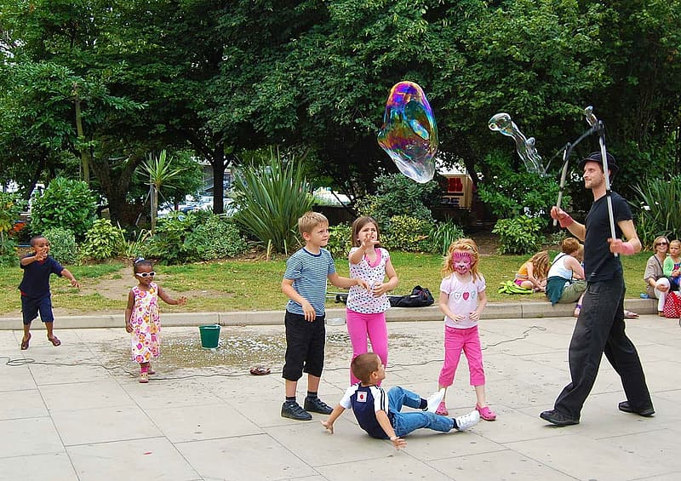

1 Story Problem Brainstorm

Student Task Statement

2 Write Story Problems About Our School

Student Task Statement

3 Centers: Choice Time

Student Task Statement
Choose a center.
Find the Pair
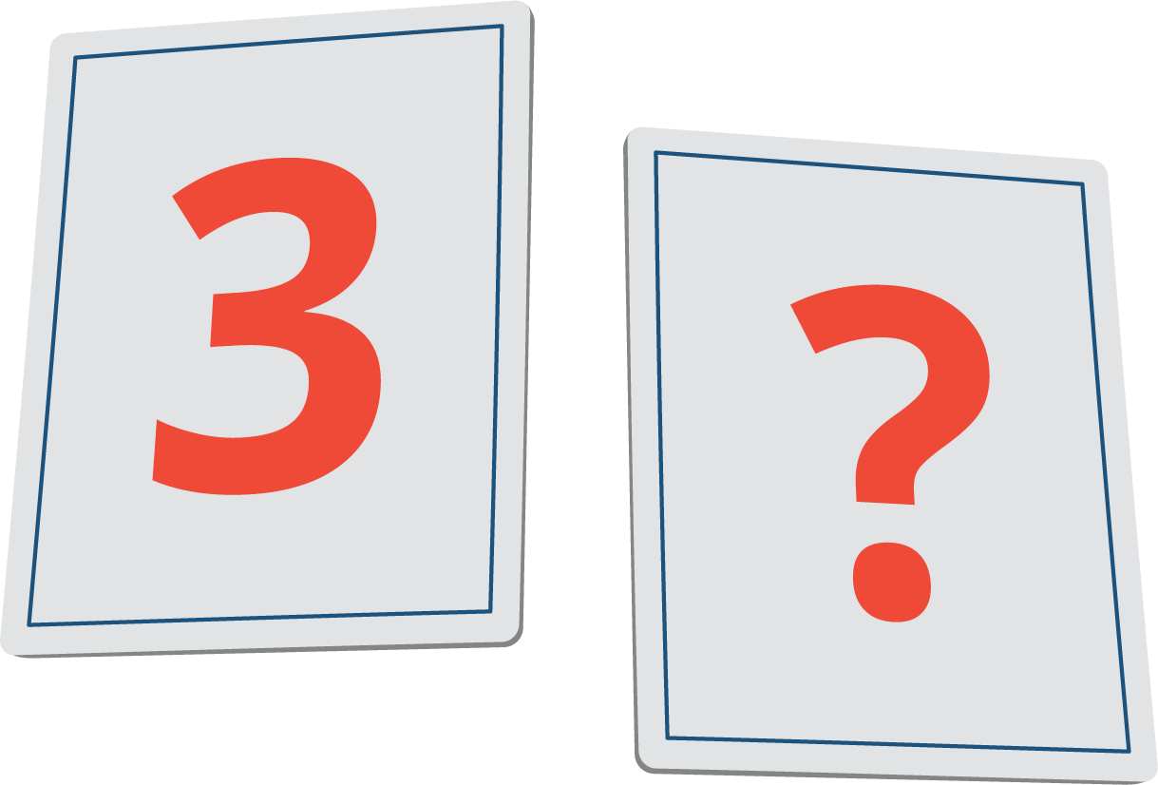
Math Stories
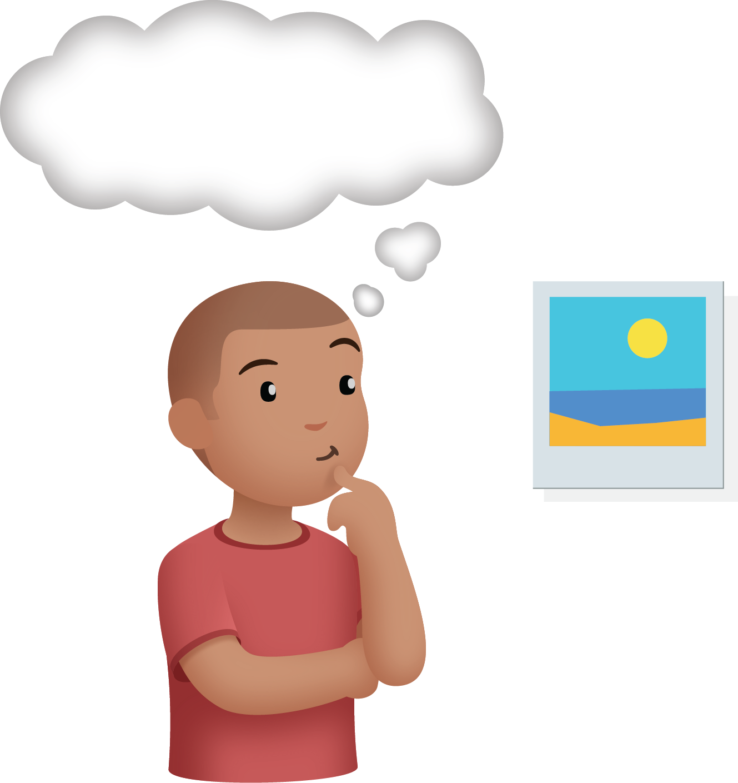
Build Shapes
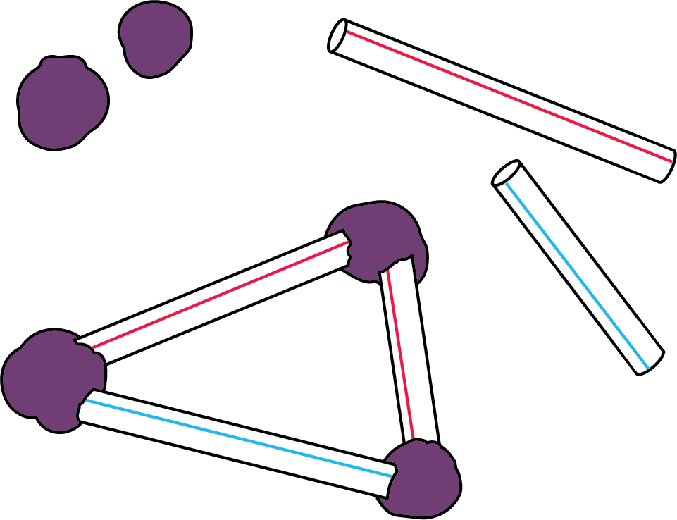
Make or Break Apart Numbers
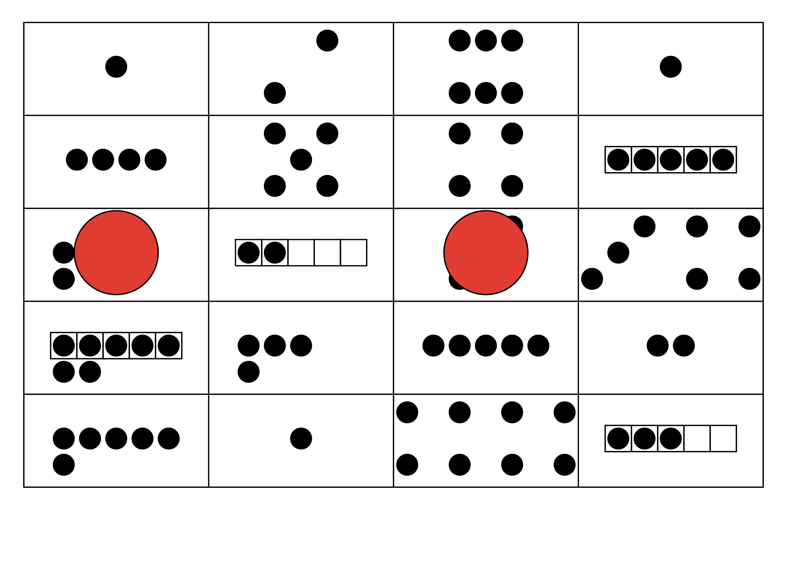
Picture Books
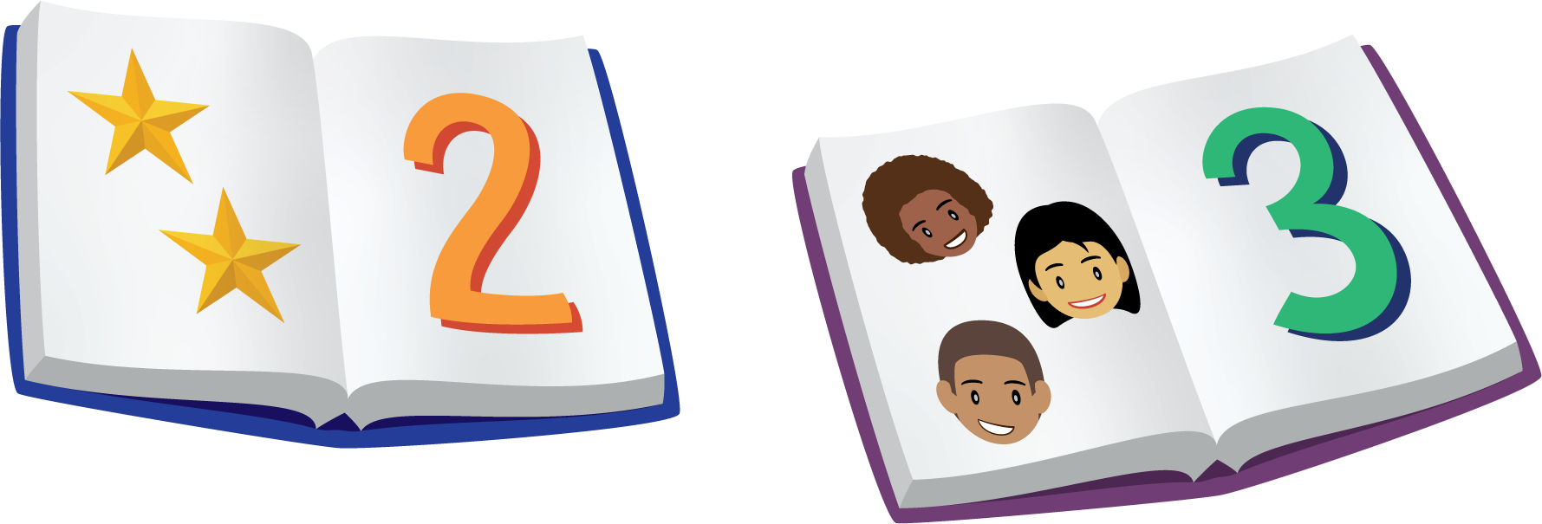
© CC BY 2021 Illustrative Mathematics®

