Lesson 6 Practice Problems
- This graph represents Andre’s distance from his bicycle as he walks in a park.
- 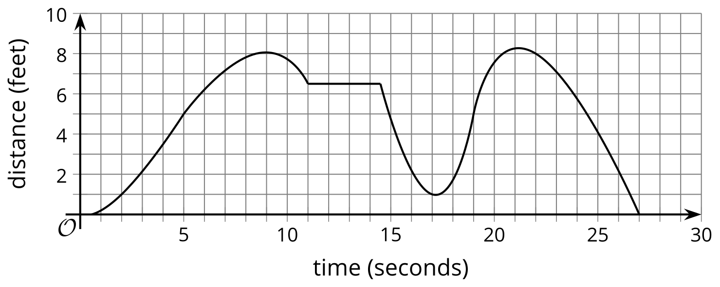
- Decide whether the following statements are true or false.
  - The graph has multiple horizontal intercepts.
  - A horizontal intercept of the graph represents the time when Andre was with his bike.
  - A minimum of the graph is $\left(17,1\right)$.
  - The graph has two maximums.
  - About 21 seconds after he left his bike, he was the farthest away from it, at about 8.3 feet.
- The graph represents the temperature in degrees Fahrenheit as a function of time.
- 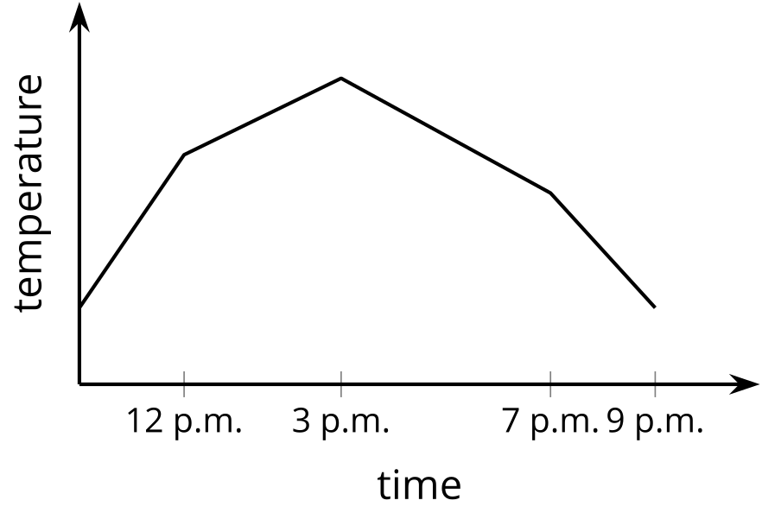
- Tell the story of the temperature throughout the day.
- Identify the maximum and minimum of the function and where the function is increasing and decreasing.
- Match each feature of the situation with a corresponding statement in function notation.
- 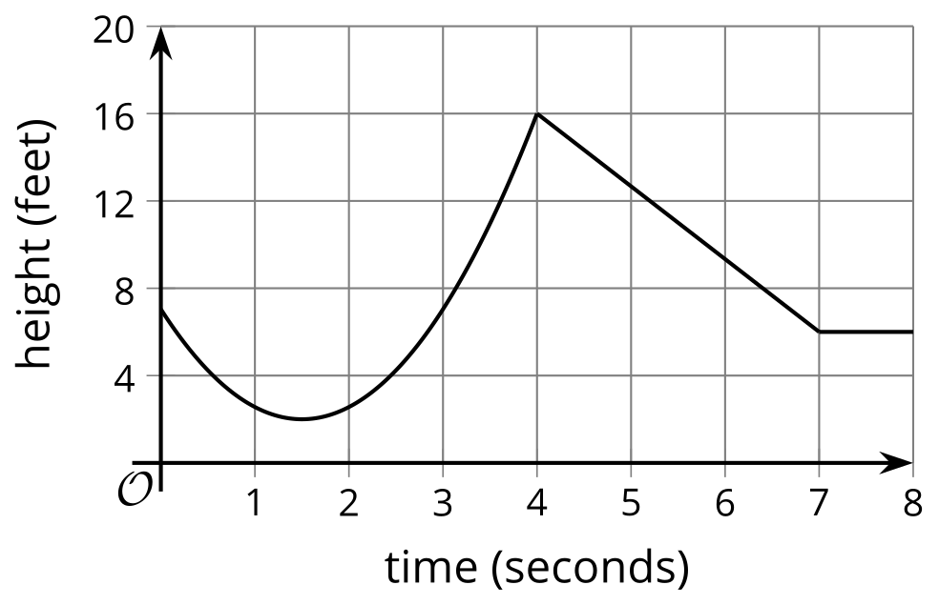
  - maximum height
  - minimum height
  - height staying the same
  - starting height
  - $h\left(0\right)=7$
  - $h\left(1.5\right)$
  - $h\left(4\right)$
  - $h\left(t\right)=6$ for $7≤t≤8$
- Here are the equations that define three functions.
- $f\left(x\right)=4x−5$
- $g\left(x\right)=4\left(x−5\right)$
- $h\left(x\right)=\frac{x}{4}−5$
  - Which function value is the largest: $f\left(100\right)$, $g\left(100\right)$, or $h\left(100\right)$?
  - Which function value is the largest: $f\left(\text{-}100\right)$, $g\left(\text{-}100\right)$, or $h\left(\text{-}100\right)$?
  - Which function value is the largest: $f\left(\frac{1}{100}\right)$, $g\left(\frac{1}{100}\right)$, or $h\left(\frac{1}{100}\right)$?
- Function $f$ is defined by the equation $f\left(x\right)=x^{2}$.
  - What is $f\left(2\right)$ ?
  - What is $f\left(3\right)$ ?
  - Explain why $f\left(2\right)+f\left(3\right)≠f\left(5\right)$.
- (From Unit 4, Lesson 4.)
- Priya bought two plants for a science experiment. When she brought them home, the first plant was 5 cm tall and the second plant was 4 cm. Since then, the first plant has grown 0.5 cm a week and the second plant has grown 0.75 cm a week.
  - Which plant is taller at the end of 2 weeks? Explain your reasoning.
  - Which plant is taller at the end of 10 weeks? Explain your reasoning.
  - Priya represents this situation with the equation $5+0.5w=4+0.75w$, where $w$ represents the end of week $w$. What does the solution to this equation, $w=4$ represent in this situation?
  - What does the solution to the inequality $5+0.5w>4+0.75w$ represent in this situation?
- (From Unit 2, Lesson 19.)
© CC BY 2019 by Illustrative Mathematics®

