Lesson 7: Addition and Subtraction on the Number Line
- Let’s match equations to number line representations.

Warm-up: Notice and Wonder: Jumps on the Number Line
What do you notice? What do you wonder?
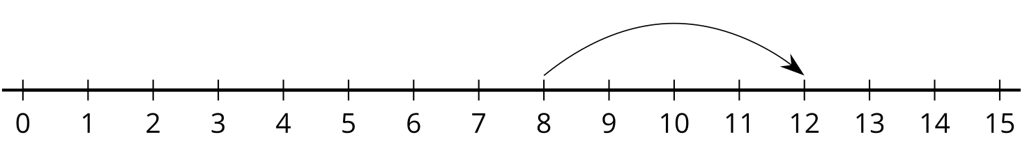
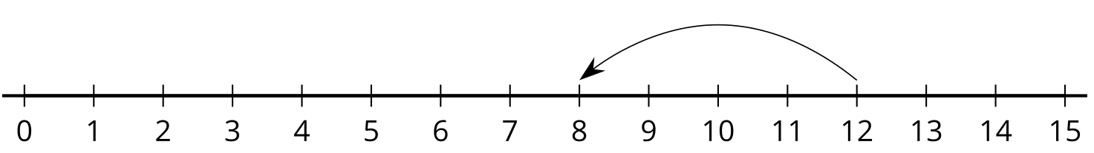

7.1: Add and Subtract
Circle the equation represented on the number line.

- 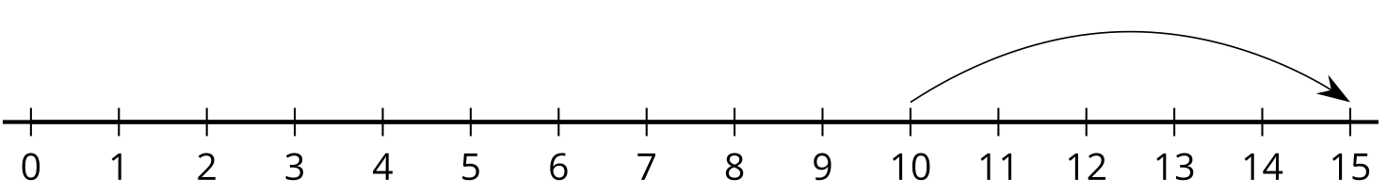
- $10+5=15$
- $15−5=10$

- 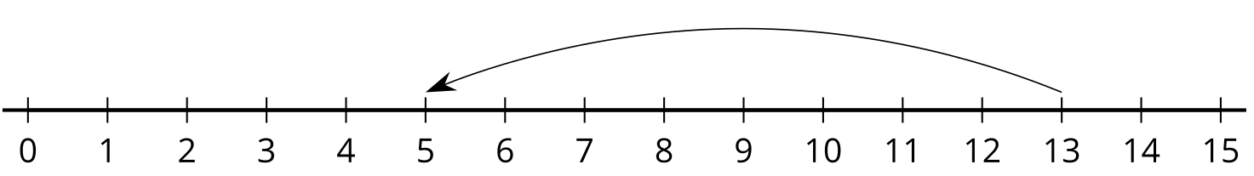
- $8+5=13$
- $13−8=5$

- 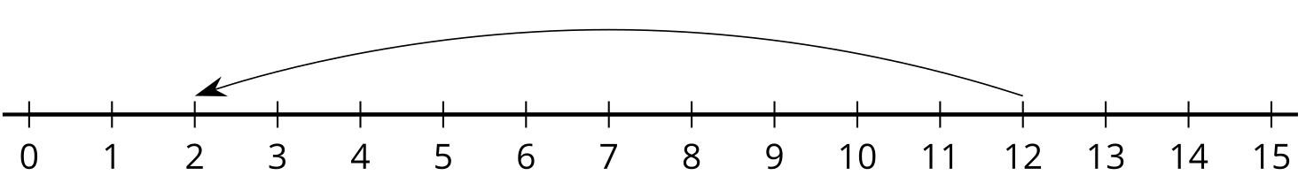
- $12−2=10$
- $12−10=2$

  - 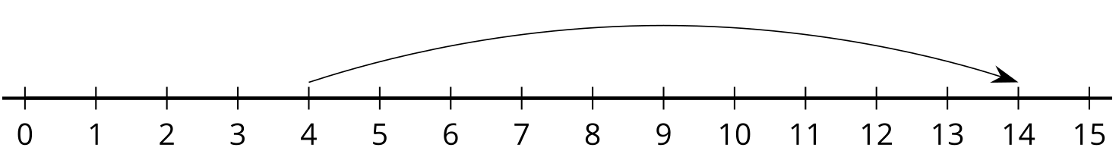
  - $4+10=14$
  - $10+4=14$
  - Explain why the other equation doesn’t match this number line.
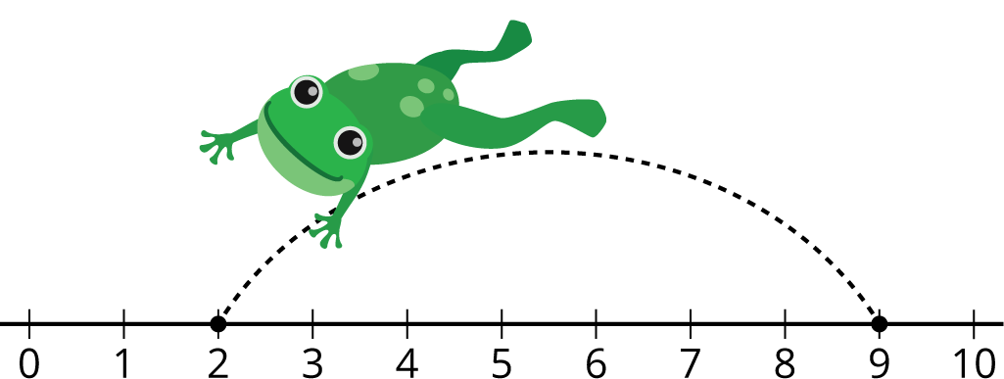

7.2: Number Lines and Equations
- Cut out the equations.
- Paste each equation next to the number line that represents it.
- Paste the equation that didn’t have a match and represent it on a number line.
a.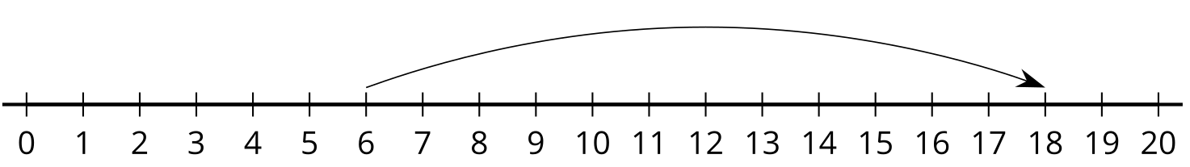
b.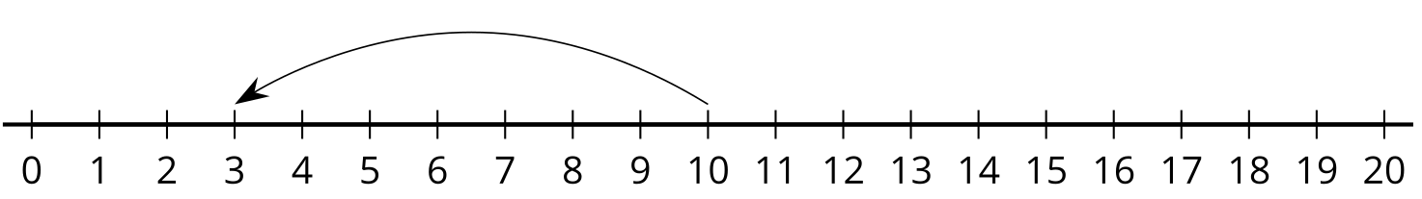
c.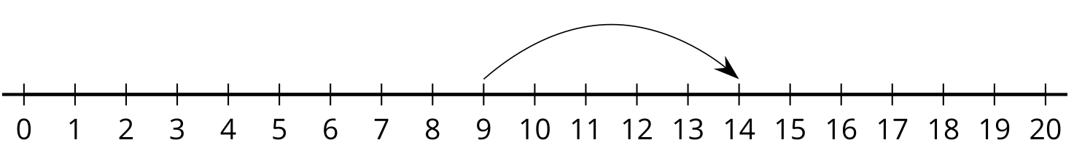
d.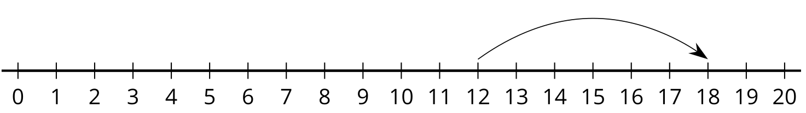
e.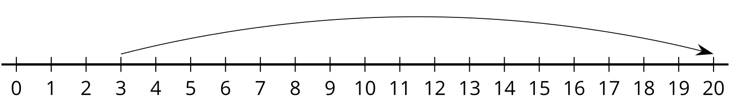
f.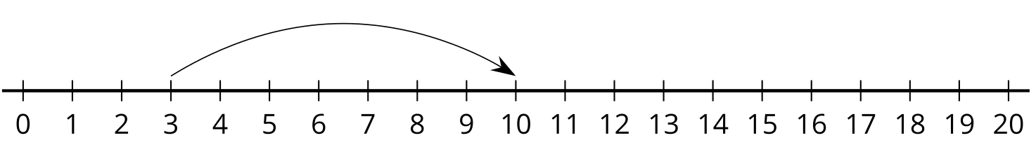
g.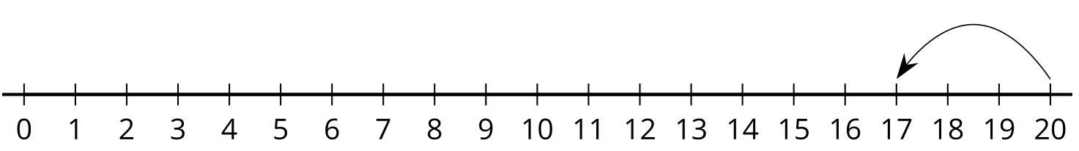
h.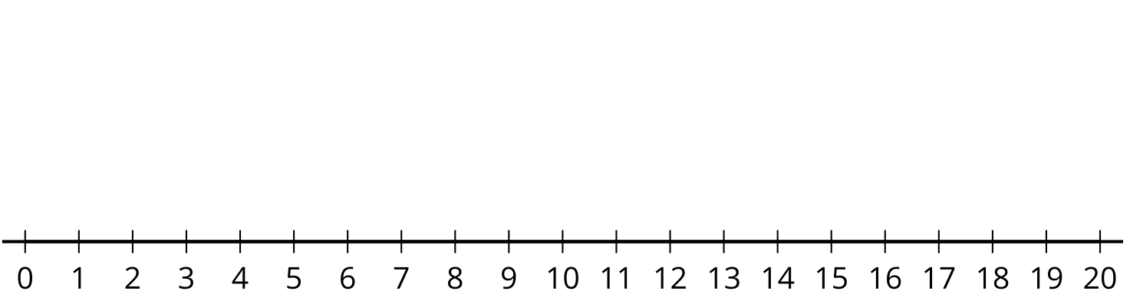
$3+7=10$ | $10−7=3$ | $12+6=18$ | $6+12=18$
$14−5=9$ | $9+5=14$ | $20−3=17$ | $3+17=20$
© CC BY 2021 Illustrative Mathematics®

