Lesson 9: Compare Story Problems
- Let’s solve story problems and write equations.

Warm-up: Number Talk: Addition and Subtraction Expressions
Find the value of each expression mentally.
- $4+6$
- $6+4$
- $10−6$
- $10−4$

9.1: Solve and Represent Story Problems
- Han has 5 lizards.
He has 3 snakes.
How many pets does he have?
- Show your thinking using drawings, numbers, or words.
- Equation: ____________________________
- Han has 8 pets.
5 of his pets are lizards.
The rest of his pets are snakes.
How many snakes does Han have?
Show your thinking using drawings, numbers, or words.
- Equation: ____________________________
- Han has an aquarium that can hold 8 pets.
He has lizards and snakes.
Show different ways Han could fill his aquarium.
Show your thinking using drawings, numbers, or words.
- Equation: ____________________________

9.2: Gallery Walk: Compare the Story Problems
As you look at your classmates' work, think about the questions and be prepared to share your answers.
- What is the same about the story problems and representations?
- What is different about the story problems and representations?
- Explain how the equation matches the story problem.

Section Summary
Section Summary
In this section, we solved story problems.
- We solved story problems where the total was unknown.
- Kiran has some fish in his fish tank.
He has 4 red fish and 5 blue fish.
How many fish does he have in all?
- 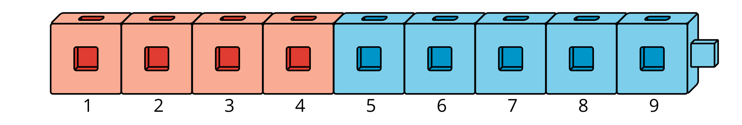
- $4+5=\boxed{9}$
- We solved story problems where both parts were unknown.
- Tyler is playing Shake and Spill.
He is playing with 10 counters.
- Show different combinations of red and yellow counters that Tyler could spill.
- $\boxed{4}+\boxed{6}=10$
- $\boxed{6}+\boxed{4}=10$
- $\boxed{5}+\boxed{5}=10$
- $\boxed{7}+\boxed{3}=10$
- We solved problems where the second part was unknown.
- 6 counters are outside the cup.
Some of the counters are under the cup.
There are 10 counters total.
How many counters are under the cup?
- I can count on from 6 to 10.
- 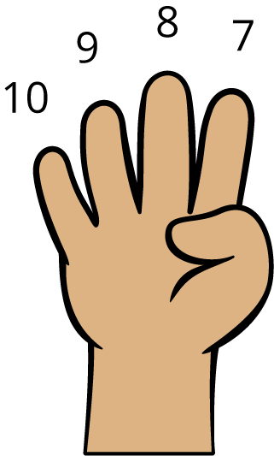
- $6+\boxed{4}=10$
- We learned that the total can come before or after the equal sign.
- $10=4+6$ is the same as $4+6=10$
- We learned that numbers can be added in any order.
- $4+6=10$ is the same as $6+4=10$
© CC BY 2021 Illustrative Mathematics®

