Unit 7 Lesson 3: Count on or Count Back to Subtract

WU Number Talk: Tens and Hundreds (Warm up)

Student Task Statement
Find the value of each expression mentally.
- $120+20$
- $120+200$
- $124+30$
- $124+300$

1 Jump Back, Back, Back

Student Task Statement
Jada and Andre found the value of $375−24$.
Here is their work.
Jada's Work
$375−24=351$
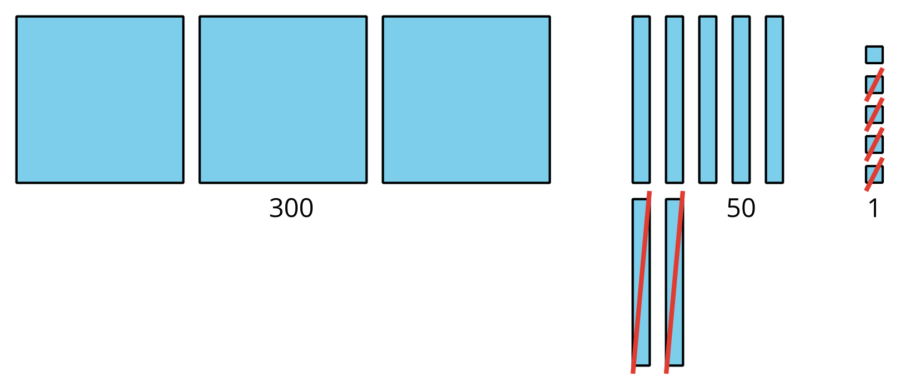
Andre's Work
$375−20=355355−4=351375−24=351$
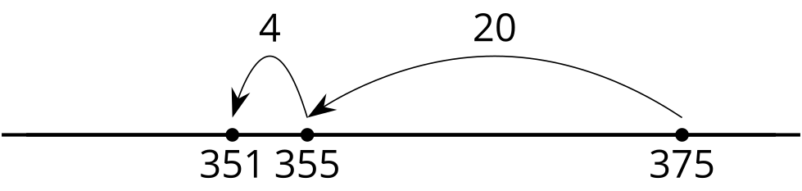
What do you notice? What do you wonder?
- Try Andre’s way to find the value of $189−73$.
- Show your thinking. Use a number line if it helps.
- Find the value of $647−46$ in your own way.
- Show your thinking. Use a number line if it helps.

2 Who Spilled Paint?

Images for Launch

Student Task Statement
Oh no! Diego spilled paint on his paper and now he can’t see all the numbers. Find the number hidden by the paint.
Find the number that makes each equation true.
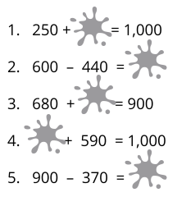
- __________
- __________
- __________
- __________
- __________
© CC BY 2021 Illustrative Mathematics®

