Lesson 8: Estimate and Measure Liquid Volume

Standards Alignments
Addressing | 3.MD.A.2, 3.NF.A, 3.OA.C.7

Teacher-facing Learning Goals
- Measure and estimate liquid volumes of objects using standard units of liters (L).

Student-facing Learning Goals
- Let’s measure and estimate liquid volume.

Lesson Purpose
The purpose of this lesson is for students to use liters to measure and estimate liquid volumes.
In previous lessons, students learned that liquid volume is a measurable attribute and that liters can be used to measure liquid volume. Students use this experience to match containers with estimated liquid volumes they can hold. They compare the marks on a ruler to the marks on a container and learn to use a container with liter marks to measure liquid volume.
This lesson has a Student Section Summary.

Access for:

Students with Disabilities
- Engagement (Activity 2)

English Learners
- MLR8 (Activity 1)

Instructional Routines
Number Talk (Warm-up)

Lesson Timeline
Warm-up | 10 min
Activity 1 | 15 min
Activity 2 | 20 min
Lesson Synthesis | 10 min
Cool-down | 5 min

Teacher Reflection Question
What ideas do students have about liquid volume from their everyday lives? How did it influence their ideas in this lesson?

Cool-down
(to be completed at the end of the lesson) 5min
Measure in Liters

Standards Alignments
Addressing | 3.MD.A.2, 3.NF.A

Student-facing Task Statement
What is the volume of the liquid shown in each image?
1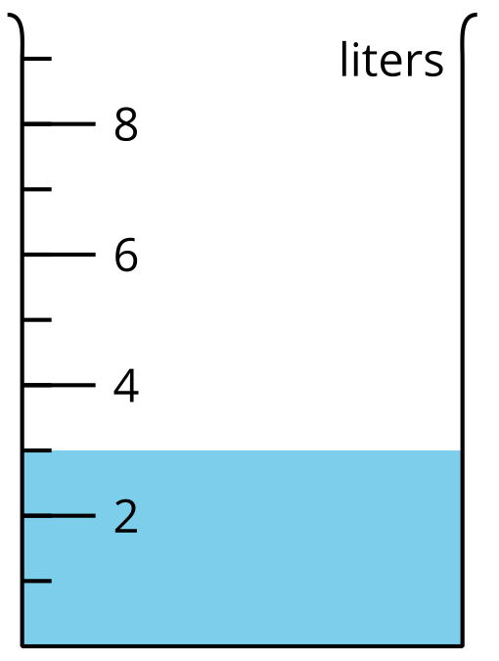
____________________
2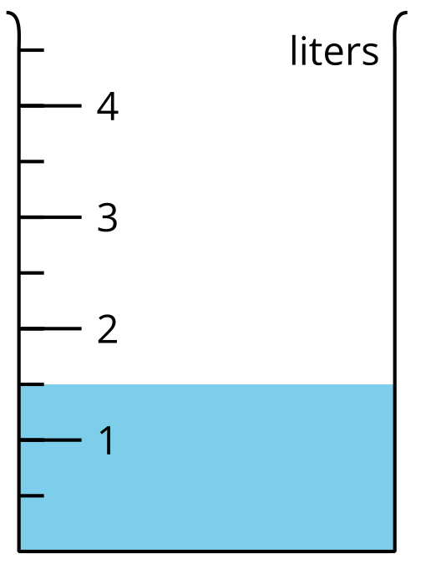
____________________

Student Responses
- 3 liters
- $1\frac{1}{2}$ liters

