Lesson 3: Two or More Lines

Standards Alignments
Addressing | 4.G.A.1

Teacher-facing Learning Goals
- Draw parallel and intersecting lines.
- Identify parallel and intersecting lines.

Student-facing Learning Goals
- Let’s look at lines that cross and lines that don’t.

Lesson Purpose
The purpose of this lesson is for students to identify and draw parallel and intersecting lines.
In previous lessons, students identified and drew rays, lines, and segments. In this lesson, they turn their attention to lines that intersect, or cross, and those that never do.
In the first activity, students draw two kinds of quadrilaterals, one of which is a rectangle. The task motivates them to consider the relationship between lines—whether they would intersect at some point or never would. Students are introduced to parallel lines in this context. Lines typically have arrows at both ends, which represents that they go on in each direction. In this unit, arrows are at the ends of lines when it is important that students distinguish lines from segments and other features.
In the second activity, students draw parallel and intersecting lines. They also practice constructing an argument for how they know that two lines are parallel (MP3). In an upcoming unit, students will classify shapes based on whether they have parallel and perpendicular sides.
To support students with the new vocabulary in this lesson, consider making time for them to add to their “word wall” during the lesson synthesis. Allow a few minutes for students to add new terms, illustrations, and definitions in their own words to an organizer as shown in the blackline master.

Access for:

Students with Disabilities
- Representation (Activity 2)

English Learners
- MLR2 (Activity 1)

Instructional Routines
How Many Do You See? (Warm-up)

Materials to Gather
- Rulers or straightedges: Activity 1, Activity 2

Materials to Copy
- Illustrated Word Wall (groups of 1): Activity 2

Lesson Timeline
Warm-up | 10 min
Activity 1 | 15 min
Activity 2 | 20 min
Lesson Synthesis | 10 min
Cool-down | 5 min

Teacher Reflection Question
In the next unit, students will analyze and categorize two-dimensional figures based on whether they have parallel and perpendicular as attributes. How does this lesson prepare that upcoming work?

Cool-down
(to be completed at the end of the lesson) 5min
Parallel and Not Quite Parallel

Standards Alignments
Addressing | 4.G.A.1

Student-facing Task Statement
- Explain why these lines are not parallel.
- 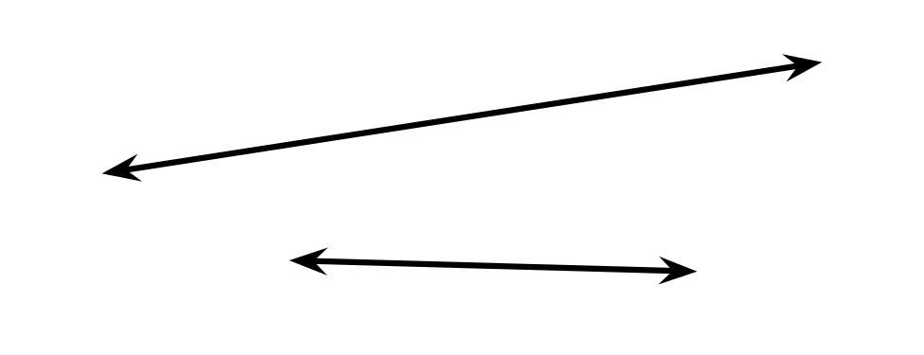
- Sketch a line that is parallel to this line.
- 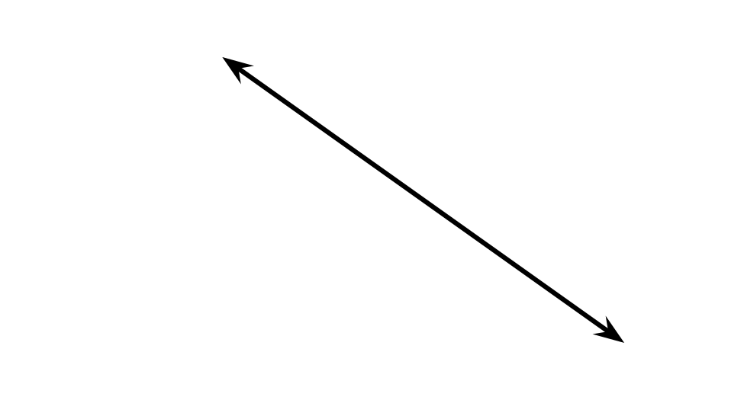

Student Responses
- Sample responses:
  - The two lines get closer to each other in one direction. If we extend them, they will eventually intersect.
  - The two lines are not the same distance apart everywhere. The gap between the two lines is noticeably wider on one side and narrower on the other, so the two lines will cross if they’re extended.
- Sample drawings:
- 
 