Lesson 6 Practice Problems
- Write a sentence to answer each question:
  - How much warmer is 82 than 40?
  - How much warmer is 82 than -40?

  - What is the difference in height between 30 m up a cliff and 87 m up a cliff? What is the distance between these positions?
  - What is the difference in height between an albatross flying at 100 m above the surface of the ocean and a shark swimming 30 m below the surface? What is the distance between them if the shark is right below the albatross?
- A company produces screens of different sizes. Based on the table, could there be a relationship between the number of pixels and the area of the screen? If so, write an equation representing the relationship. If not, explain your reasoning.
- square inches of screen | - number of pixels
- 6 | - 31,104
- 72 | - 373,248
- 105 | - 544,320
- 300 | - 1,555,200
- (From Unit 2, Lesson 8.)
- Find each difference.
  - $\left(\text{-}5\right)−6$
  - $35−\left(\text{-}8\right)$
  - $\frac{2}{5}−\frac{3}{5}$
  - $\text{-}4\frac{3}{8}−\left(\text{-}1\frac{1}{4}\right)$
- A family goes to a restaurant. When the bill comes, this is printed at the bottom of it:
- Gratuity Guide For Your Convenience:
15% would be $4.89
18% would be $5.87
20% would be $6.52
- How much was the price of the meal? Explain your reasoning.
- (From Unit 4, Lesson 10.)
- Which is a scaled copy of Polygon A? Identify a pair of corresponding sides and a pair of corresponding angles. Compare the areas of the scaled copies.
- 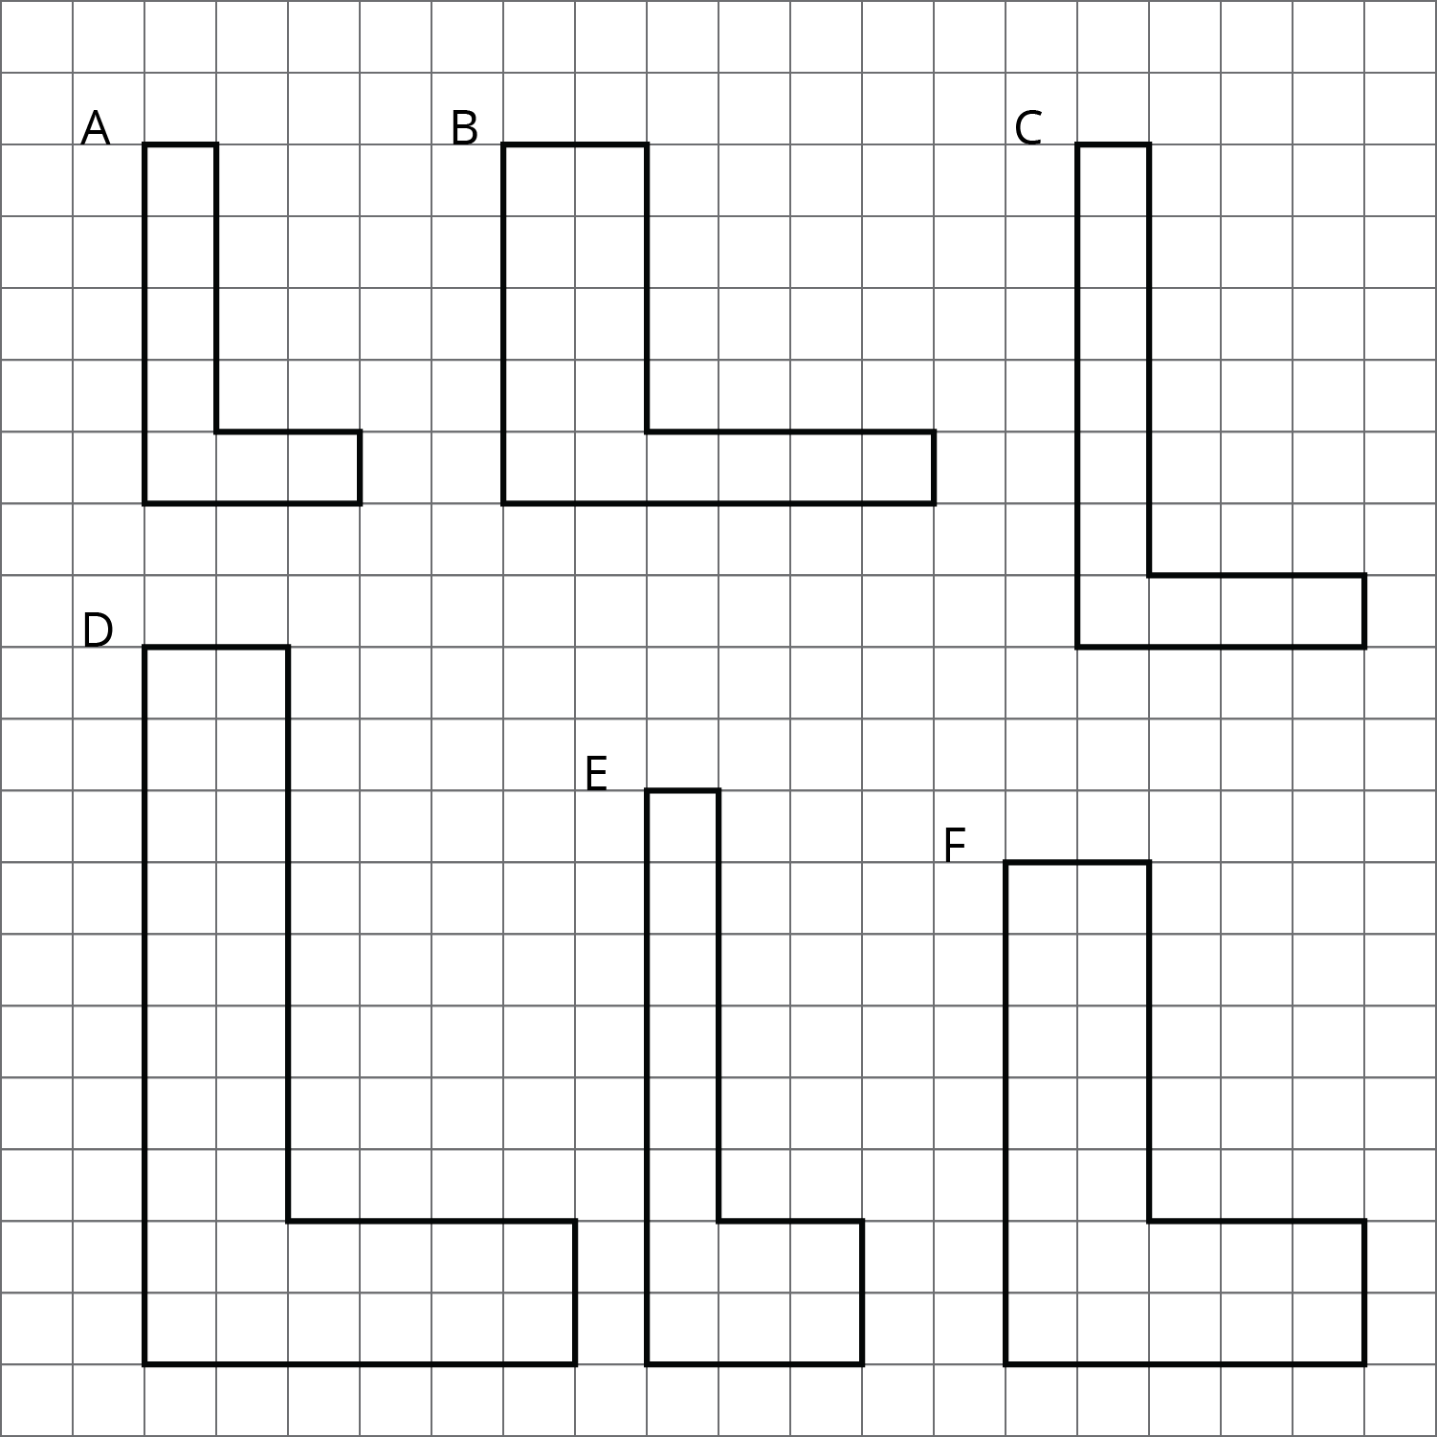
- (From Unit 1, Lesson 2.)
© CC BY Open Up Resources. Adaptations CC BY IM.

