Lesson 7: Using Histograms to Answer Statistical Questions

7.1: Which One Doesn’t Belong: Questions
Here are four questions about the population of Alaska. Which question does not belong? Be prepared to explain your reasoning.
- In general, at what age do Alaska residents retire?
- At what age can Alaskans vote?
- What is the age difference between the youngest and oldest Alaska residents with a full-time job?
- Which age group is the largest part of the population: 18 years or younger, 19–25 years, 25–34 years, 35–44 years, 45–54 years, 55–64 years, or 65 years or older?

7.2: Measuring Earthworms
An earthworm farmer set up several containers of a certain species of earthworms so that he could learn about their lengths. The lengths of the earthworms provide information about their ages. The farmer measured the lengths of 25 earthworms in one of the containers. Each length was measured in millimeters.
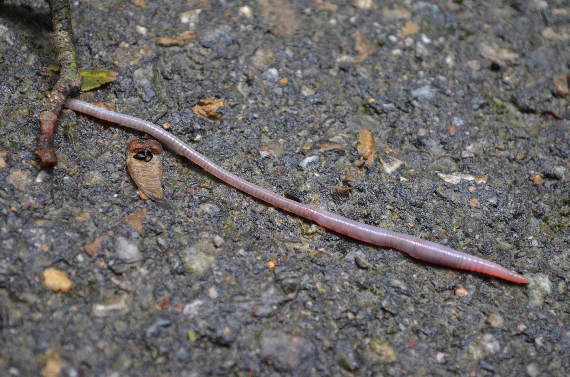
- Using a ruler, draw a line segment for each length:
  - 20 millimeters
  - 40 millimeters
  - 60 millimeters
  - 80 millimeters
  - 100 millimeters
- Here are the lengths, in millimeters, of the 25 earthworms.
- 6 | - 11 | - 18 | - 19 | - 20 | - 23 | - 23 | - 25
- 25 | - 26 | - 27 | - 27 | - 28 | - 29 | - 32 | - 33
- 41 | - 42 | - 48 | - 52 | - 54 | - 59 | - 60 | - 77
- 93

- Complete the table for the lengths of the 25 earthworms.
- length | - frequency
- 0 millimeters to less than 20 millimeters
- 20 millimeters to less than 40 millimeters
- 40 millimeters to less than 60 millimeters
- 60 millimeters to less than 80 millimeters
- 80 millimeters to less than 100 millimeters
- Use the grid and the information in the table to draw a histogram for the worm length data. Be sure to label the axes of your histogram.
- 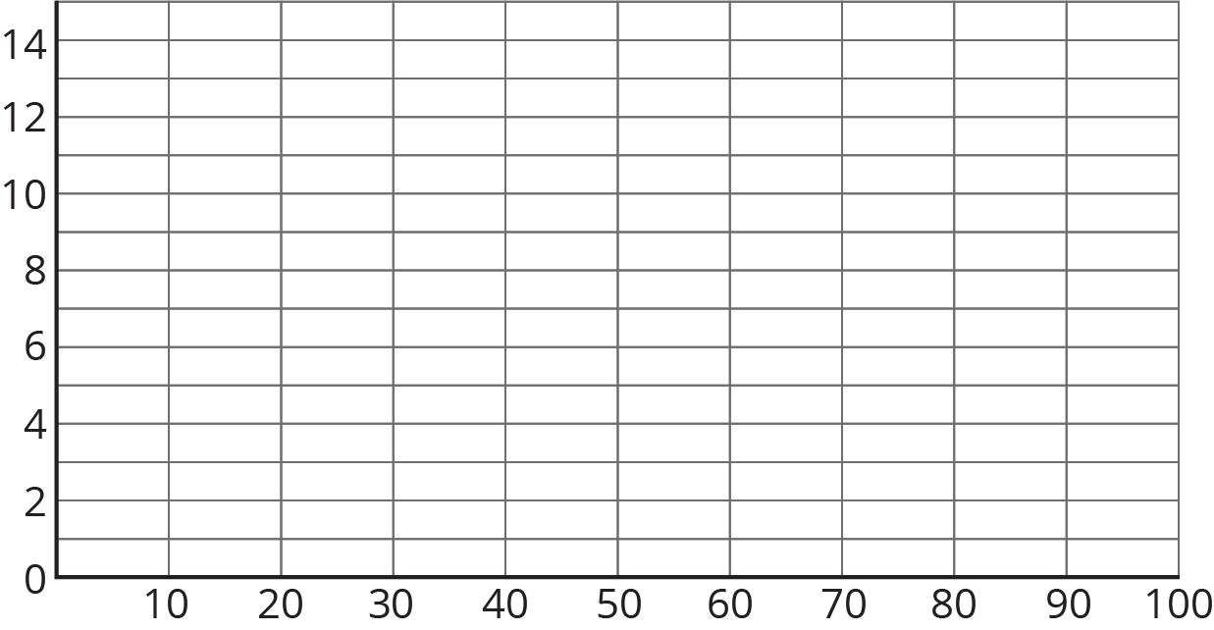
- Based on the histogram, what is a typical length for these 25 earthworms? Explain how you know.
- Write 1–2 sentences to describe the spread of the data. Do most of the worms have a length that is close to your estimate of a typical length, or are they very different in length?

Are you ready for more?
Here is another histogram for the earthworm measurement data. In this histogram, the measurements are in different groupings.
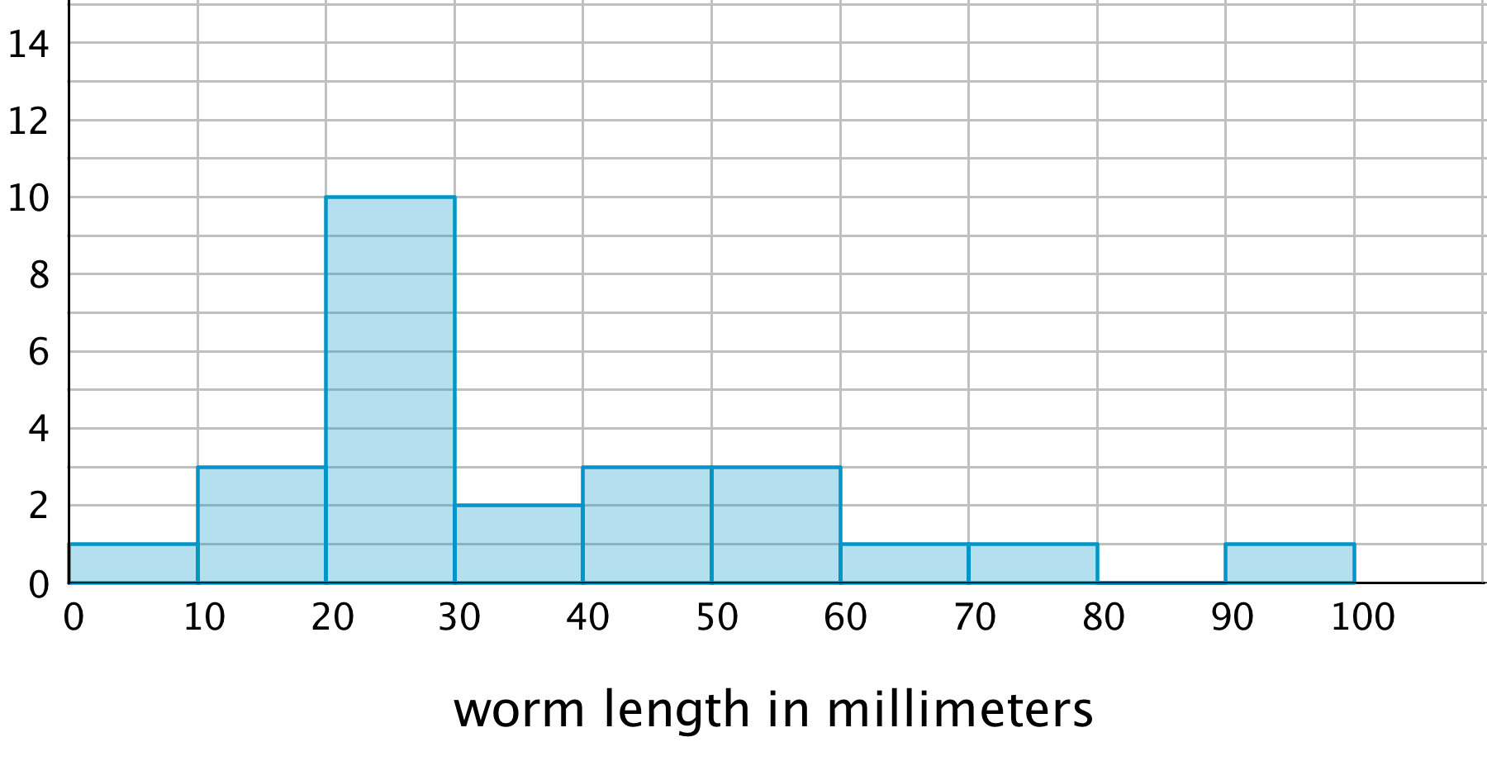
- Based on this histogram, what is your estimate of a typical length for the 25 earthworms?
- Compare this histogram with the one you drew. How are the distributions of data summarized in the two histograms the same? How are they different?
- Compare your estimates of a typical earthworm length for the two histograms. Did you reach different conclusions about a typical earthworm length from the two histograms?

7.3: Tall and Taller Players
Professional basketball players tend to be taller than professional baseball players.
Here are two histograms that show height distributions of 50 male professional baseball players and 50 male professional basketball players.
- Decide which histogram shows the heights of baseball players and which shows the heights of basketball players. Be prepared to explain your reasoning.
- 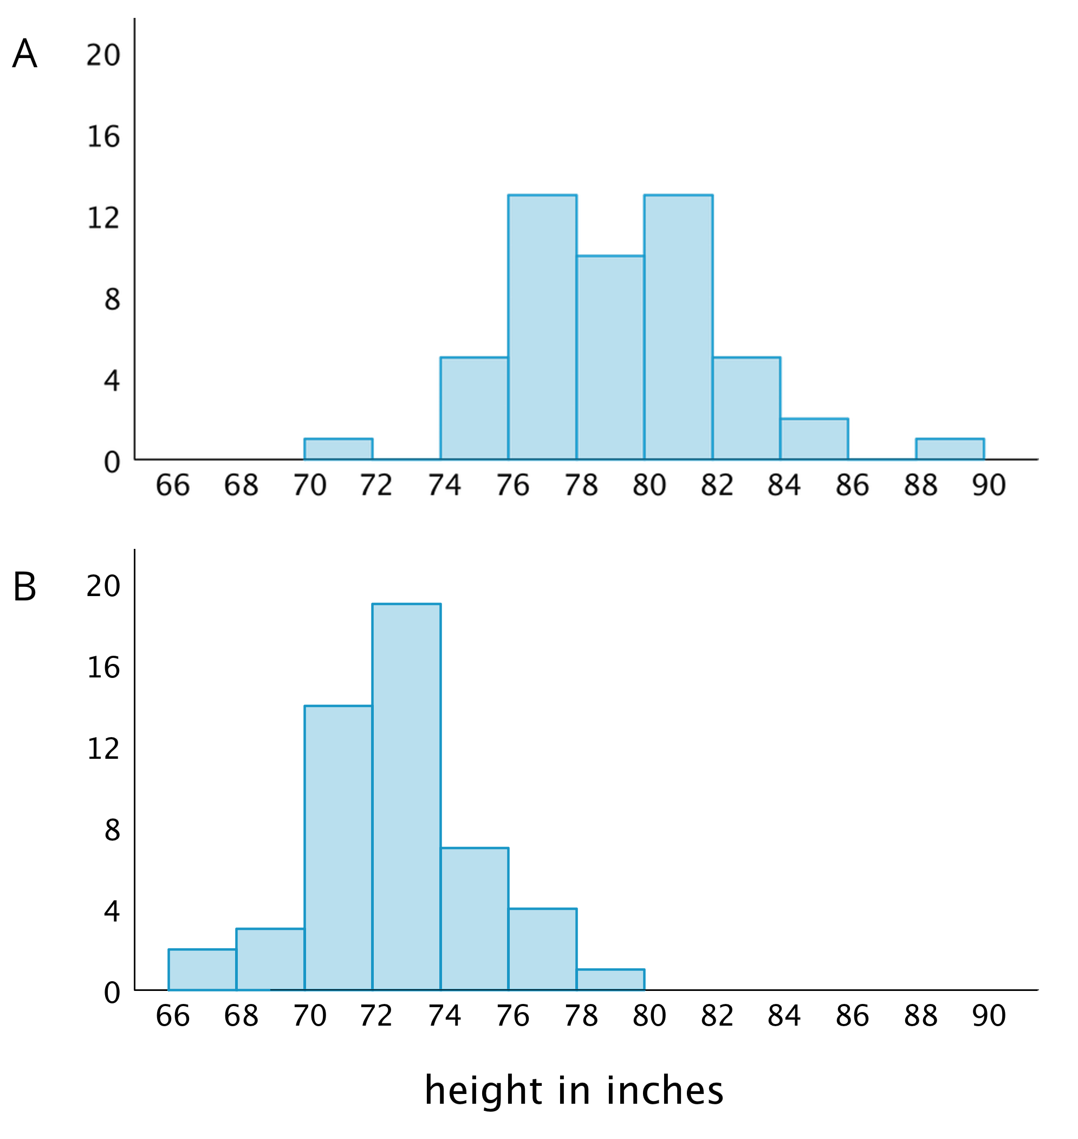
- Write 2–3 sentences that describe the distribution of the heights of the basketball players. Comment on the center and spread of the data.
- Write 2–3 sentences that describe the distribution of the heights of the baseball players. Comment on the center and spread of the data.

Lesson 7 Summary
Here are the weights, in kilograms, of 30 dogs.
10 | 11 | 12 | 12 | 13 | 15 | 16 | 16
17 | 18 | 18 | 19 | 20 | 20 | 20 | 21
22 | 22 | 22 | 23 | 24 | 24 | 26 | 26
28 | 30 | 32 | 32 | 34 | 34

Before we draw a histogram, let’s consider a couple of questions.
- What are the smallest and largest values in our data set? This gives us an idea of the distance on the number line that our histogram will cover. In this case, the minimum is 10 and the maximum is 34, so our number line needs to extend from 10 to 35 at the very least.
- (Remember the convention we use to mark off the number line for a histogram: we include the left boundary of a bar but exclude the right boundary. If 34 is the right boundary of the last bar, it won't be included in that bar, so the number line needs to go a little greater than the maximum value.)
- What group size or bin size seems reasonable here? We could organize the weights into bins of 2 kilograms (10, 12, 14, . . .), 5 kilograms, (10, 15, 20, 25, . . .), 10 kilograms (10, 20, 30, . . .), or any other size. The smaller the bins, the more bars we will have, and vice versa.
Let’s use bins of 5 kilograms for the dog weights. The boundaries of our bins will be: 10, 15, 20, 25, 30, 35. We stop at 35 because it is greater than the maximum.
Next, we find the frequency for the values in each group. It is helpful to organize the values in a table.
weights in kilograms | frequency
10 to less than 15 | 5
15 to less than 20 | 7
20 to less than 25 | 10
25 to less than 30 | 3
30 to less than 35 | 5
Now we can draw the histogram.
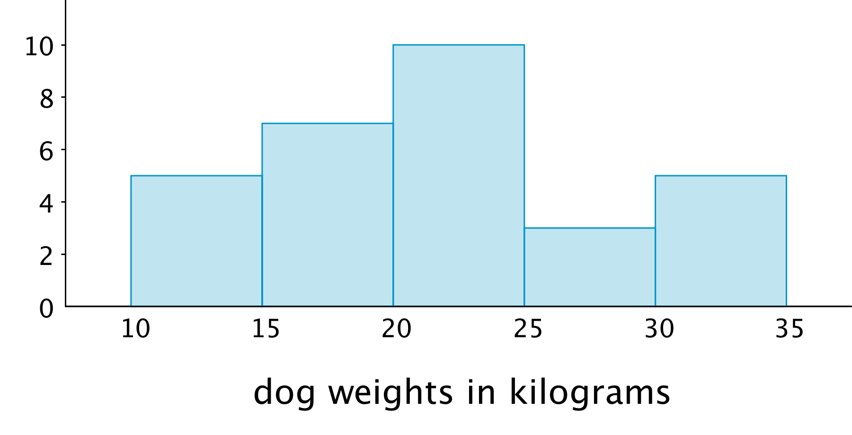
The histogram allows us to learn more about the dog weight distribution and describe its center and spread.
© CC BY Open Up Resources. Adaptations CC BY IM.

