Lesson 5: Areas of Parallelograms
Let's investigate the area of parallelograms some more.

5.1: A Parallelogram and Its Rectangles
Elena and Tyler were finding the area of this parallelogram:
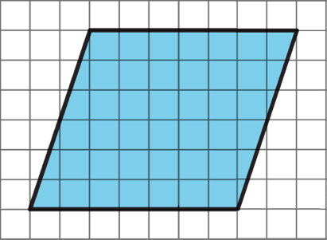
Here is how Elena did it:
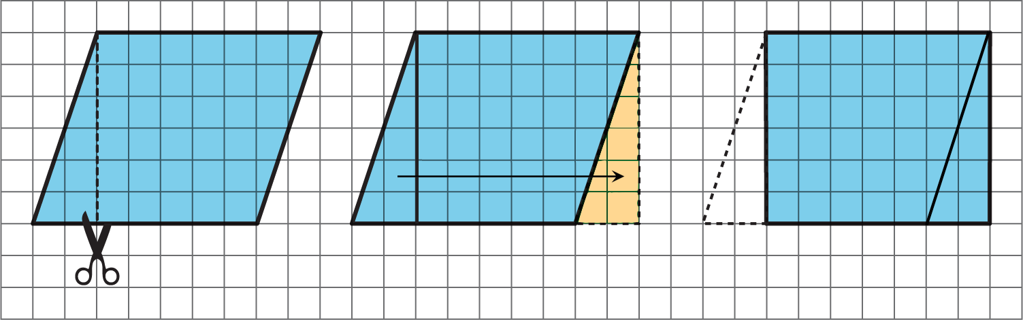
Here is how Tyler did it:
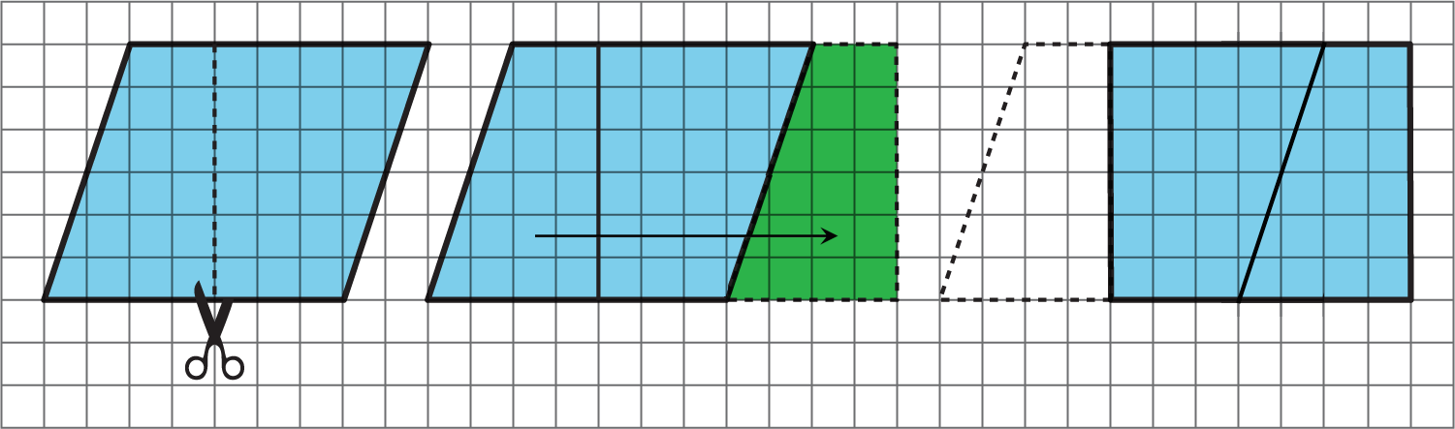
How are the two strategies for finding the area of a parallelogram the same? How they are different?

5.2: Finding the Formula for Area of Parallelograms
For each parallelogram:
- Identify a base and a corresponding height, and record their lengths in the table.
- Find the area of the parallelogram and record it in the last column of the table.
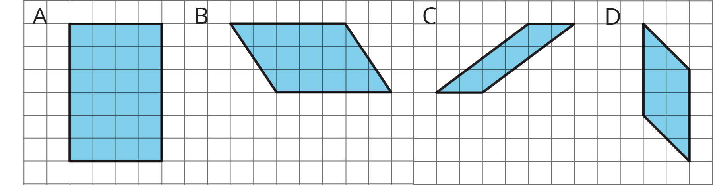
parallelogram | base (units) | height (units) | area (sq units)
A
B
C
D
any parallelogram | $b$ | $h$
In the last row, write an expression for the area of any parallelogram, using $b$ and $h$ .

Are you ready for more?
- What happens to the area of a parallelogram if the height doubles but the base is unchanged? If the height triples? If the height is 100 times the original?
- What happens to the area if both the base and the height double? Both triple? Both are 100 times their original lengths?

5.3: More Areas of Parallelograms
- Find the area of each parallelogram. Show your reasoning.
- 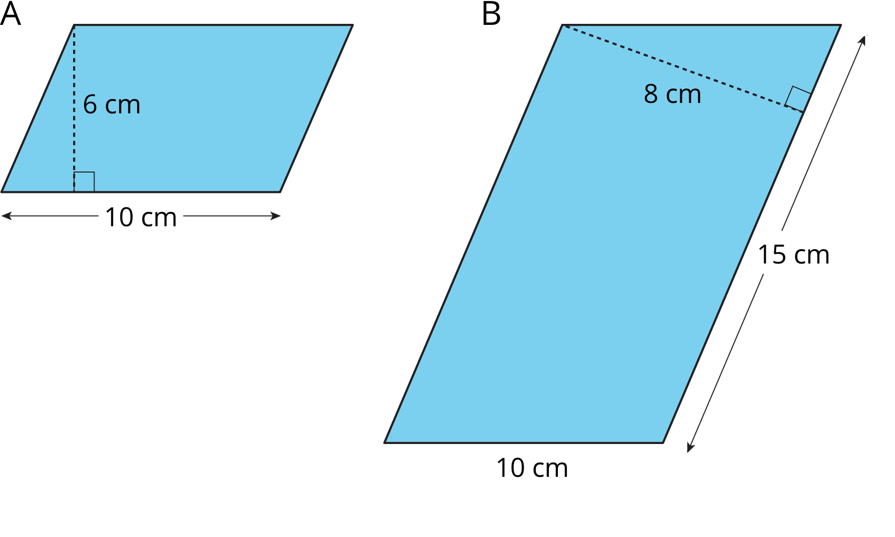
- 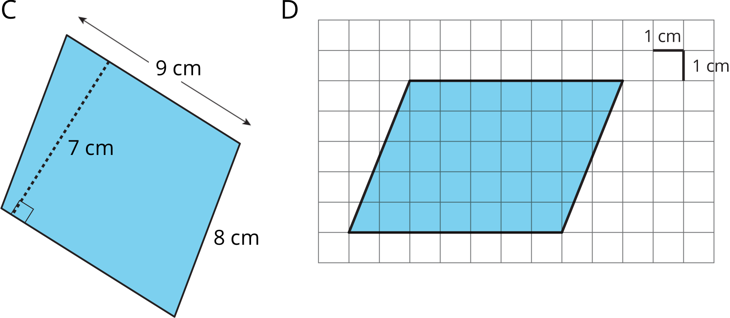
- In Parallelogram B, what is the corresponding height for the base that is 10 cm long? Explain or show your reasoning.
- Two different parallelograms P and Q both have an area of 20 square units. Neither of the parallelograms are rectangles.
- On the grid, draw two parallelograms that could be P and Q.

Are you ready for more?
Here is a parallelogram composed of smaller parallelograms. The shaded region is composed of four identical parallelograms. All lengths are in inches.
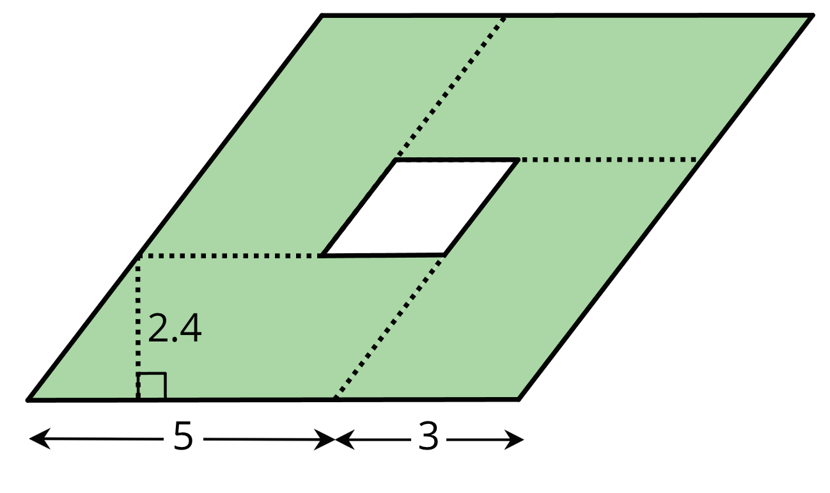
What is the area of the unshaded parallelogram in the middle? Explain or show your reasoning.

Lesson 5 Summary
In this lesson, we learned about 2 important parts of parallelograms, the base and the height.
- We can choose any of the four sides of a parallelogram as the base. Both the side (the segment) and its length (the measurement) are called the base.
- If we draw any perpendicular segment from a point on the base to the opposite side of the parallelogram, that segment will always have the same length. We call that value the height. There are infinitely many segments that can represent the height!
Any pair of base and corresponding height can help us find the area of a parallelogram, but some base-height pairs are more easily identified than others.
We often use letters to stand for numbers. If $b$ is the length of a base of a parallelogram (in units), and $h$ is the length of the corresponding height (in units), then the area of the parallelogram (in square units) is the product of these two numbers, $b⋅h$. Notice that we write the multiplication symbol with a small dot instead of a $×$ symbol. This is so that we don’t get confused about whether $×$ means multiply, or whether the letter $x$ is standing in for a number.
When a parallelogram is drawn on a grid and has horizontal sides, we can use a horizontal side as the base. When it has vertical sides, we can use a vertical side as the base. The grid can help us find (or estimate) the lengths of the base and of the corresponding height.
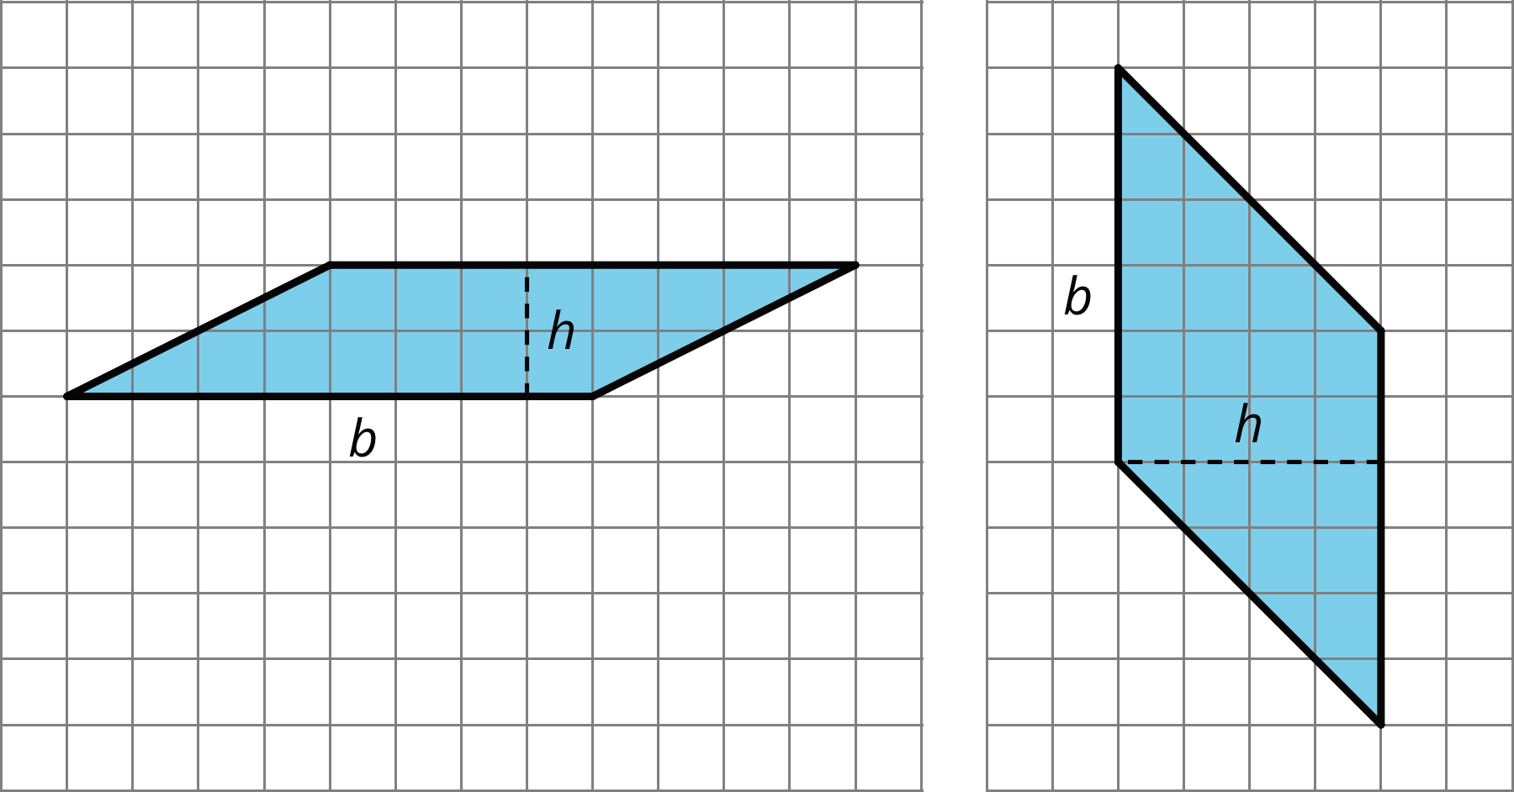
When a parallelogram is not drawn on a grid, we can still find its area if a base and a corresponding height are known.
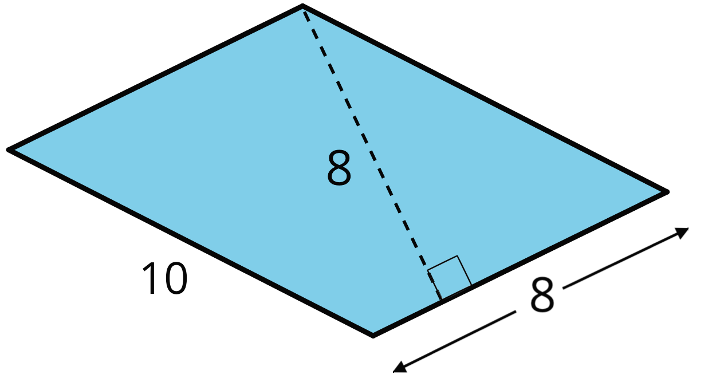
In this parallelogram, the corresponding height for the side that is 10 units long is not given, but the height for the side that is 8 units long is given. This base-height pair can help us find that the area is 64 square units since $8⋅8=64$.
Regardless of their shape, parallelograms that have the same base and the same height will have the same area; the product of the base and height will be equal. Here are some parallelograms with the same pair of base-height measurements.
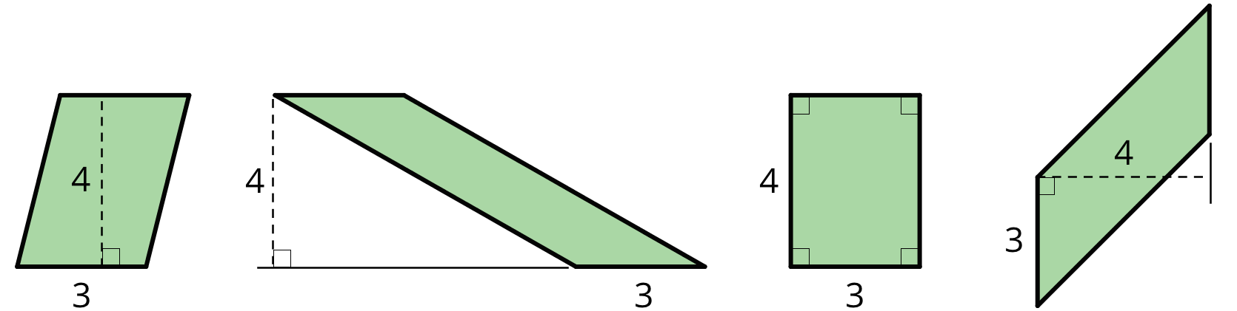
© CC BY Open Up Resources. Adaptations CC BY IM.

