Unit 4 Lesson 4: Representing Functions at Rational Inputs

1 Math Talk: Unknown Exponents (Warm up)

Student Task Statement
Solve each equation mentally.
- $5^{q}=125$
- $\frac{1}{5^{r}}=\frac{1}{125}$
- $5^{t}=\frac{1}{125}$
- ${125}^{u}=5$

2 Population of Nigeria

Student Task Statement
In 1990, Nigeria had a population of about 95.3 million. By 2000, there were about 122.4 million people, an increase of about 28.4%. During that decade, the population can be reasonably modeled by an exponential function.
- Express the population of Nigeria $f\left(d\right)$, in millions of people, $d$ decades since 1990.
- Write an expression to represent the population of Nigeria in 1996.
- A student said, “The population of Nigeria grew at a rate of 2.84% every year.”
  - Explain or show why the student’s statement is incorrect.
  - Find the correct annual growth rate. Explain or show your reasoning.

3 Got Caffeine?

Student Task Statement
In healthy adults, caffeine has an average half-life of about 6 hours. Let's suppose a healthy man consumes a cup of coffee that contains 100 mg of caffeine at noon.
- Each of the following expressions describes the amount of caffeine in the man's body some number of hours after consumption. How many hours after consumption?
  - $100⋅{\left(\frac{1}{2}\right)}^{1}$
  - $100⋅{\left(\frac{1}{2}\right)}^{3}$
  - $100⋅{\left(\frac{1}{2}\right)}^{\frac{1}{6}}$
  - $100⋅{\left(\frac{1}{2}\right)}^{t}$

  - Write a function $g$ to represent the amount of caffeine left in the body, $h$ hours after it enters the bloodstream.
  - The function $f$ represents the amount of caffeine left in the body after $t$ 6-hour periods. Explain why $g\left(6\right)=f\left(1\right)$.

Activity Synthesis

Function $g$
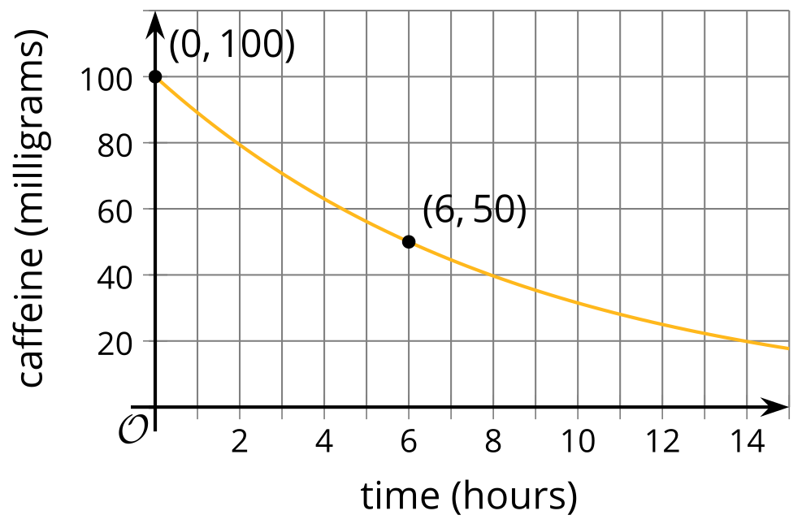

Function $f$
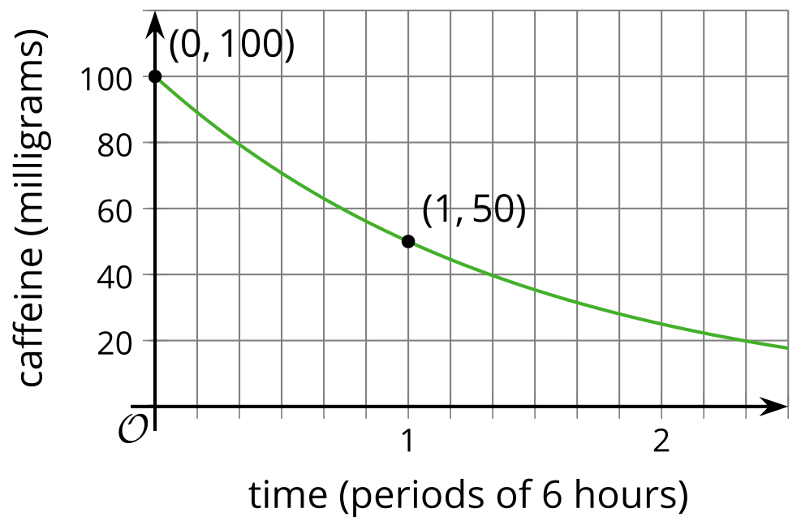
© CC BY 2019 by Illustrative Mathematics®

