Lesson 14: Finding Cylinder Dimensions

14.1: A Cylinder of Unknown Height
What is a possible volume for this cylinder if the diameter is 8 cm? Explain your reasoning.
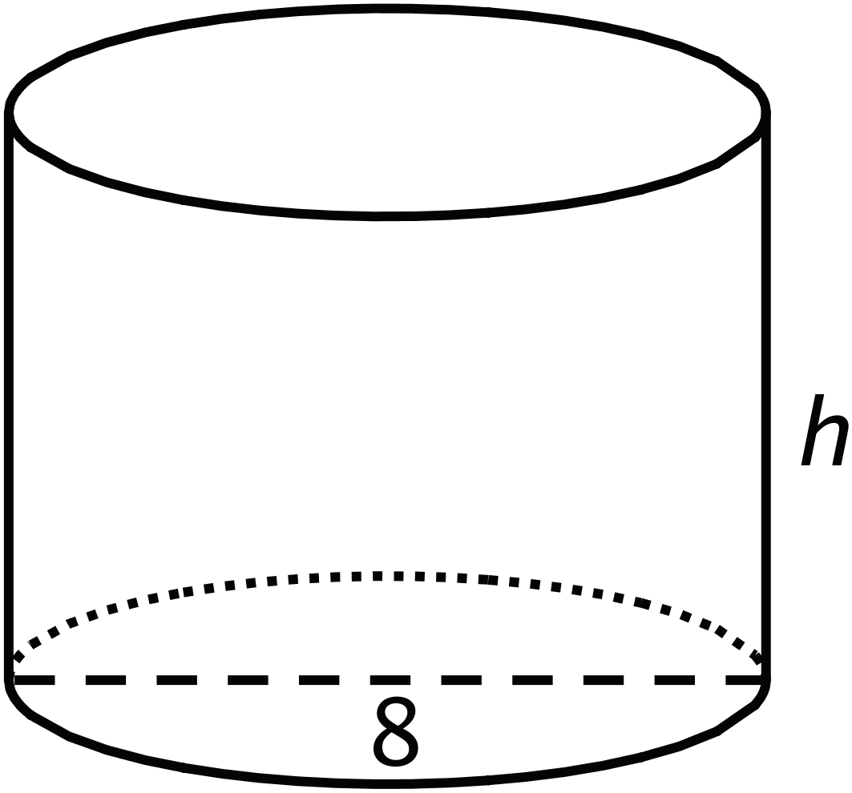

14.2: What’s the Dimension?
The volume $V$ of a cylinder with radius $r$ is given by the formula $V=πr^{2}h$.
- The volume of this cylinder with radius 5 units is $50π$ cubic units. This statement is true: $50π=5^{2}πh$
- 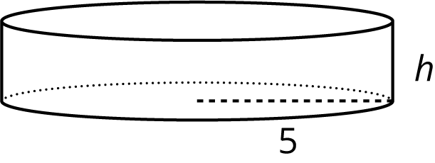
- What does the height of this cylinder have to be? Explain how you know.
- The volume of this cylinder with height 4 units is $36π$ cubic units. This statement is true: $36π=r^{2}π4$
- 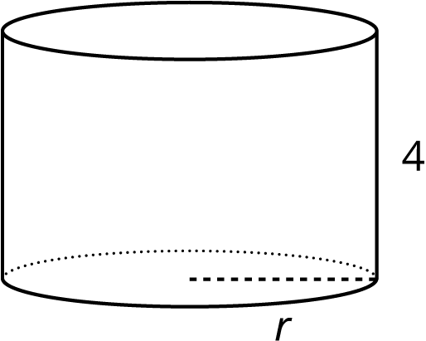
- What does the radius of this cylinder have to be? Explain how you know.

Are you ready for more?
Suppose a cylinder has a volume of $36π$ cubic inches, but it is not the same cylinder as the one you found earlier in this activity.
- What are some possibilities for the dimensions of the cylinder?
- How many different cylinders can you find that have a volume of $36π$ cubic inches?

14.3: Cylinders with Unknown Dimensions
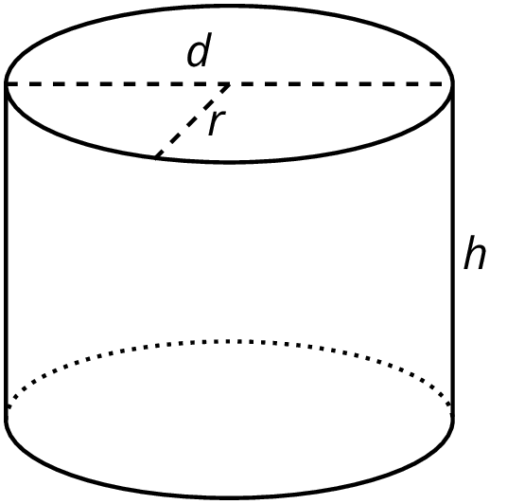
Each row of the table has information about a particular cylinder. Complete the table with the missing dimensions.
diameter (units) | radius (units) | area of the base (square units) | height (units) | volume (cubic units)
 | 3 |  | 5
12 |  |  |  | $108π$
 |  |  | 11 | $99π$
8 |  |  |  | $16π$
 |  |  | 100 | $16π$
 | 10 |  |  | $20π$
20 |  |  |  | 314
 |  |  | $b$ | $π⋅b⋅a^{2}$

Lesson 14 Summary
In an earlier lesson we learned that the volume, $V$, of a cylinder with radius $r$ and height $h$ is
$V=πr^{2}h$
We say that the volume depends on the radius and height, and if we know the radius and height, we can find the volume. It is also true that if we know the volume and one dimension (either radius or height), we can find the other dimension.
For example, imagine a cylinder that has a volume of $500π$ cm³ and a radius of 5 cm, but the height is unknown. From the volume formula we know that
$500π=π⋅25⋅h$
must be true. Looking at the structure of the equation, we can see that $500=25h$. That means that the height has to be 20 cm, since $500÷25=20$.
Now imagine another cylinder that also has a volume of $500π$ cm³ with an unknown radius and a height of 5 cm. Then we know that
$500π=π⋅r^{2}⋅5$
must be true. Looking at the structure of this equation, we can see that $r^{2}=100$. So the radius must be 10 cm.
© CC BY Open Up Resources. Adaptations CC BY IM.

