Unit 7 Lesson 3: Randomness in Groups

1 Study Selection (Warm up)

Student Task Statement
A reporter wants to know how people feel about the governor of her state. She decides to ask 100 people their opinions and thinks of several ways to ask the 100 people. For each method, explain the benefits and drawbacks, then choose the method for selecting 100 people that would best represent the people of the state.
- Go to the capital city and find 100 people interested in politics to respond to the survey.
- Ask the 100 most politically influential people in the state to respond to the survey.
- Obtain census data for the state and select 100 people from the list to survey using a random process.
- Ask 50 registered voters who voted for the governor and 50 registered voters who did not vote for the governor to respond to the survey.

2 Hip Hop Memory

Student Task Statement
A research group interested in comparing the effect of different types of music on short-term memory gathers 200 volunteers for a study. One group will listen to a hip hop music playlist while trying to memorize a list of 20 words. A second group will listen to a playlist of orchestral music while trying to memorize the list of 20 words. After a break, the number of words recalled correctly by each individual is measured and the results for the two groups are compared.
- Is this an experimental study or an observational study? Explain your reasoning.
- Which group do you hypothesize will recall more words? Explain your reasoning.
- Here are some options for splitting the volunteers into groups. Which method will best address the intention of the study? Explain your reasoning.
  - Divide groups based on their preferred music style.
  - Divide groups based on their age. The youngest 100 listen to hip hop music, and the older 100 listen to orchestral music.
  - Divide groups based on the order in which they come in to do the study. The first 100 listen to hip hop music, and the next 100 listen to orchestral music.
  - Write all the volunteer names on slips of paper, put them in a jar and shake it, then draw out 100 slips. These will listen to the hip hop playlist while the others listen to orchestral music.

3 Random Rectangles

Student Task Statement
A company offers solar power systems made up of 1 square meter cells arranged into rectangles. They use the designs for their first 100 customers to list the ways people arrange the cells. They are interested in investigating this question: “What is the mean area of the rectangles created by our customers?”
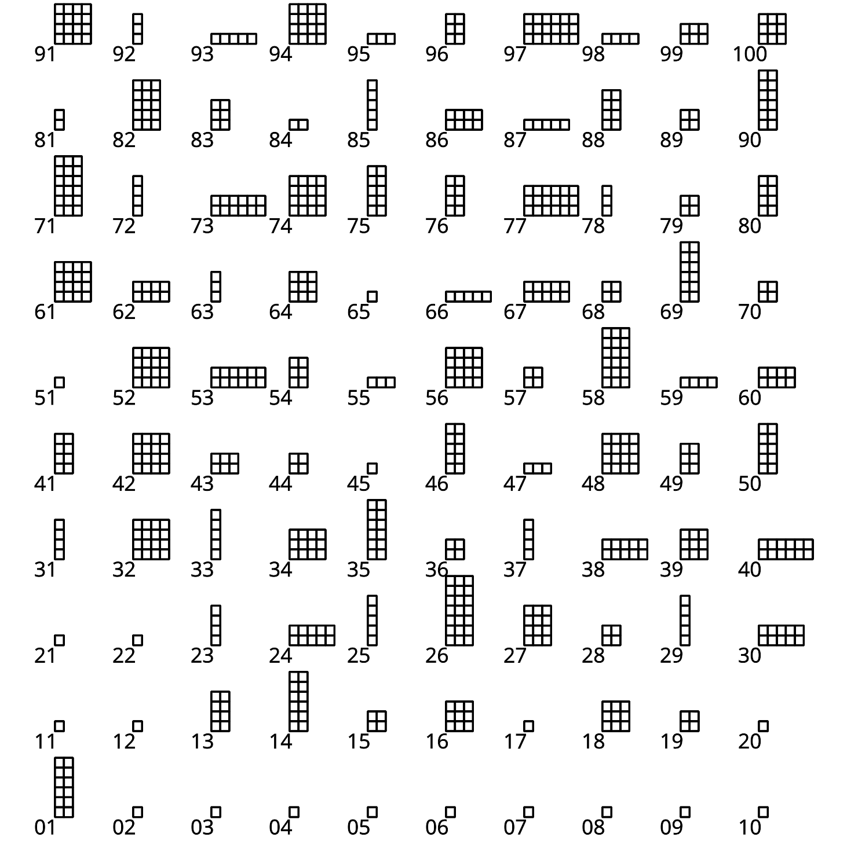
- Collect a sample of 5 rectangles using the methods here.
  - Look quickly at the chart and select 5 rectangles by their numbers. Record the numbers of the rectangles you choose.
  - Select a number between 1 and 95. Use that number and the next 4 numbers for another sample of 5 rectangles. For example, if you select 8, then you would use rectangles 8, 9, 10, 11, and 12.
  - Look closer at the rectangles and choose your 5 favorite. Record the numbers of the rectangles you choose.
  - Use a random number generator to select 5 numbers between 1 and 100.
- For each method, find the mean area of the rectangles in the sample.
- Which method do you think is best for estimating the mean area for the entire population? Explain your reasoning.
© CC BY 2019 by Illustrative Mathematics

