Lesson 8: Equations on a Number Line
- Let’s write equations and represent them on a number line.

8.1: Represent Equations
Represent each equation on the number line.
- $15+7=22$
- $18−6=12$
- $46+7=53$
- $33−9=24$
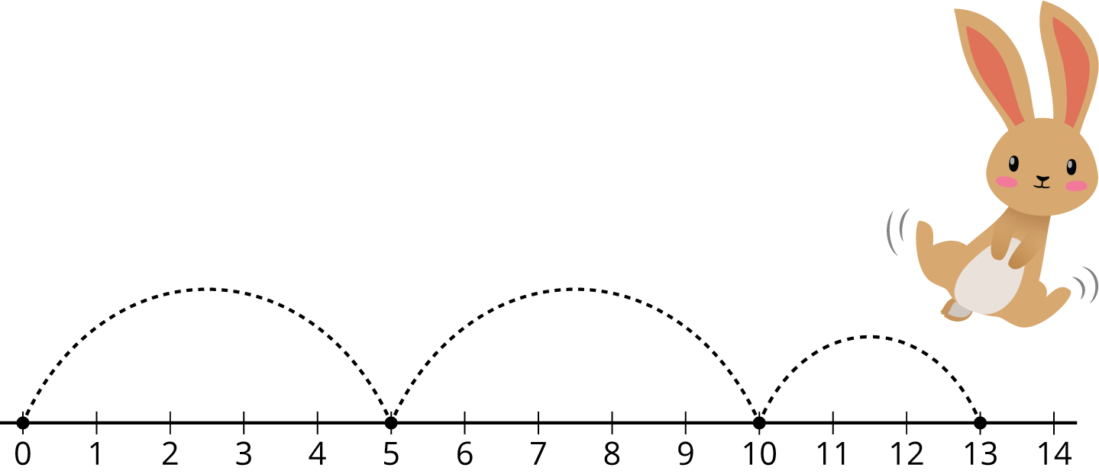

8.2: Write Equations
For each number line, write an equation that matches the diagram.
- Equation:__________________________
- 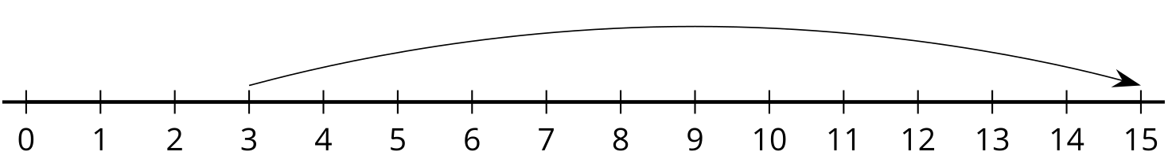
- Equation:__________________________
- 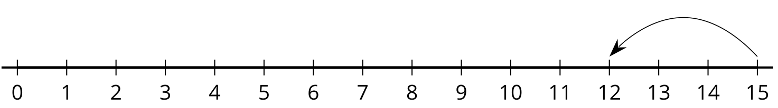
- Equation:__________________________
- 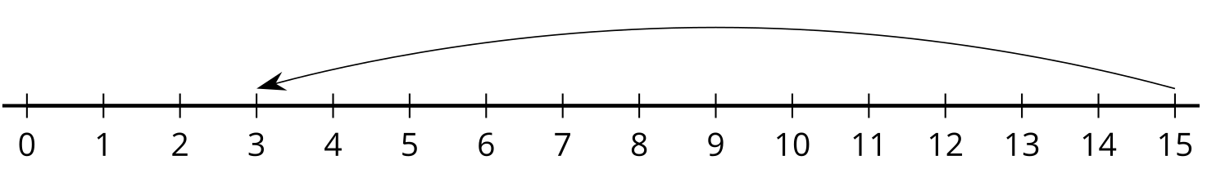
- Equation:__________________________
- 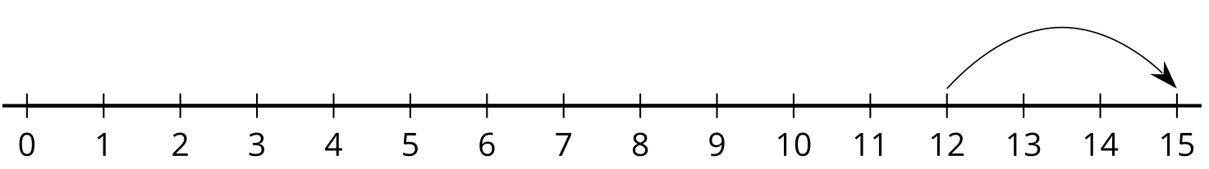
- Compare your equations with your partner.
- Pick the 2 number lines you think are most alike. Explain your choice to your partner.
© CC BY 2021 Illustrative Mathematics®

