Lesson 10: Center Day 2
- Let’s play games to practice adding and subtracting.

Warm-up: Number Talk: Subtraction Methods
Find the value of each expression mentally.
- $7−2$
- $8−2$
- $7−5$
- $8−6$

10.2: Centers: Choice Time
Choose a center.
Math Stories
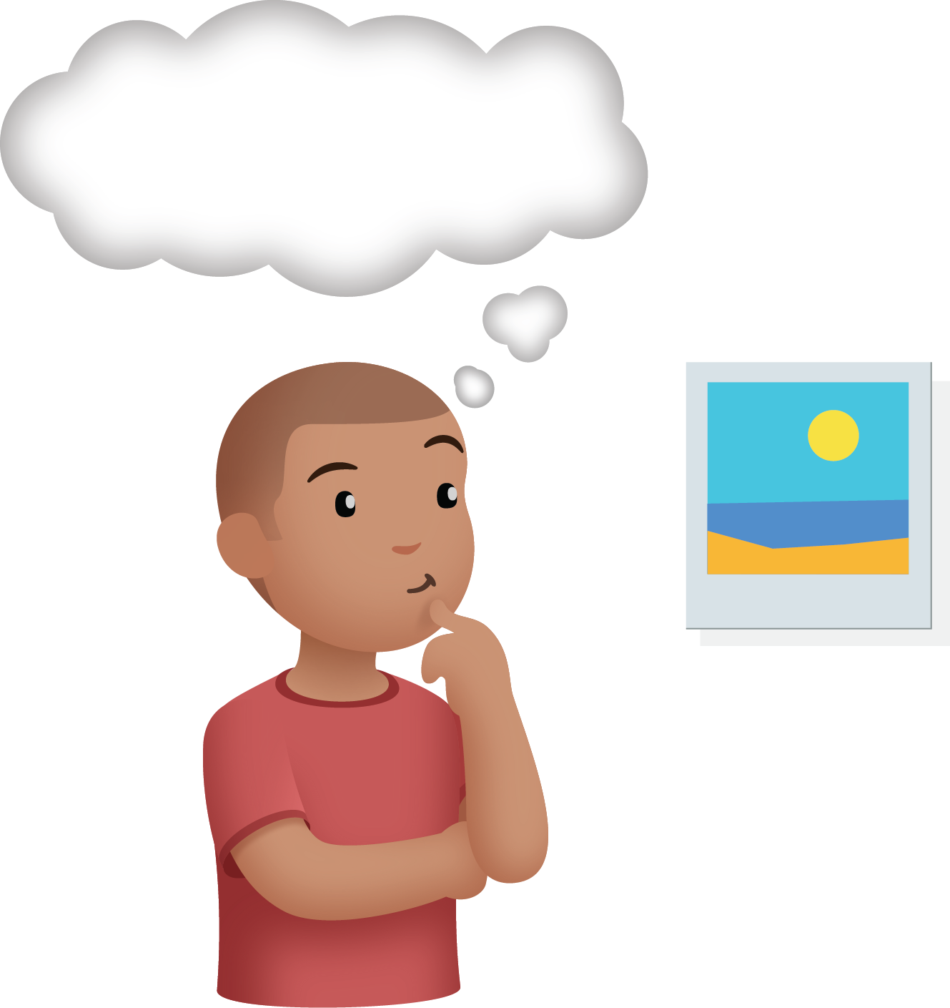
Shake and Spill
Capture Squares
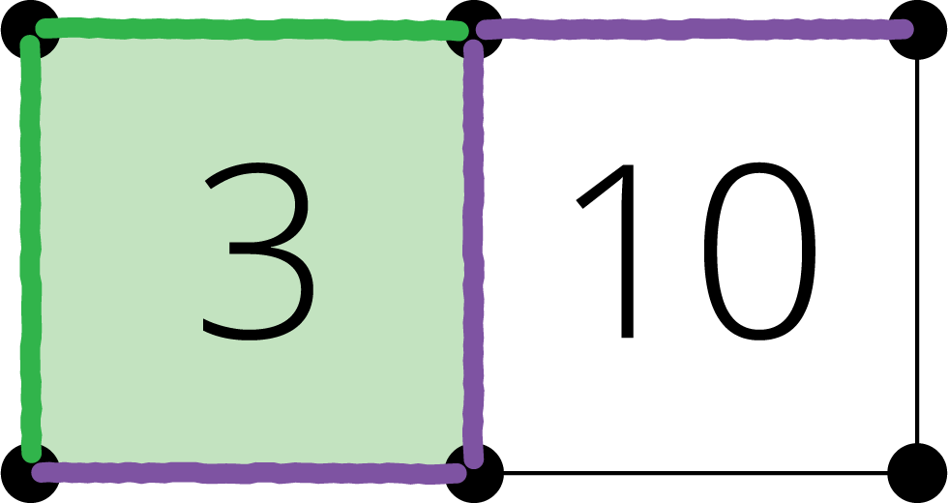
© CC BY 2021 Illustrative Mathematics®

