Unit 7 Lesson 4: Add and Subtract Three-digit Numbers in Different Ways

WU Number Talk: Count Back by Place (Warm up)

Student Task Statement
Find the value of each expression mentally.
- $586−100$
- $486−20$
- $457−200$
- $257−30$

1 Zero Tens and Zero Ones

Student Task Statement
Mai and Lin were asked to find the value of $500−387$.
Here is their work.
Mai's Work
$387+?=500$
$387+100=487$
$487+10=497$
$497+3=500$
$100+10+3=113$
Lin's Work
$387=300+80+7$
$500−300=200$
$200−80=120$
$120−7=113$
Find the value of each expression.
Show your thinking.
- Try Mai’s way to find the value of $600−476$.
- Try Lin’s way to find the value of $400−134$.

2 Add or Subtract with Expanded Form

Student Task Statement
- Andre and Diego showed their thinking with equations to find the value of $427+351$.
- Andre's Work
- 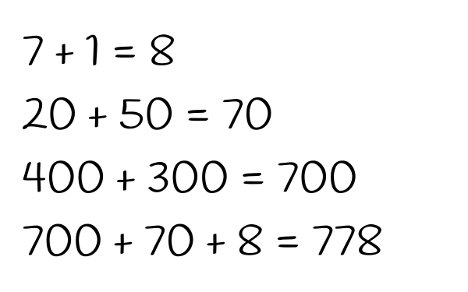
- Diego's Work
- 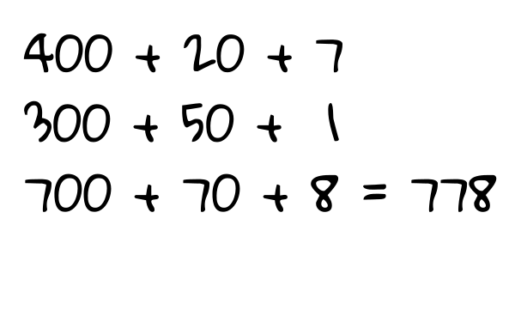
- What is the same or different about their work?
- Discuss with your partner.
- Try Andre’s way to find the value of $725+243$.
- Try Diego’s way to find the value of $863−432$.
- Choose your own way to find the value of $163+326$. Show your thinking.
- Choose your own way to find the value of $692−571$. Show your thinking.
© CC BY 2021 Illustrative Mathematics®

