Unit 6 Lesson 3 Cumulative Practice Problems
- Here is a table and a scatter plot that compares points per game to free throw attempts for a basketball team during a tournament.
- player | - free throw  attempts | - points
- player A | - 5.5 | - 28.3
- player B | - 2.1 | - 18.6
- player C | - 4.1 | - 13.7
- player D | - 1.6 | - 10.6
- player E | - 3.1 | - 10.4
- player F | - 1 | - 5
- player G | - 1.2 | - 5
- player H | - 0.7 | - 4.7
- player I | - 1.5 | - 3.7
- player J | - 1.5 | - 3.5
- player K | - 1.2 | - 3.1
- player L | - 0 | - 1
- player M | - 0 | - 0.8
- player N | - 0 | - 0.6
- 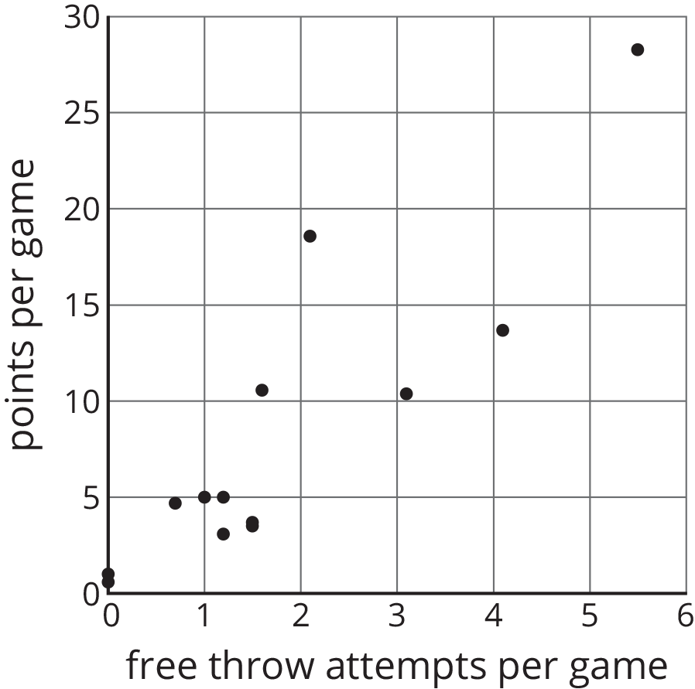
  - Circle the point that represents the data for Player E.
  - What does the point $(2.1,18.6)$ represent?
  - In that same tournament, Player O on another team scored 14.3 points per game with 4.8 free throw attempts per game. Plot a point on the graph that shows this information.
- Select all the representations that are appropriate for comparing exam score to number of hours of sleep the night before the exam.
  - Histogram
  - Scatter plot
  - Dot plot
  - Table
  - Box plot
- (From Unit 6, Lesson 2.)
- A cylinder has a volume of $36π$ cm³ and height $h$. Complete this table for the volume of other cylinders with the same radius but different heights.
- height (cm) | - volume (cm³)
- $h$ | - $36π$
- $2h$
- $5h$
- $\frac{h}{2}$
- $\frac{h}{5}$
- (From Unit 5, Lesson 17.)
© CC BY Open Up Resources. Adaptations CC BY IM.

