Lesson 10: Designing Simulations
Let’s simulate some real-life scenarios.

10.1: Number Talk: Division
Find the value of each expression mentally.
$\left(4.2+3\right)÷2$
$\left(4.2+2.6+4\right)÷3$
$\left(4.2+2.6+4+3.6\right)÷4$
$\left(4.2+2.6+4+3.6+3.6\right)÷5$

10.2: Breeding Mice
A scientist is studying the genes that determine the color of a mouse’s fur. When two mice with brown fur breed, there is a 25% chance that each baby will have white fur. For the experiment to continue, the scientist needs at least 2 out of 5 baby mice to have white fur.
To simulate this situation, you can flip a coin twice for each baby mouse.
- If the coin lands heads up both times, it represents a mouse with white fur.
- Any other result represents a mouse with brown fur.
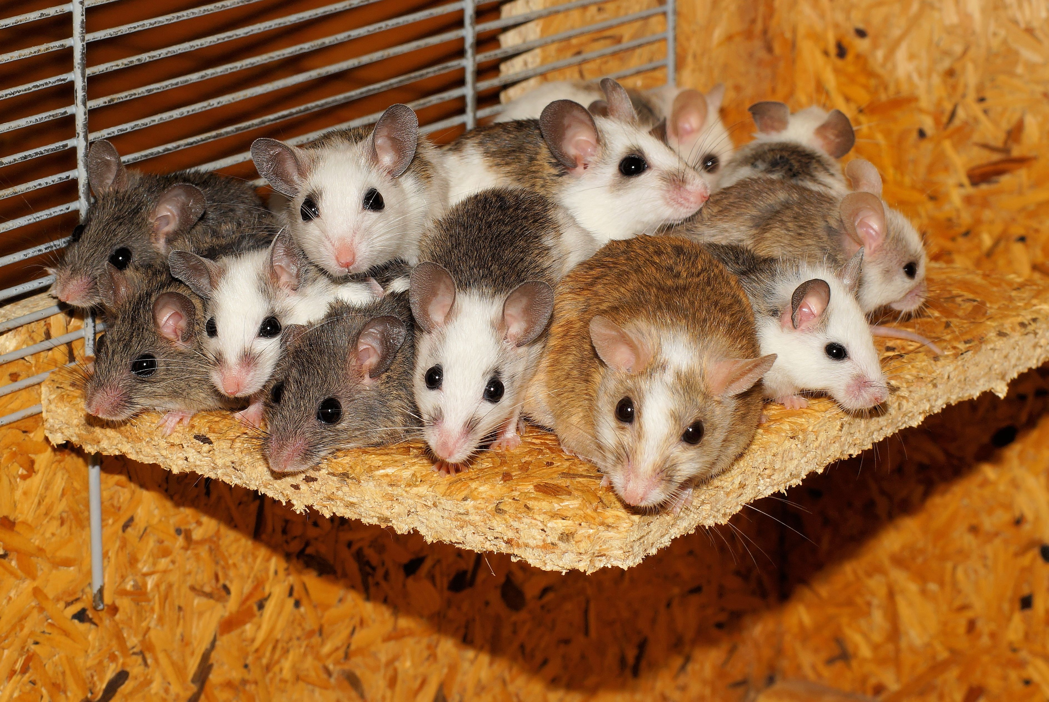
- Simulate 3 litters of 5 baby mice and record your results in the table.
 | - mouse 1 | - mouse 2 | - mouse 3 | - mouse 4 | - mouse 5 | - Do at least 2  have white fur?
- simulation 1
- simulation 2
- simulation 3
- Based on the results from everyone in your group, estimate the probability that the scientist’s experiment will be able to continue.
- How could you improve your estimate?

Are you ready for more?
For a certain pair of mice, the genetics show that each offspring has a probability of $\frac{1}{16}$ that they will be albino. Describe a simulation you could use that would estimate the probability that at least 2 of the 5 offspring are albino.

10.3: Designing Simulations
Your teacher will give your group a paper describing a situation.
- Design a simulation that you could use to estimate a probability. Show your thinking. Organize it so it can be followed by others.
- Explain how you used the simulation to answer the questions posed in the situation.

Lesson 10 Summary
Many real-world situations are difficult to repeat enough times to get an estimate for a probability. If we can find probabilities for parts of the situation, we may be able to simulate the situation using a process that is easier to repeat.
For example, if we know that each egg of a fish in a science experiment has a 13% chance of having a mutation, how many eggs do we need to collect to make sure we have 10 mutated eggs? If getting these eggs is difficult or expensive, it might be helpful to have an idea about how many eggs we need before trying to collect them.
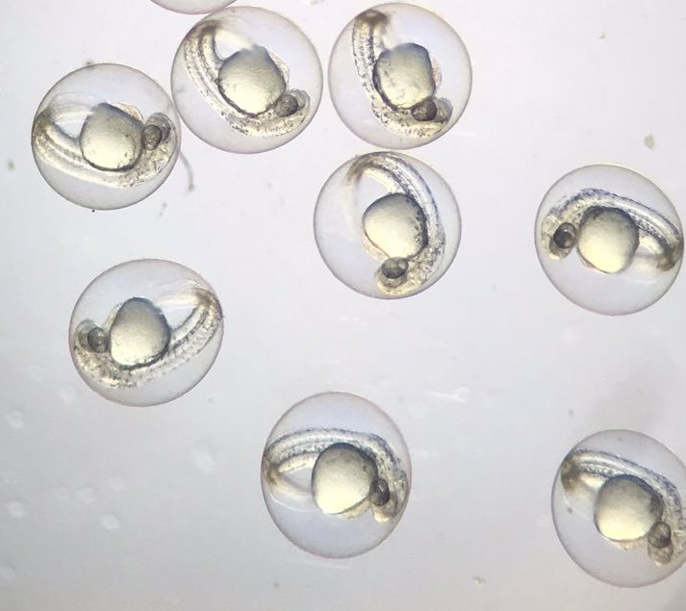
We could simulate this situation by having a computer select random numbers between 1 and 100. If the number is between 1 and 13, it counts as a mutated egg. Any other number would represent a normal egg. This matches the 13% chance of each fish egg having a mutation.
We could continue asking the computer for random numbers until we get 10 numbers that are between 1 and 13. How many times we asked the computer for a random number would give us an estimate of the number of fish eggs we would need to collect.
To improve the estimate, this entire process should be repeated many times. Because computers can perform simulations quickly, we could simulate the situation 1,000 times or more.
© CC BY Open Up Resources. Adaptations CC BY IM.

