Lesson 8: Describing Distributions on Histograms

8.1: Which One Doesn’t Belong: Histograms
Which histogram does not belong? Be prepared to explain your reasoning.
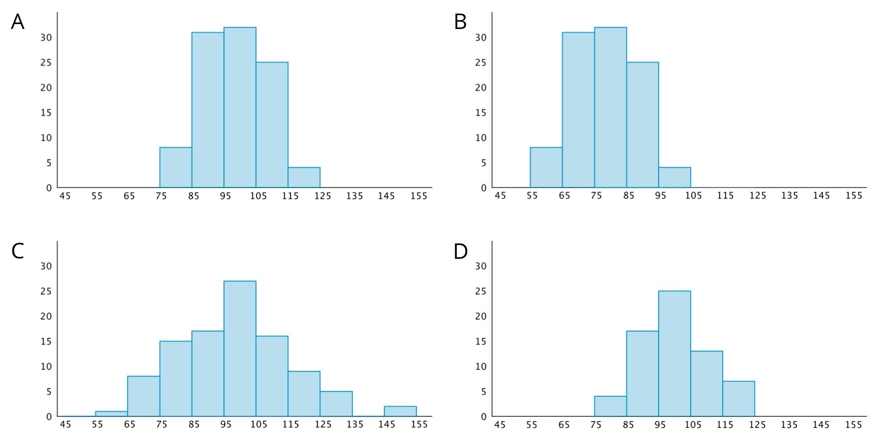

8.2: Sorting Histograms
- Your teacher will give your group a set of histogram cards. Sort them into two piles—one for histograms that are approximately symmetrical, and another for those that are not.
- Discuss your sorting decisions with another group. Do both groups agree which cards should go in each pile? If not, discuss the reasons behind the differences and see if you can reach agreement. Record your final decisions.
  - Histograms that are approximately symmetrical:
  - Histograms that are not approximately symmetrical:
- Histograms are also described by how many major peaks they have. Histogram A is an example of a distribution with a single peak that is not symmetrical.
- Which other histograms have this feature?
- Some histograms have a gap, a space between two bars where there are no data points. For example, if some students in a class have 7 or more siblings, but the rest of the students have 0, 1, or 2 siblings, the histogram for this data set would show gaps between the bars because no students have 3, 4, 5, or 6 siblings.
- Which histograms do you think show one or more gaps?
- Sometimes there are a few data points in a data set that are far from the center. Histogram A is an example of a distribution with this feature.
- Which other histograms have this feature?

8.3: Getting to School
Your teacher will provide you with some data that your class collected the other day.
- Use the data to draw a histogram that shows your class’s travel times.
- 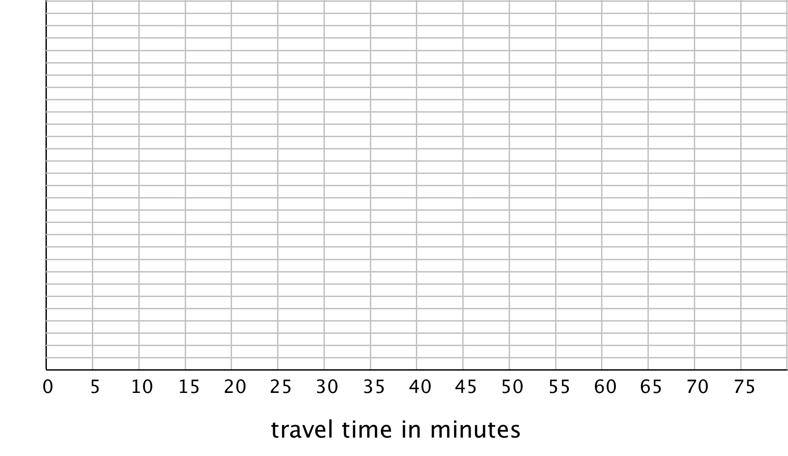
- Describe the distribution of travel times. Comment on the center and spread of the data, as well as the shape and features.
- Use the data on methods of travel to draw a bar graph. Include labels for the horizontal axis.
- Describe what you learned about your class’s methods of transportation to school. Comment on any patterns you noticed.
- Compare the histogram and the bar graph that you drew. How are they the same? How are they different?

Are you ready for more?
Use one of these suggestions (or make up your own). Research data to create a histogram. Then, describe the distribution.
- Heights of 30 athletes from multiple sports
- Heights of 30 athletes from the same sport
- High temperatures for each day of the last month in a city you would like to visit
- Prices for all the menu items at a local restaurant

Lesson 8 Summary
We can describe the shape and features of the distribution shown on a histogram. Here are two distributions with very different shapes and features.
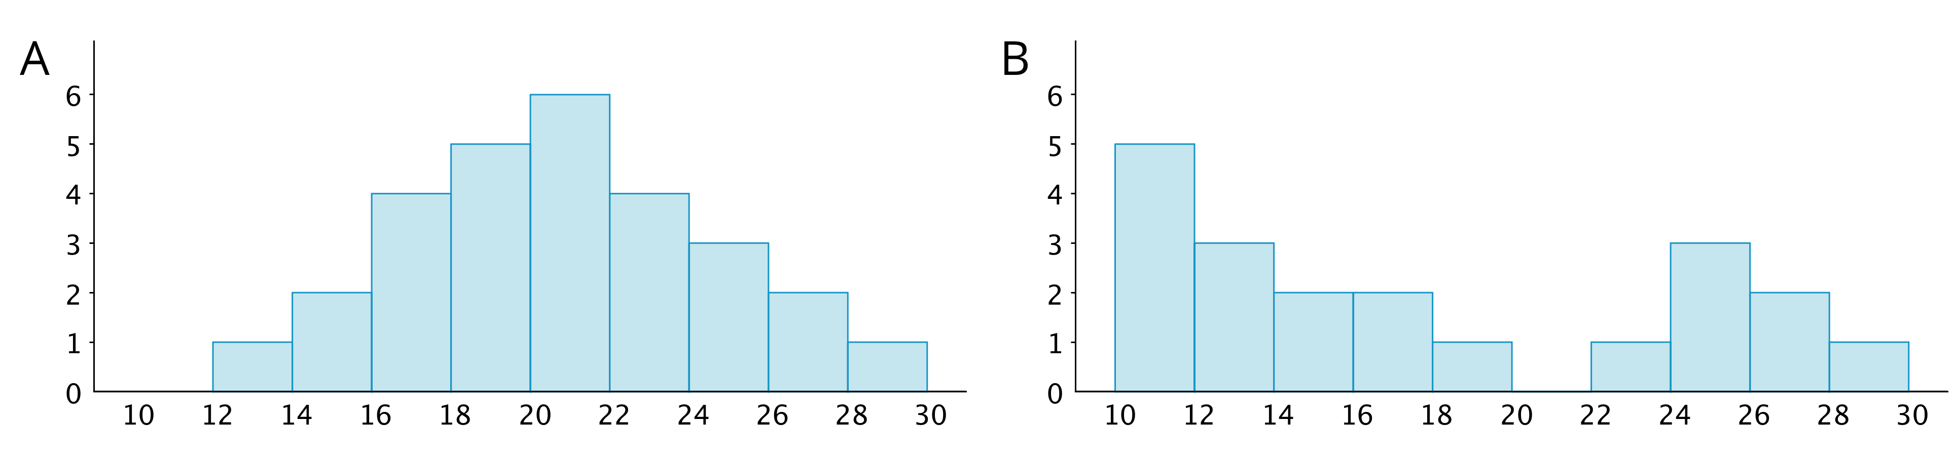
- Histogram A is very symmetrical and has a peak near 21. Histogram B is not symmetrical and has two peaks, one near 11 and one near 25.
- Histogram B has two clusters. A cluster forms when many data points are near a particular value (or a neighborhood of values) on a number line.
- Histogram B also has a gap between 20 and 22. A gap shows a location with no data values.
Here is a bar graph showing the breeds of 30 dogs and a histogram for their weights.
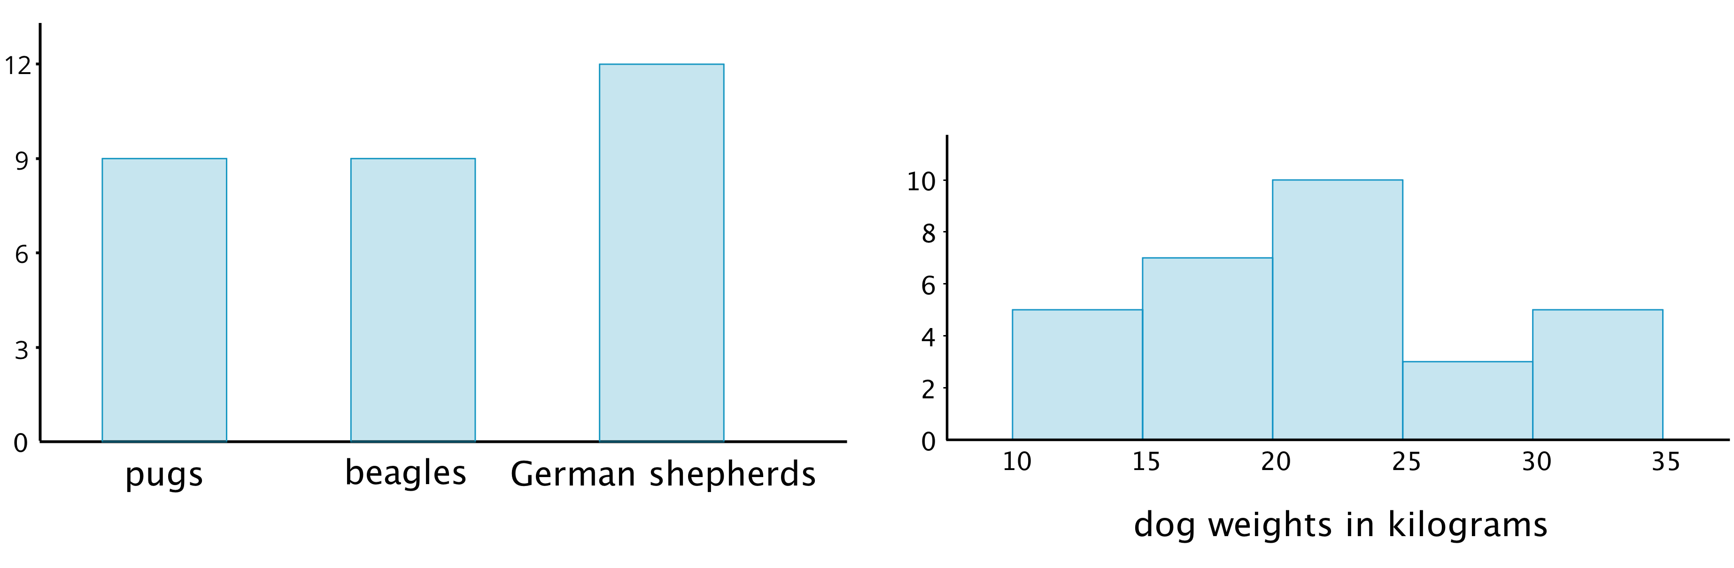
Bar graphs and histograms may seem alike, but they are very different.
- Bar graphs represent categorical data. Histograms represent numerical data.
- Bar graphs have spaces between the bars. Histograms show a space between bars only when no data values fall between the bars.
- Bars in a bar graph can be in any order. Histograms must be in numerical order.
- In a bar graph, the number of bars depends on the number of categories. In a histogram, we choose how many bars to use.
© CC BY Open Up Resources. Adaptations CC BY IM.

