Lesson 8: Equivalent Quadratic Expressions

8.1: Diagrams of Products
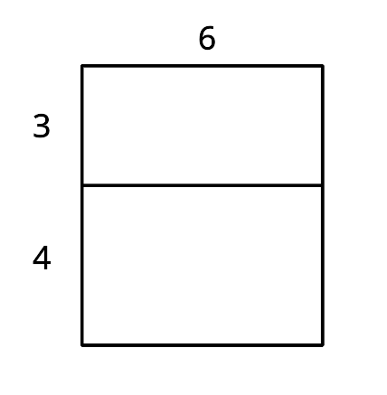
- Explain why the diagram shows that $6(3+4)=6⋅3+6⋅4$.
- Draw a diagram to show that $5(x+2)=5x+10$.

8.2: Drawing Diagrams to Represent More Products
Applying the distributive property to multiply out the factors of, or expand, $4(x+2)$ gives us $4x+8$, so we know the two expressions are equivalent. We can use a rectangle with side lengths $(x+2)$ and 4 to illustrate the multiplication.
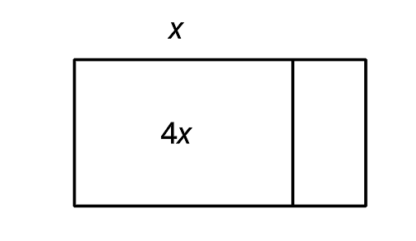
- Draw a diagram to show that $n(2n+5)$ and $2n^{2}+5n$ are equivalent expressions.
- For each expression, use the distributive property to write an equivalent expression. If you get stuck, consider drawing a diagram.
- a. $6\left(\frac{1}{3}n+2\right)$
- b. $p(4p+9)$
- c. $5r\left(r+\frac{3}{5}\right)$
- d. $(0.5w+7)w$

8.3: Using Diagrams to Find Equivalent Quadratic Expressions
- Here is a diagram of a rectangle with side lengths $x+1$ and $x+3$. Use this diagram to show that $(x+1)(x+3)$ and $x^{2}+4x+3$ are equivalent expressions.
- 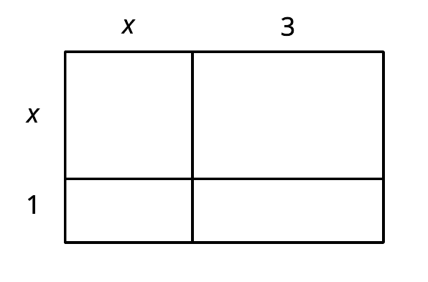
- Draw diagrams to help you write an equivalent expression for each of the following:
  - $(x+5)^{2}$
  - $2x(x+4)$
  - $(2x+1)(x+3)$
  - $(x+m)(x+n)$
- Write an equivalent expression for each expression without drawing a diagram:
  - $(x+2)(x+6)$
  - $(x+5)(2x+10)$

Are you ready for more?
- Is it possible to arrange an $x$ by $x$ square, five $x$ by 1 rectangles and six 1 by 1 squares into a single large rectangle? Explain or show your reasoning.
- What does this tell you about an equivalent expression for $x^{2}+5x+6$?
- Is there a different non-zero number of 1 by 1 squares that we could have used instead that would allow us to arrange the combined figures into a single large rectangle?

Lesson 8 Summary
A quadratic function can often be defined by many different but equivalent expressions. For example, we saw earlier that the predicted revenue, in thousands of dollars, from selling a downloadable movie at $x$ dollars can be expressed with $x(18−x)$, which can also be written as $18x−x^{2}$. The former is a product of $x$ and $18−x$, and the latter is a difference of $18x$ and $x^{2}$, but both expressions represent the same function.
Sometimes a quadratic expression is a product of two factors that are each a linear expression, for example $(x+2)(x+3)$. We can write an equivalent expression by thinking about each factor, the $(x+2)$ and $(x+3)$, as the side lengths of a rectangle, and each side length decomposed into a variable expression and a number.
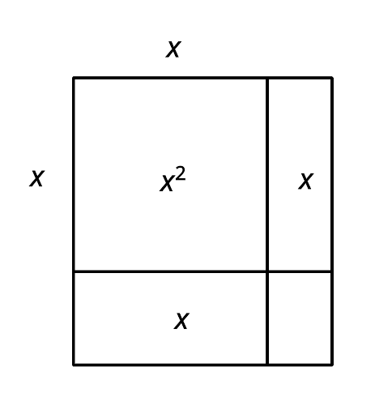
Multiplying $(x+2)$ and $(x+3)$ gives the area of the rectangle. Adding the areas of the four sub-rectangles also gives the area of the rectangle. This means that $(x+2)(x+3)$ is equivalent to $x^{2}+2x+3x+6$, or to $x^{2}+5x+6$.
Notice that the diagram illustrates the distributive property being applied. Each term of one factor (say, the $x$ and the 2 in $x+2$) is multiplied by every term in the other factor (the $x$ and the 3 in $x+3$).
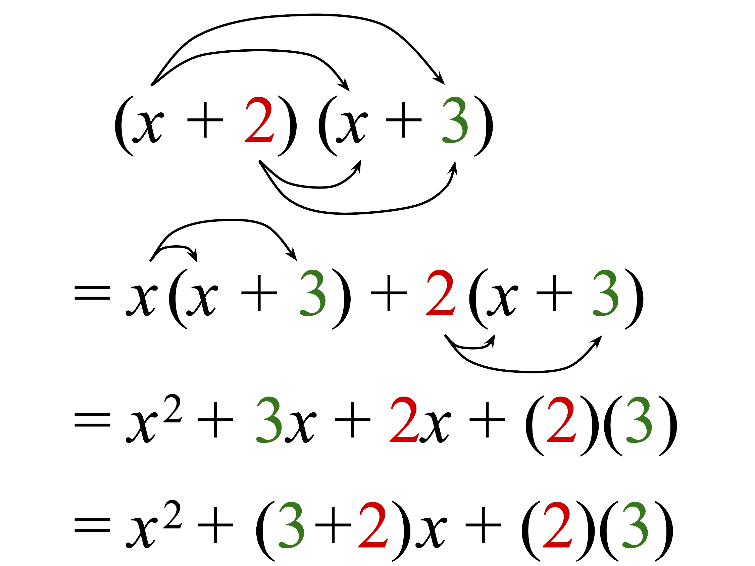
In general, when a quadratic expression is written in the form of $(x+p)(x+q)$, we can apply the distributive property to rewrite it as $x^{2}+px+qx+pq$ or $x^{2}+(p+q)x+pq$.
© CC BY 2019 by Illustrative Mathematics

