Lesson 2: Make and Break Apart Pattern Block Designs
- Let’s make and break apart pattern block designs.

Warm-up: Which One Doesn’t Belong: Pattern Block Designs
Which one doesn’t belong?
A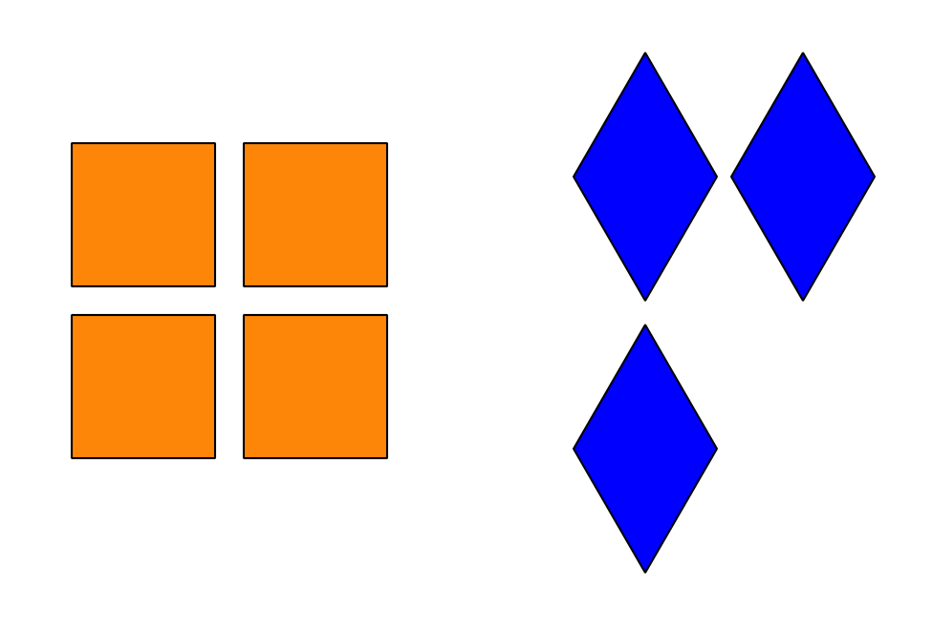
B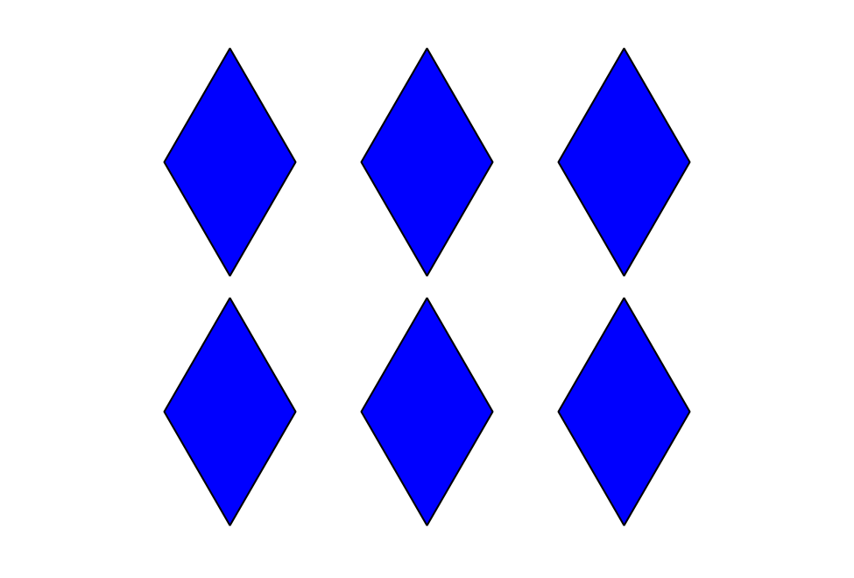
C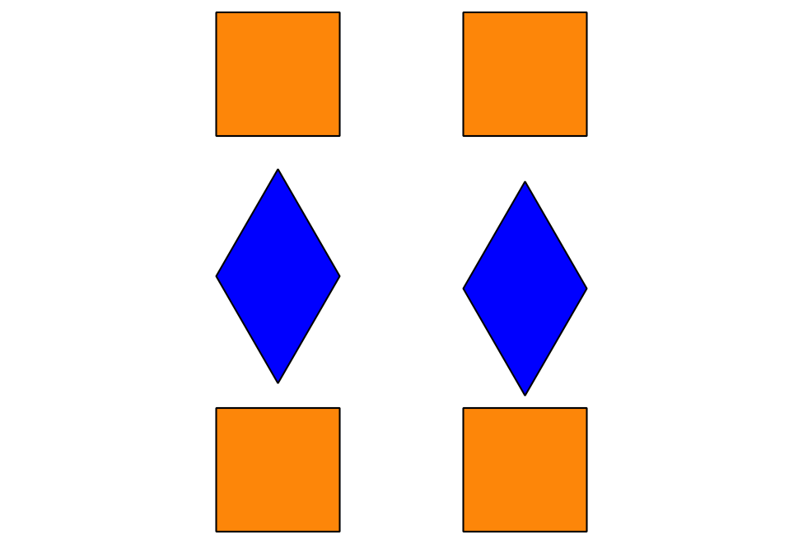
D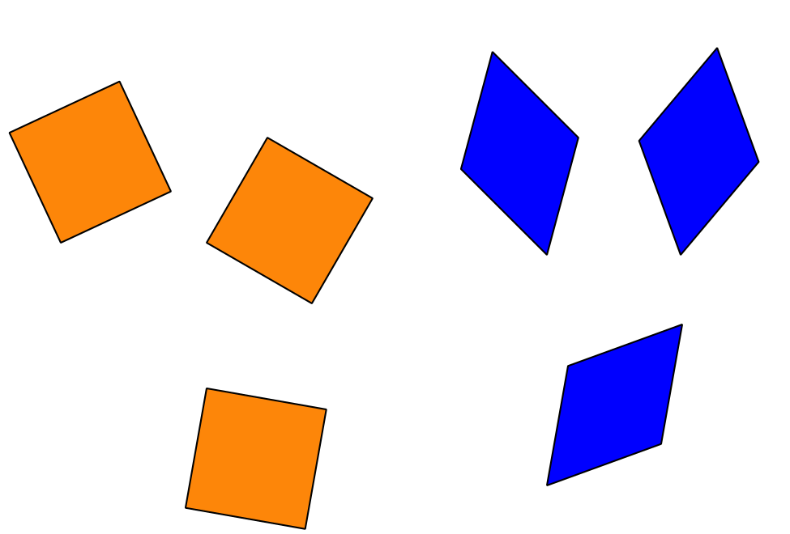

2.1: Create Pattern Blocks Designs
My Design

2.2: Han’s Pattern Block Design
Han used 8 pattern blocks.

- 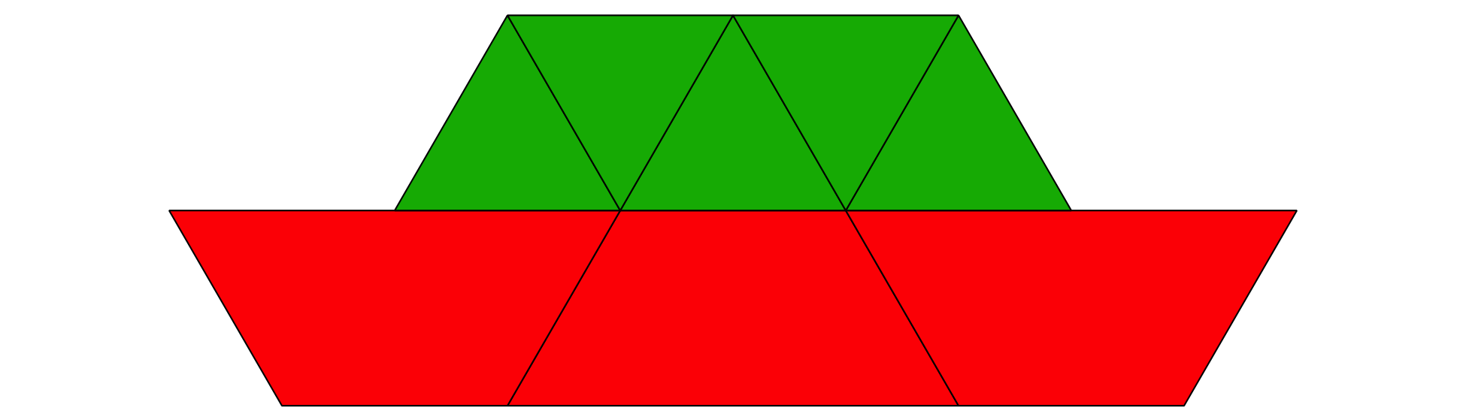
- Expression: ___________________________

- 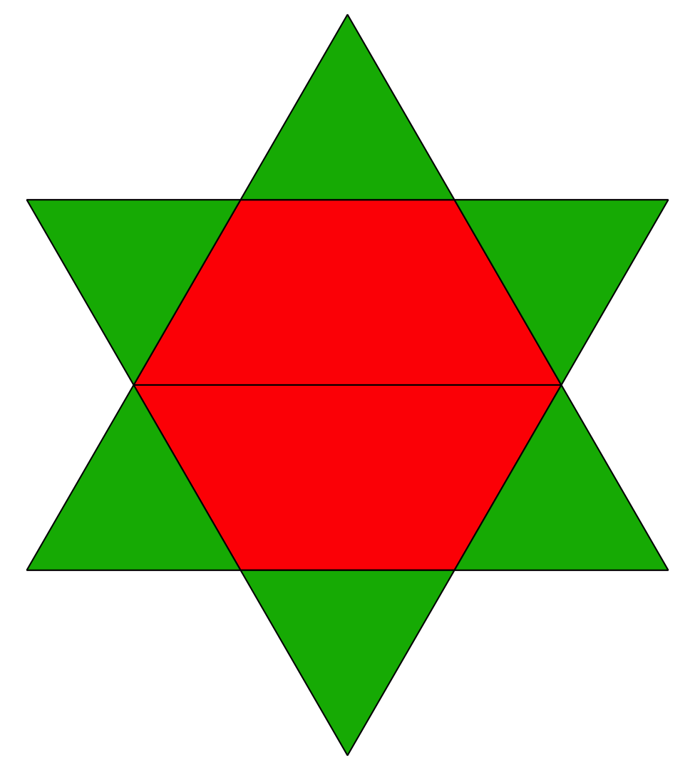
- Expression: ___________________________

- 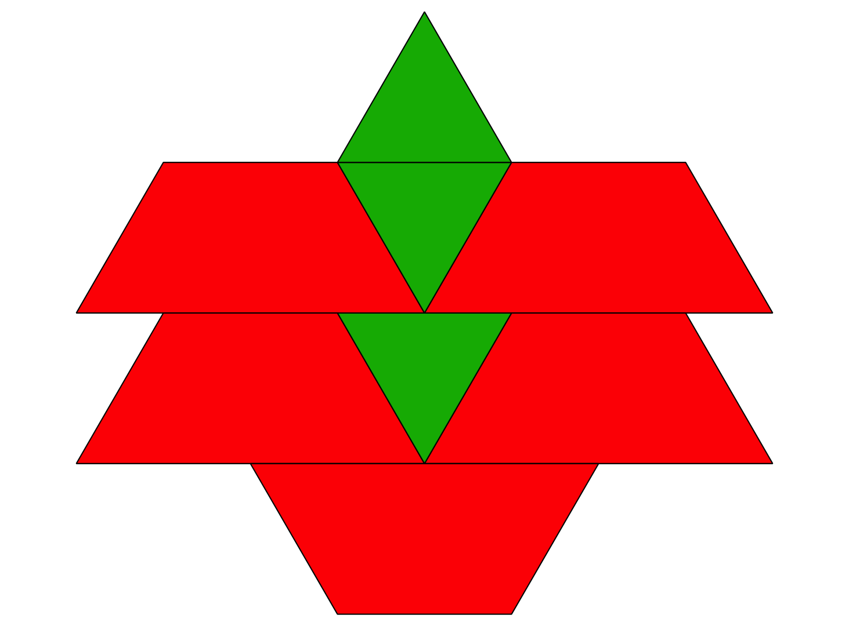
- Expression: ___________________________

- 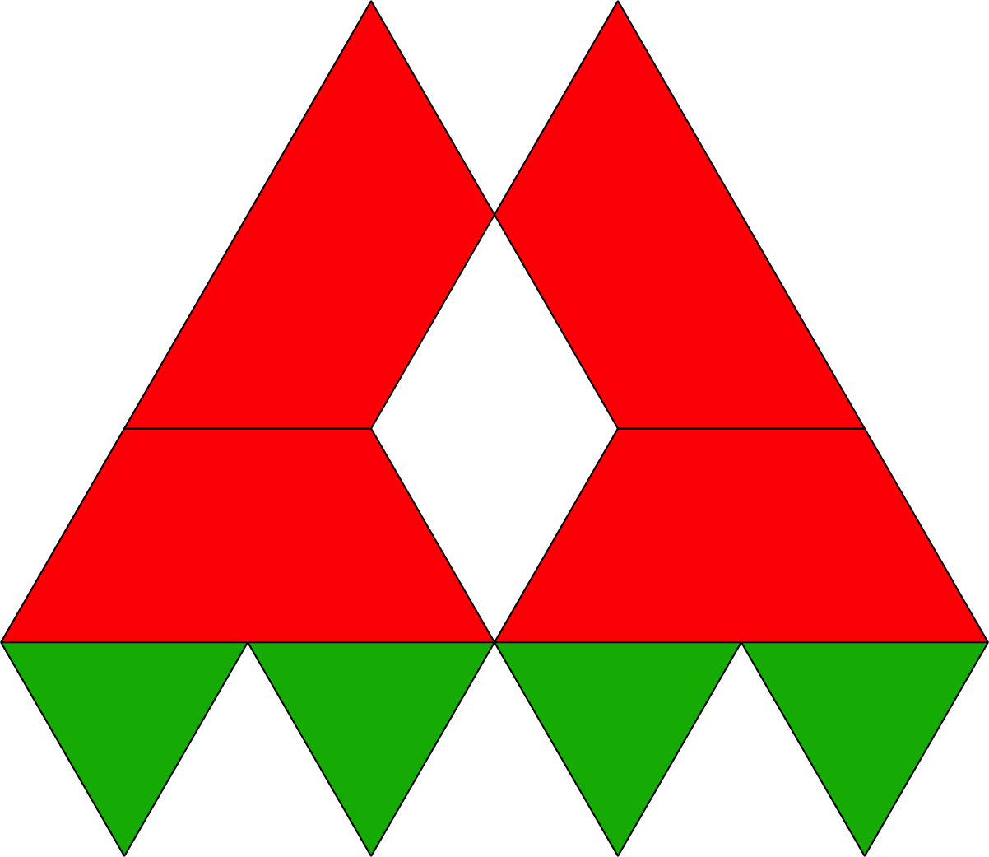
- Expression: ___________________________

2.3: Centers: Choice Time
Choose a center.
Check it Off
Bingo
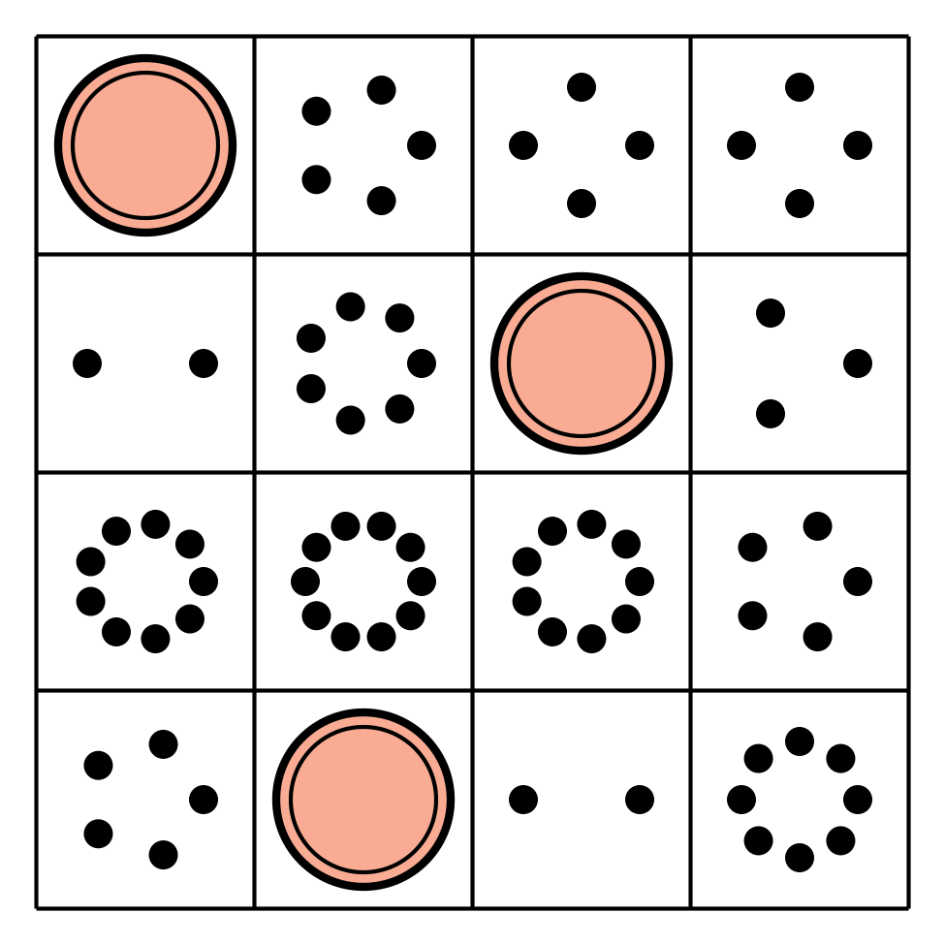
Find the Value of
Expressions
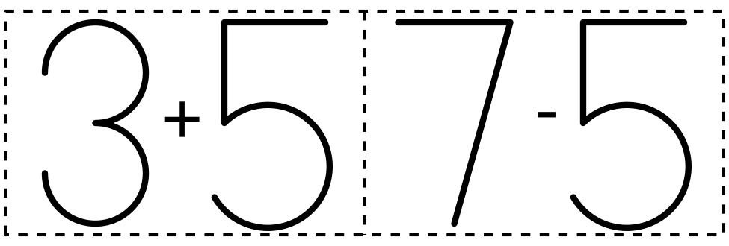
Shake and Spill
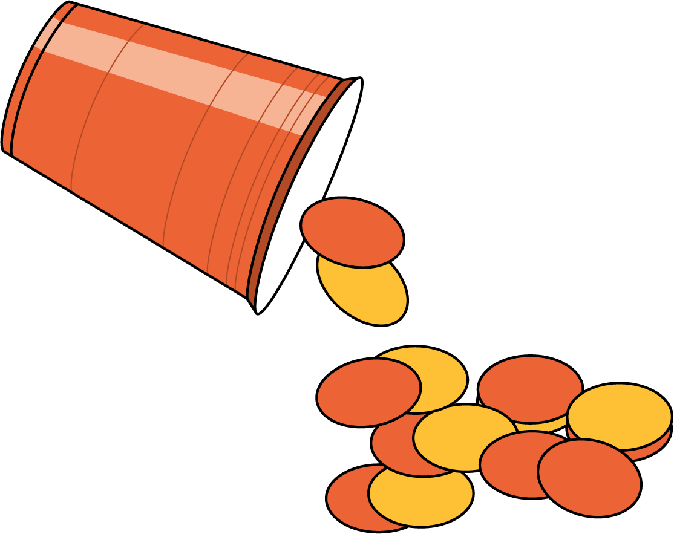
© CC BY 2021 Illustrative Mathematics®

