Teacher Presentation Materials

Unit 1 Lesson 3: Construction Techniques 1: Perpendicular Bisectors

1 Find All the Points! (Warm up)

Student Task Statement
Here are 2 points labeled $A$ and $B$, and a line segment $CD$:
- Mark 5 points that are a distance $CD$ away from point $A$. How could you describe all points that are a distance $CD$ away from point $A$?
- Mark 5 points that are a distance $CD$ away from point $B$. How could you describe all points that are a distance $CD$ away from point $B$?
- In a different color, mark all the points that are a distance $CD$ away from both $A$ and $B$ at the same time.

2 Human Perpendicular Bisector

Student Task Statement
Your teacher will mark points $A$ and $B$ on the floor. Decide where to stand so you are the same distance from point $A$ as you are from point $B$. Think of another place you could stand in case someone has already taken that spot.
After everyone sits down, draw a diagram of what happened.

3 How Well Can You Slice It?

Images for Launch
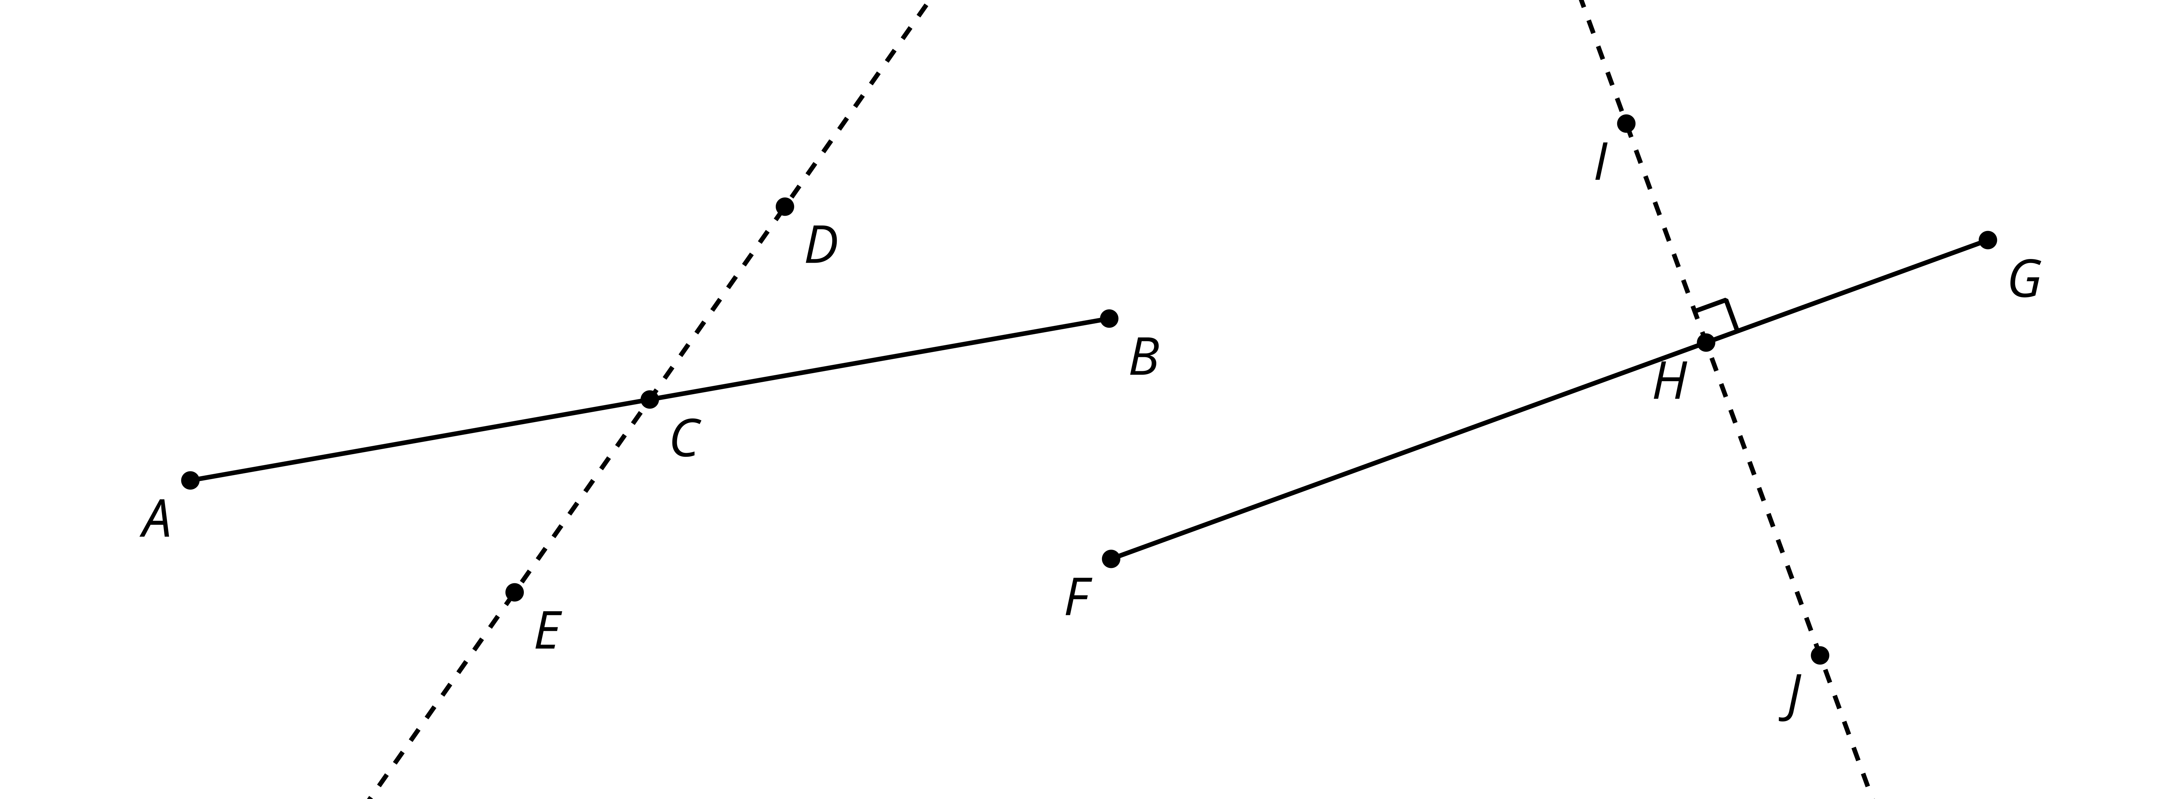

Student Task Statement
Use the tools available to find the perpendicular bisector of segment $PQ$.
After coming up with a method, make a copy of segment $PQ$ on tracing paper and look for another method to find its perpendicular bisector.
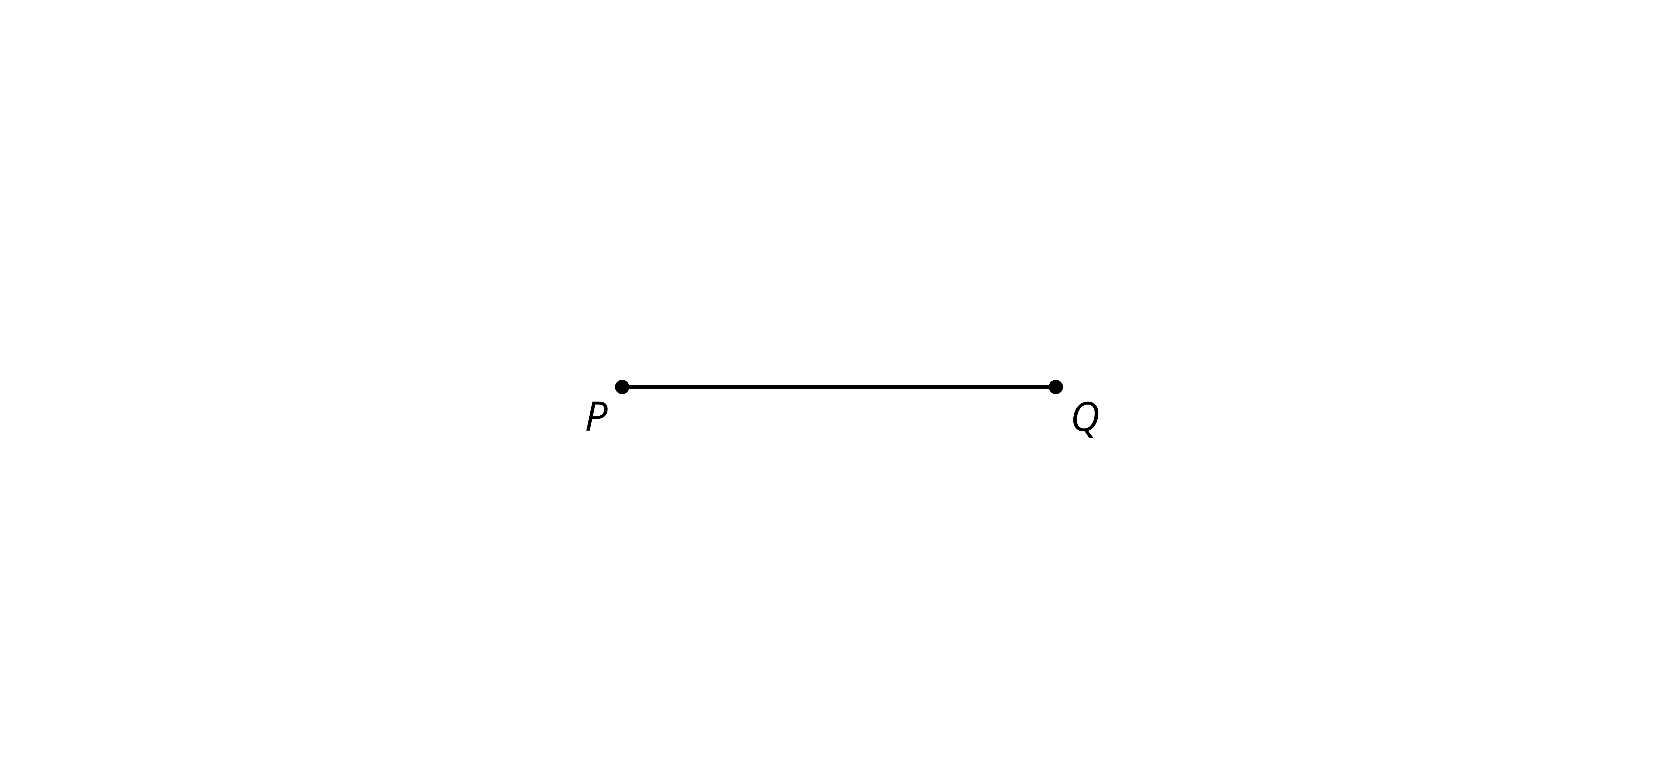

Images for Activity Synthesis

$\overline{AB}⊥\overline{CD},AE=EB$
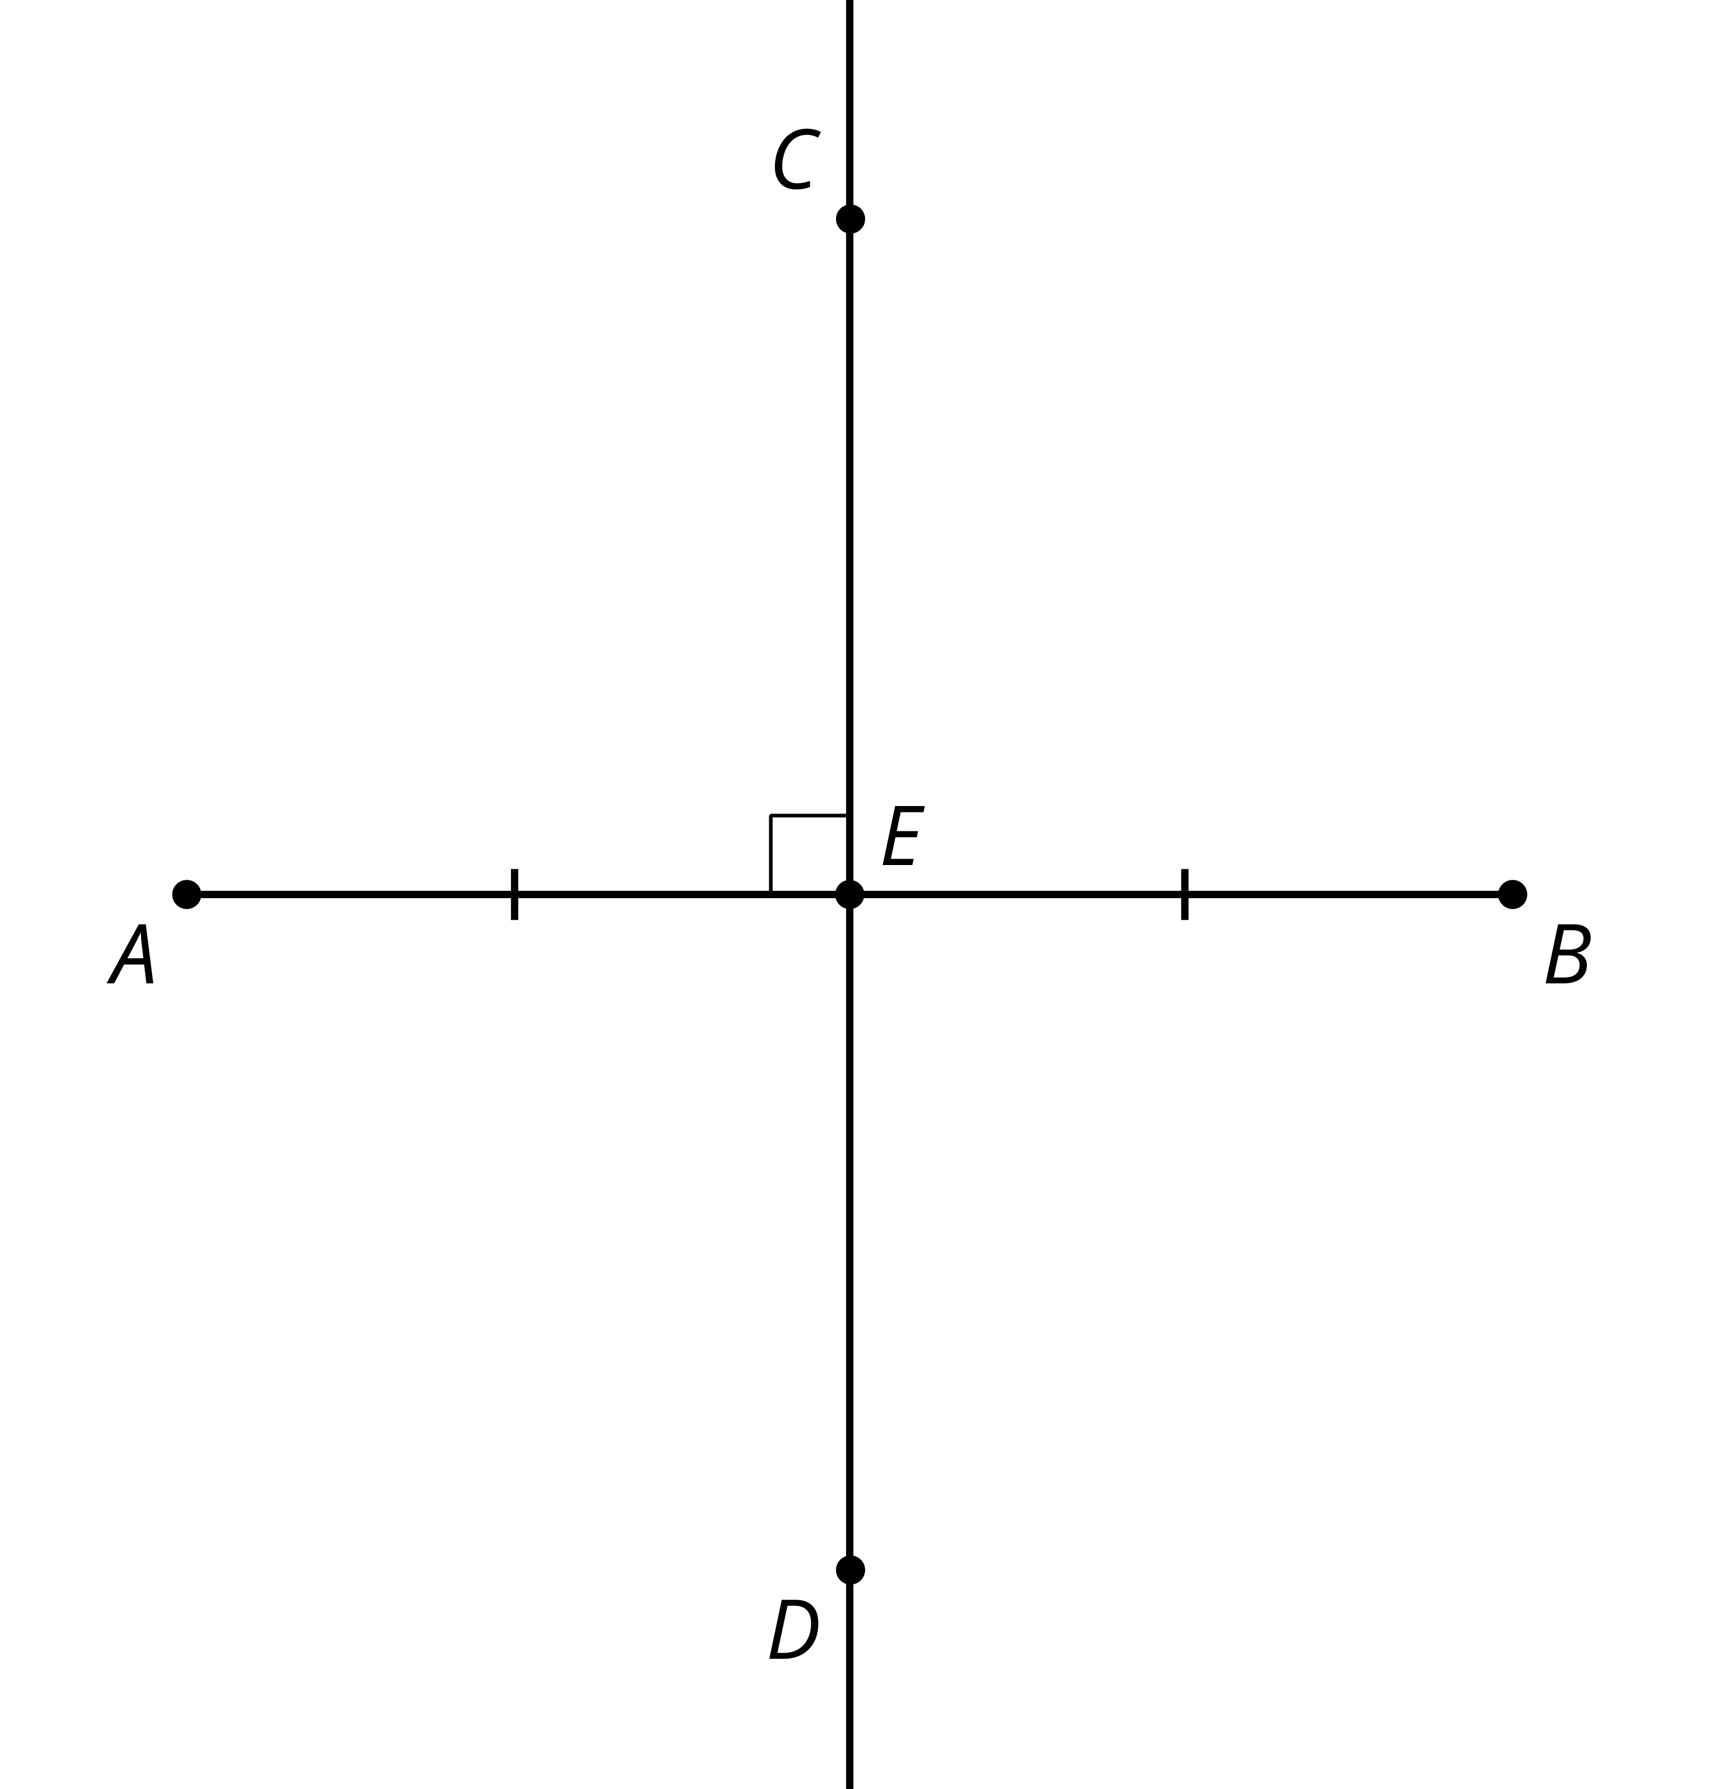
© CC BY 2019 by Illustrative Mathematics

