Lesson 1 Practice Problems
- Sketch the solid of rotation formed by rotating the given two-dimensional figure using the horizontal line shown as an axis of rotation.
- 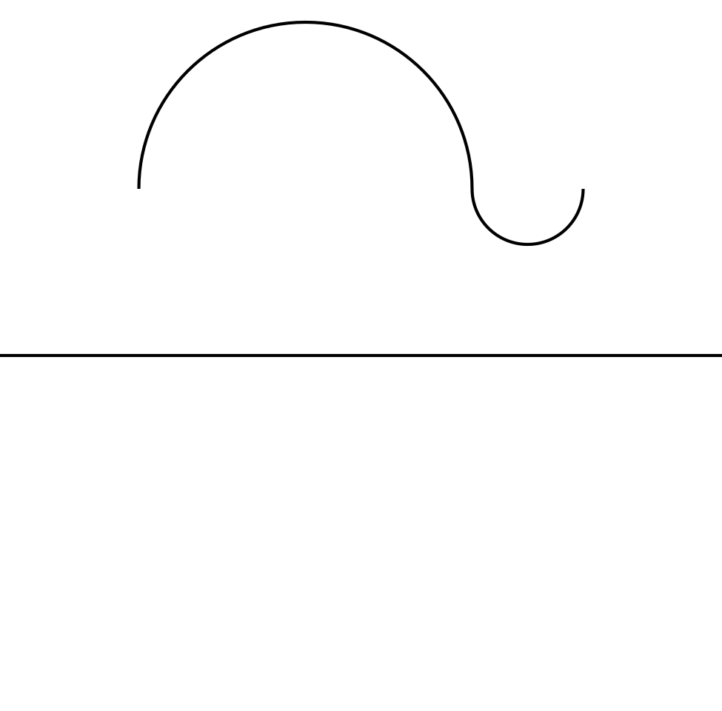
- Draw a two-dimensional figure that could be rotated using a vertical axis of rotation to give the barrel shown.
- 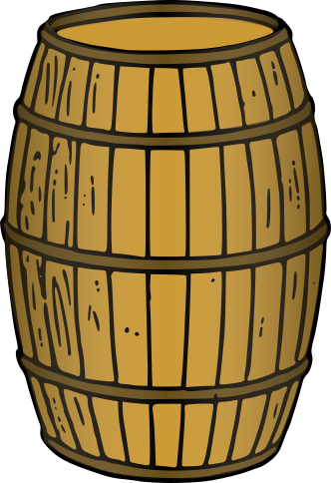
- Match the two-dimensional figure and axis of rotation with the solid of rotation that can be formed by rotating the figure using that axis.
  - 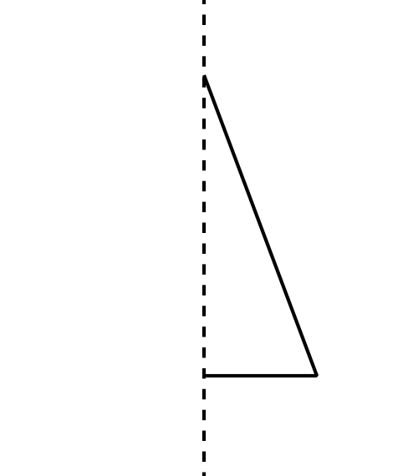
  - 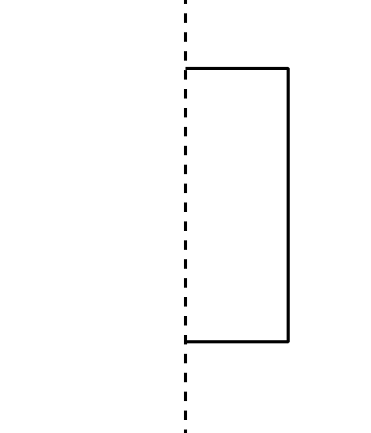
  - 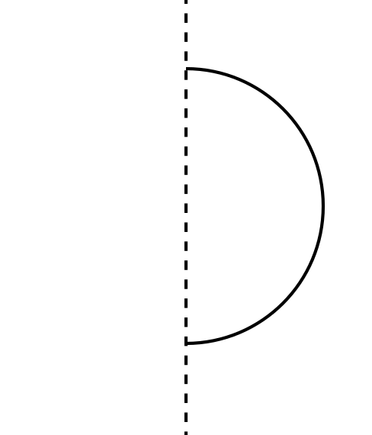
  - a cylinder
  - a sphere
  - a cone
- Find the area of the shaded region.
- 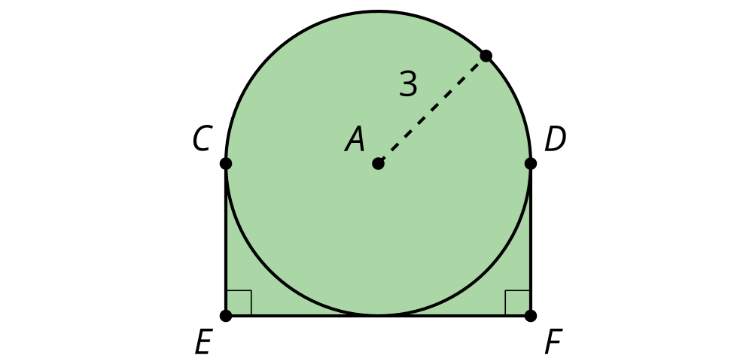
- (From Unit 4, Lesson 11.)
- Technology required. Find the area of the figure.
- 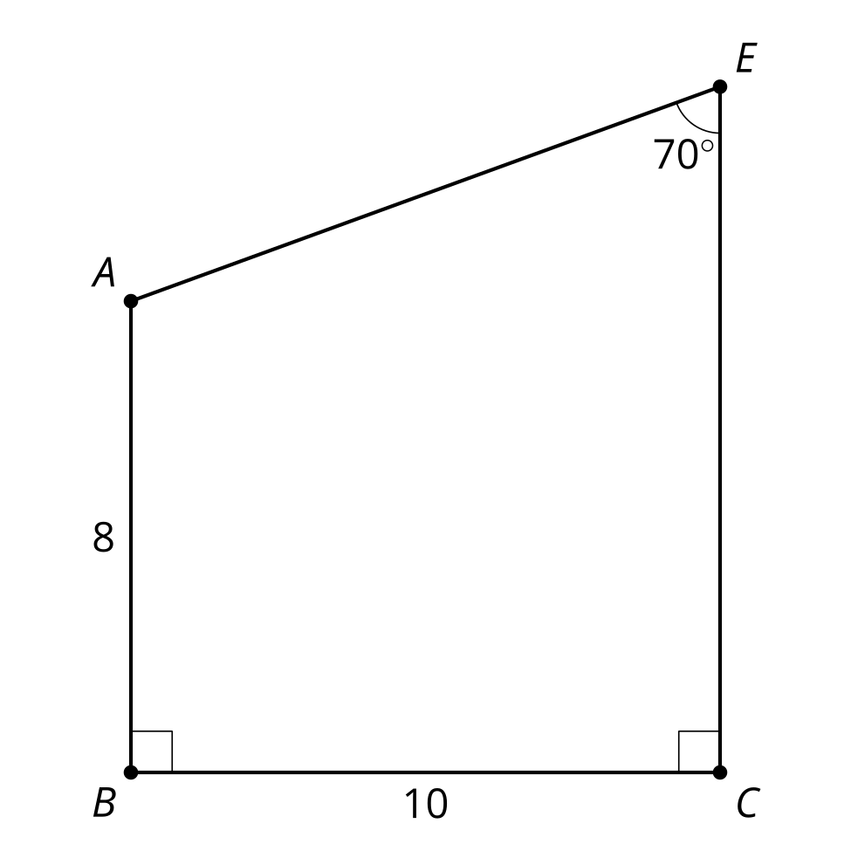
- (From Unit 4, Lesson 11.)
- Technology required. This stop sign is a regular octagon. It has side lengths of 12 inches. What is the area? What is the perimeter?
- (From Unit 4, Lesson 10.)
- Right triangle $ABC$ is shown.
- Select all expressions which are equal to the length of side $BC$.
- 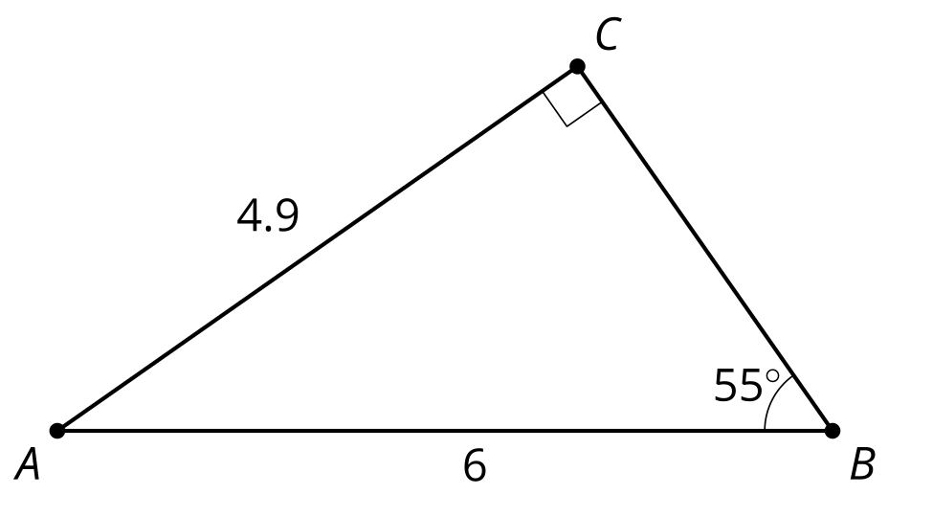
  - $\sqrt{{4.9}^{2}+6^{2}}$
  - $\sqrt{6^{2}−{4.9}^{2}}$
  - $4.9sin\left(55\right)$
  - $\frac{4.9}{sin\left(55\right)}$
  - $4.9tan\left(55\right)$
  - $\frac{4.9}{tan\left(55\right)}$
  - $6cos\left(55\right)$
  - $\frac{6}{cos\left(55\right)}$
- (From Unit 4, Lesson 6.)
© CC BY 2019 by Illustrative Mathematics®

