Unit 1 Lesson 2 Cumulative Practice Problems
- Each of the six cards shows a shape.
- 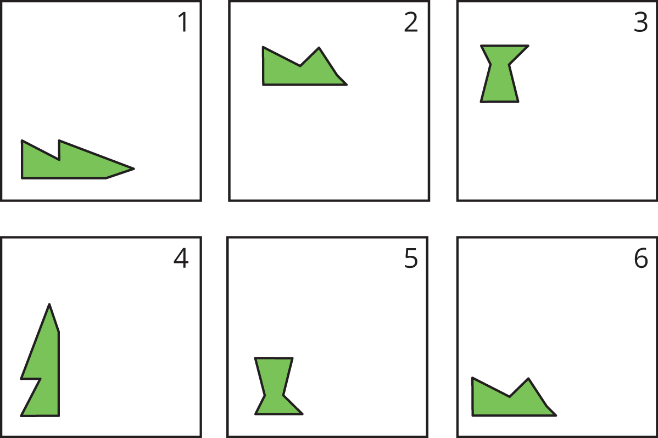
  - Which pair of cards shows a shape and its image after a rotation?
  - Which pair of cards shows a shape and its image after a reflection?
- The five frames show a shape's different positions.
- 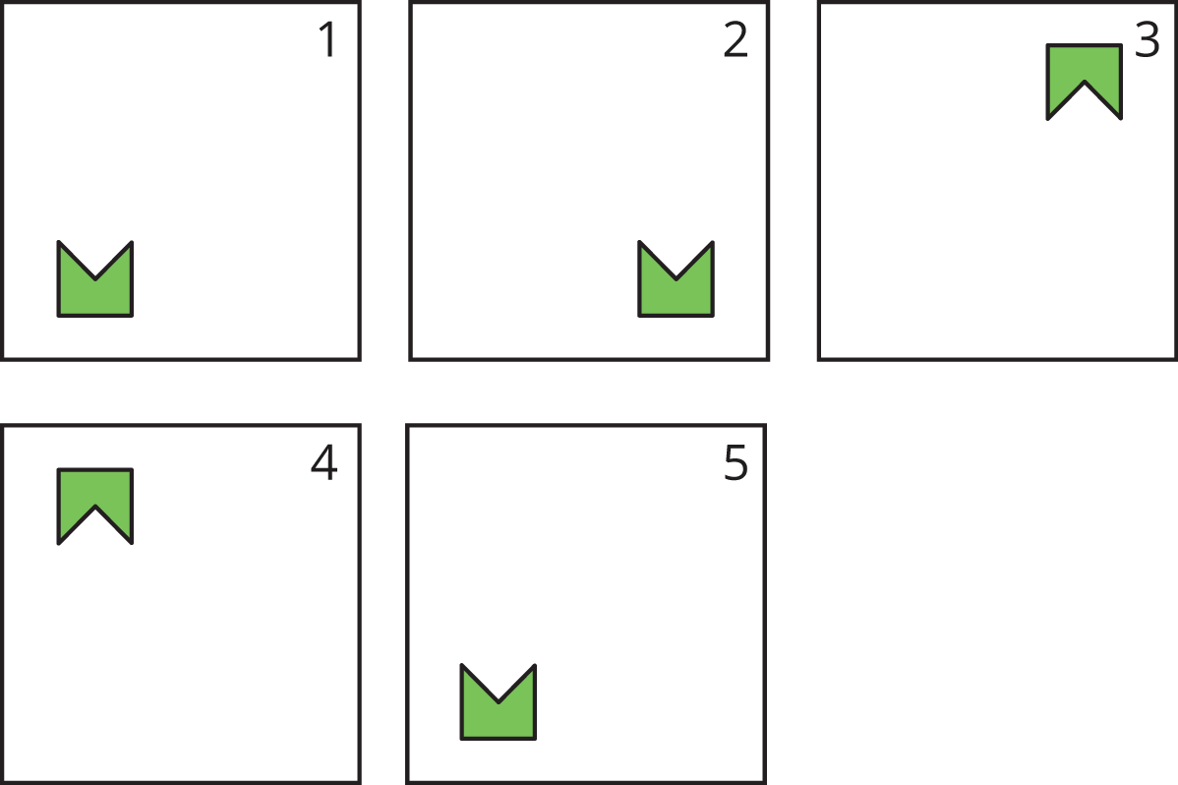
- Describe how the shape moves to get from its position in each frame to the next.
- The rectangle seen in Frame 1 is rotated to a new position, seen in Frame 2.
- 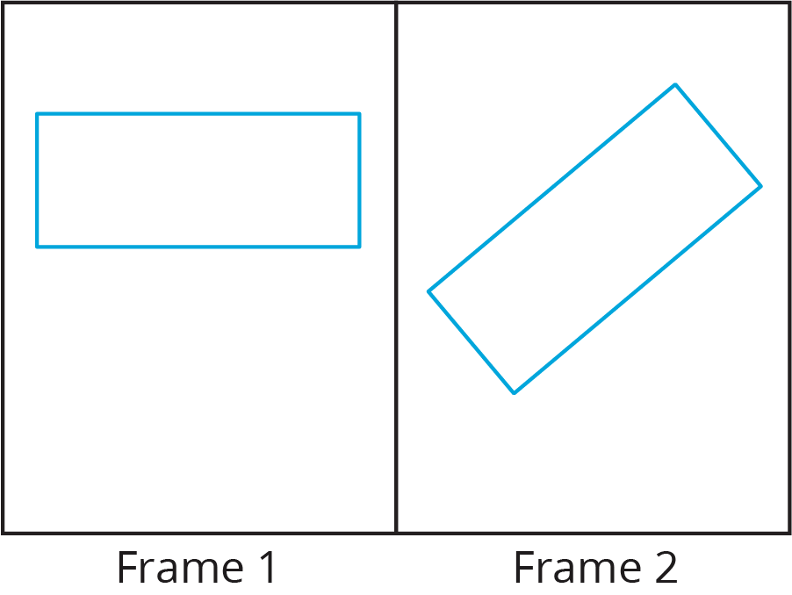
- Select all the ways the rectangle could have been rotated to get from Frame 1 to Frame 2.
  - 40 degrees clockwise
  - 40 degrees counterclockwise
  - 90 degrees clockwise
  - 90 degrees counterclockwise
  - 140 degrees clockwise
  - 140 degrees counterclockwise
- (From Unit 1, Lesson 1.)
© CC BY Open Up Resources. Adaptations CC BY IM.

