Lesson 11: Fractional Side Lengths Greater Than 1
- Let’s find the area of more rectangles.

Warm-up: True or False: Thirds
Decide if each statement is true or false. Be prepared to explain your reasoning.
- $10÷3=10×\frac{1}{3}$
- $10÷3=10\frac{1}{3}$
- $\frac{10}{3}=5×\frac{2}{3}$

11.1: Greater Than One
- Find the area of the shaded region in square units. Explain or show your reasoning.
- 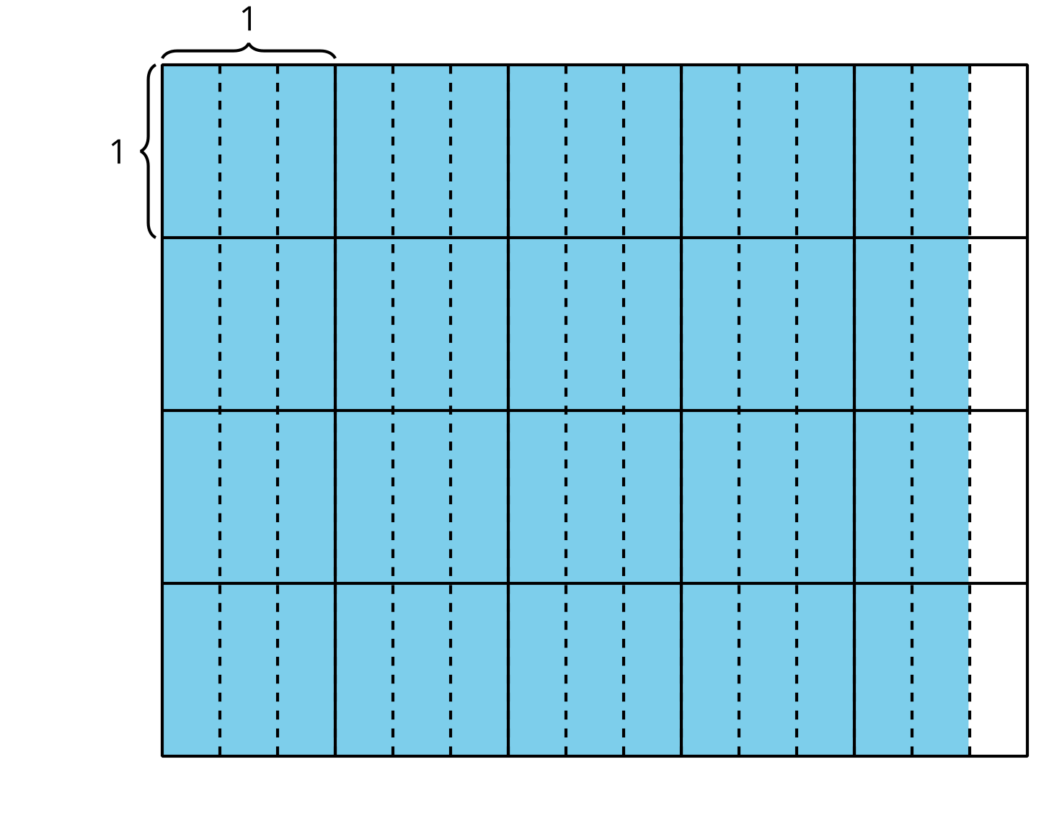
- Select all the expressions which represent the area of the shaded region in square units. For each correct expression, explain your reasoning.
  - $4\frac{2}{3}×4$
  - $16×\frac{8}{3}$
  - $\frac{14}{3}×4$
  - $\frac{56}{3}$
  - $4×\frac{5}{3}$

11.2: Diagrams and Expressions for Area

  - Write a multiplication expression to represent the area of the shaded region.
  - 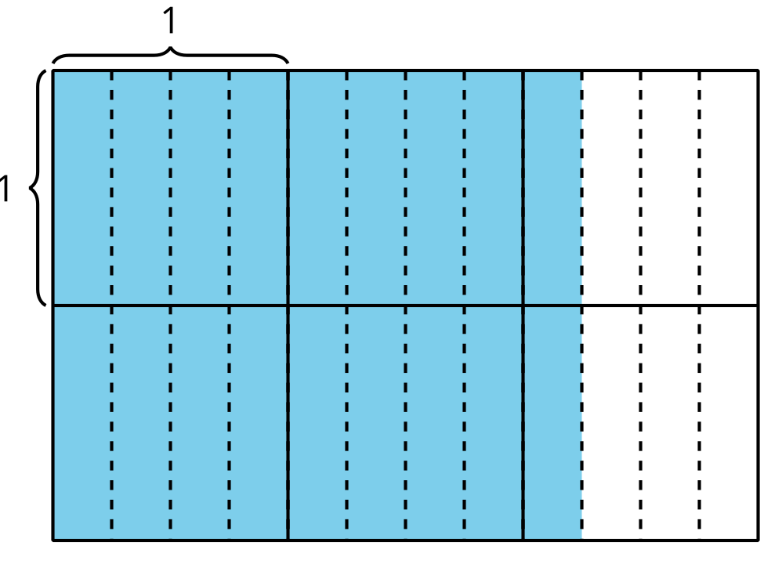
  - What is the area of the shaded region?

  - Write a multiplication expression to represent the area of the shaded region.
  - 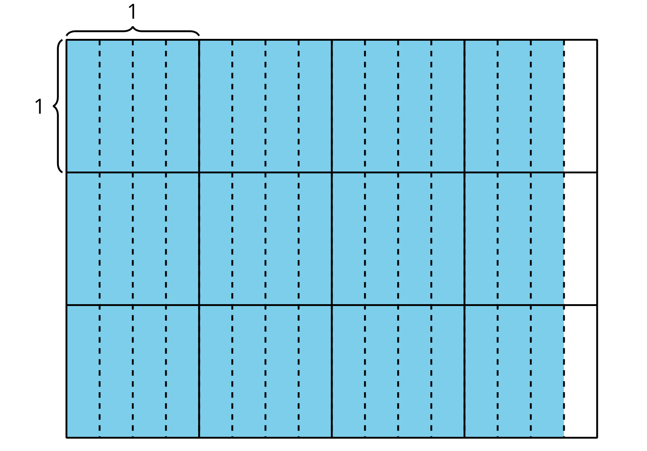
  - What is the area of the shaded region?
© CC BY 2021 Illustrative Mathematics®

