Unit 8 Lesson 4: One More and One Less

WU How Many Do You See: One Less (Warm up)

Student Task Statement
How many do you see?
How do you see them?
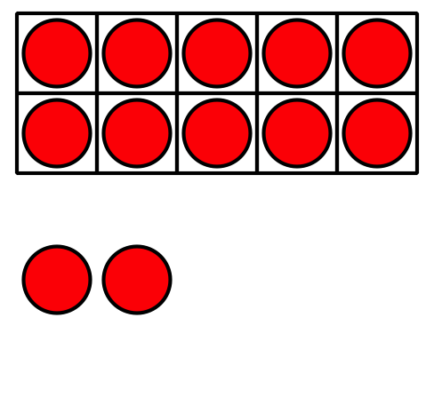
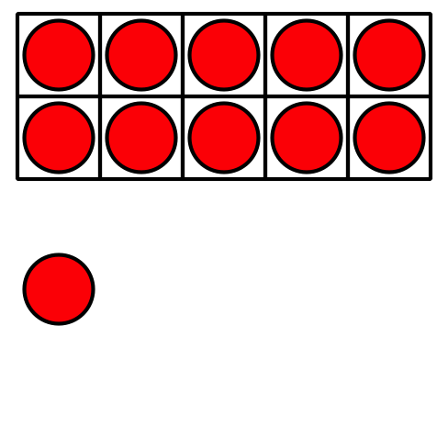
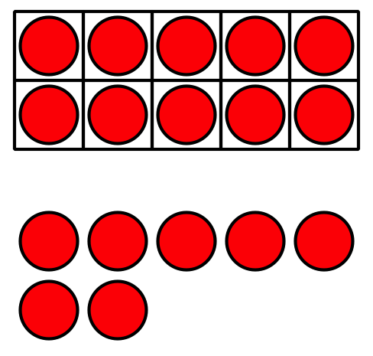
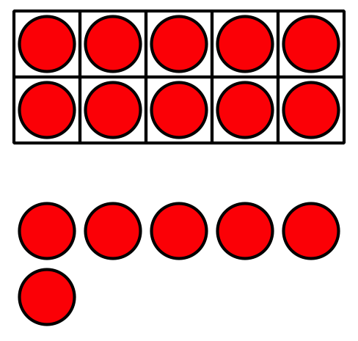

1 Count Out and Show One More or One Less

Student Task Statement
Show your number.
Show how your partner changed the number.
Round 1:
Starting Number:
_______________
New Number:
_______________
Round 2:
Starting Number:
_______________
New Number:
_______________
Round 3:
Starting Number:
_______________
New Number:
_______________
Round 4:
Starting Number:
_______________
New Number:
_______________

2 Color One More or One Less

Student Task Statement
- Roll to choose a number and 1 more or 1 less.
- Color the number that is 1 more or 1 less than your number.
- Record the starting number and the new number.
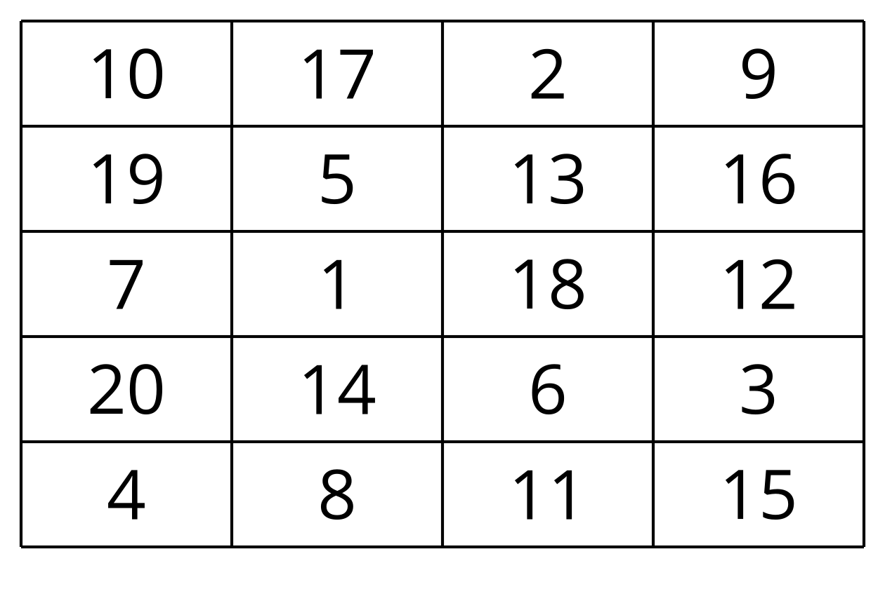
Starting Number:
New Number:
Round 1:
_______________
_______________
Round 2:
_______________
_______________
Round 3:
_______________
_______________
Round 4:
_______________
_______________

3 Centers: Choice Time

Student Task Statement
Choose a center.
Less, Same, More
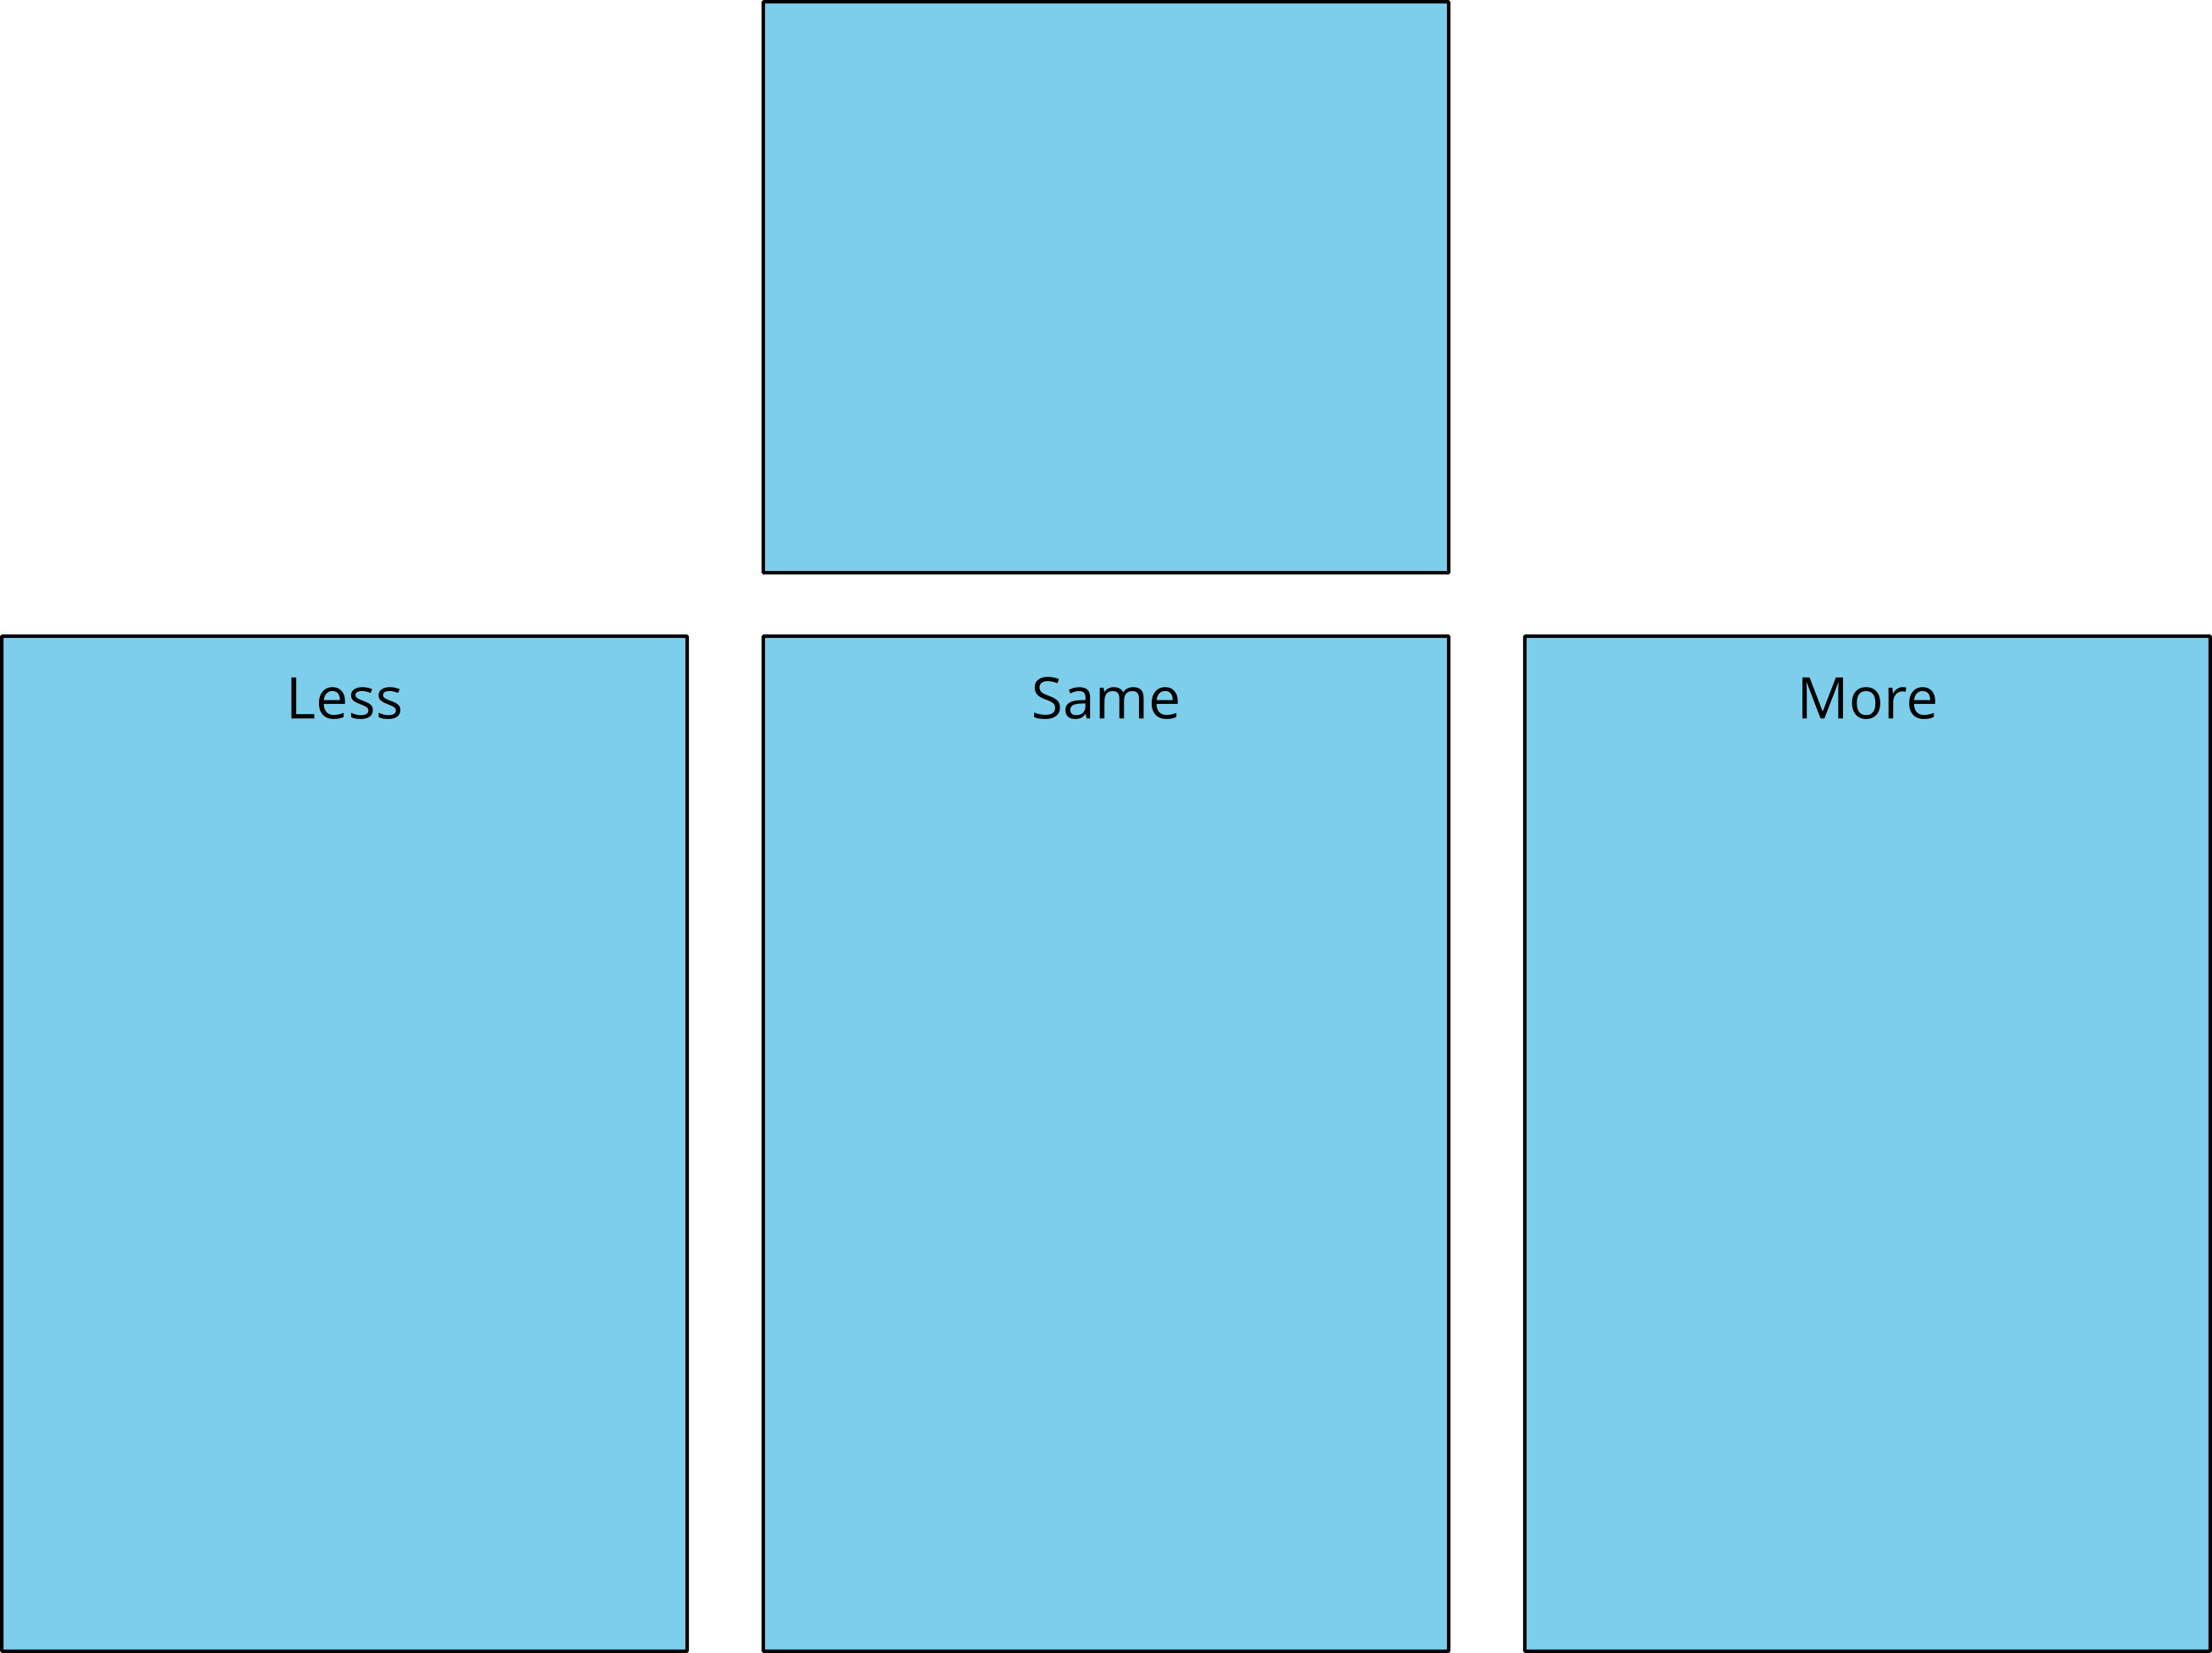
Math Fingers
Tower Build
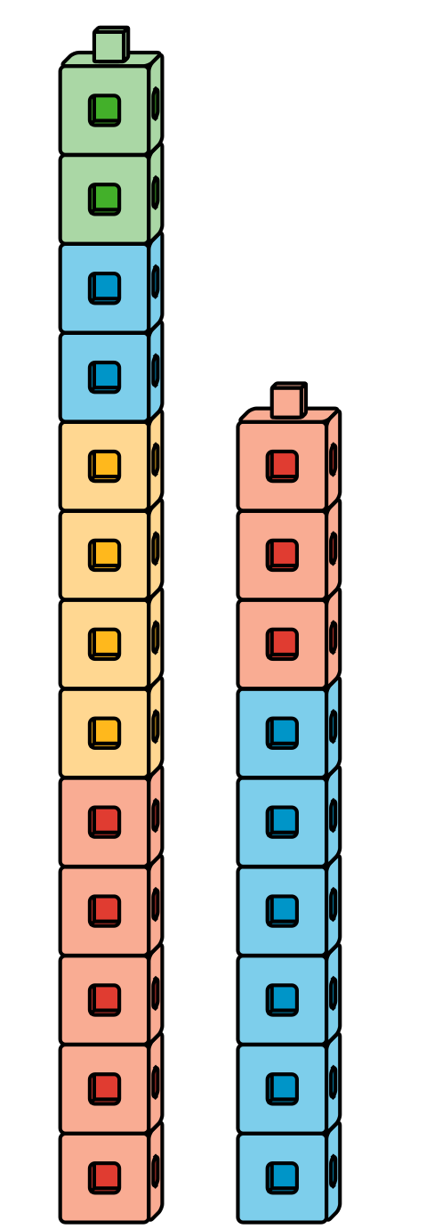
Math Stories
Which One
© CC BY 2021 Illustrative Mathematics®

