Lesson 12: Equations with Unknowns
- Let’s represent equations with a ? for the unknown.

Warm-up: True or False: Making Tens
Decide if each statement is true or false. Be prepared to explain your reasoning.
- $40=10+27+3$
- $47=20+7+3+10$
- $60=3+47+10$

12.1: Number Line Riddles
Solve riddles to find the mystery number.
For each riddle:
- Write an equation that represents the riddle and write a ? for the unknown.
- Write the mystery number. Represent the equation on the number line.
- I started at 15 and jumped 17 to the right. Where did I end?
- Equation: _______________________________
- Mystery number: _______________________
- I started at a number and jumped 20 to the left. I ended at 33. Where did I start?
- Equation: _______________________________
- Mystery number: _______________________
- I started on 42 and ended at 80. How far did I jump?
- Equation: _______________________________
- Mystery number: _______________________
- I started at 76 and jumped 27 to the left. Where did I end?
- Equation: _______________________________
- Mystery number: _______________________
- I started at a number and jumped 19 to the right. I ended at 67. Where did I start?
- Equation: _______________________________
- Mystery number: _______________________
- I started at 92 and ended at 33. How far did I jump?
- Equation: _______________________________
- Mystery number: _______________________
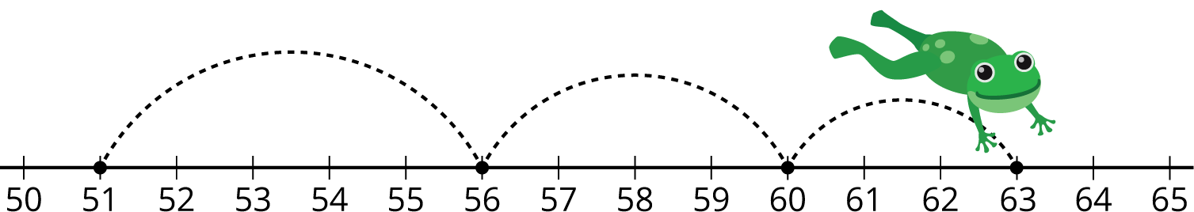

12.2: Make the Equations True
Find the number that makes each equation true.
Show your thinking on the number line.
- $?−48=19$
- $86−?=39$
- $?+57=72$
- $73+?=91$
© CC BY 2021 Illustrative Mathematics®

