Unit 7 Lesson 8: Compose Tens and Hundreds to Add

WU How Many Do You See: Too Many Tens (Warm up)

Student Task Statement
How many do you see? How do you see them?
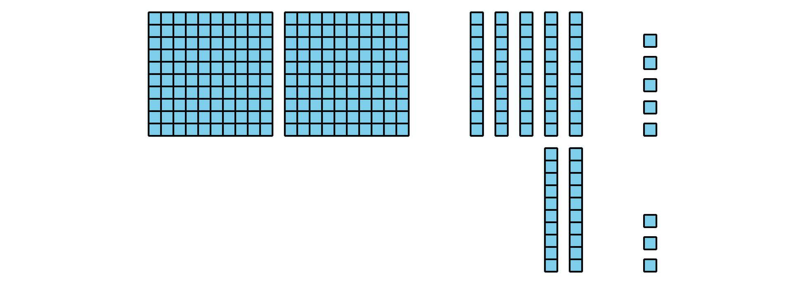
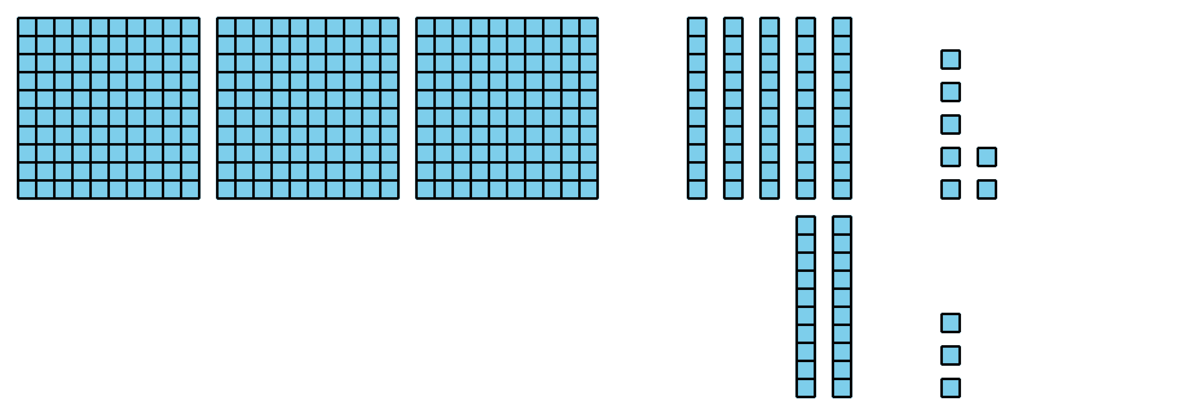
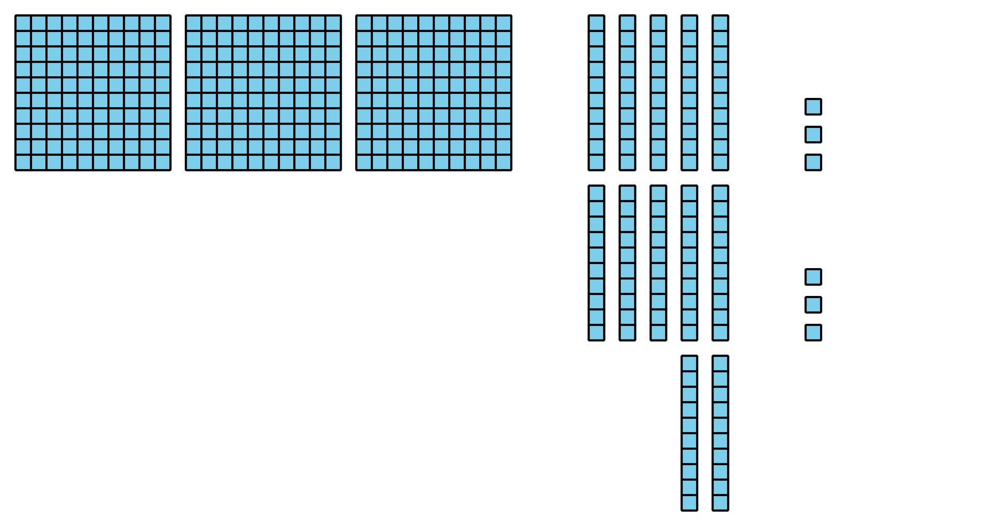

1 Compare the Sums

Student Task Statement
Find the value of each sum. Show your thinking. Use base-ten blocks if it helps.
- $273+18$
- $273+81$
- $273+88$
- What was the same and different about the sums?
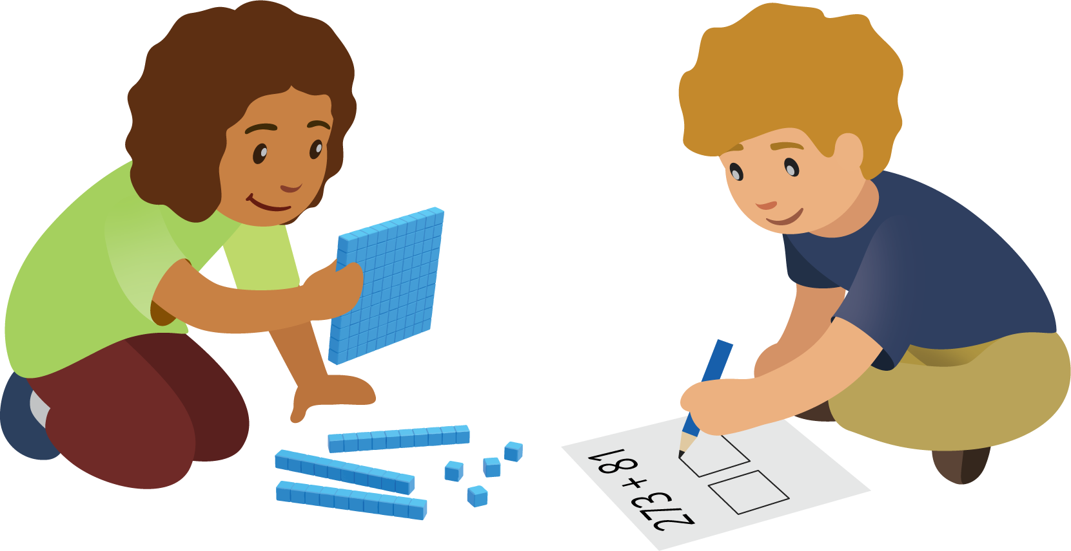

2 Different Ways to Show Your Thinking

Student Task Statement
- Priya and Lin were asked to find the value of $358+67$.
- Priya's work
- 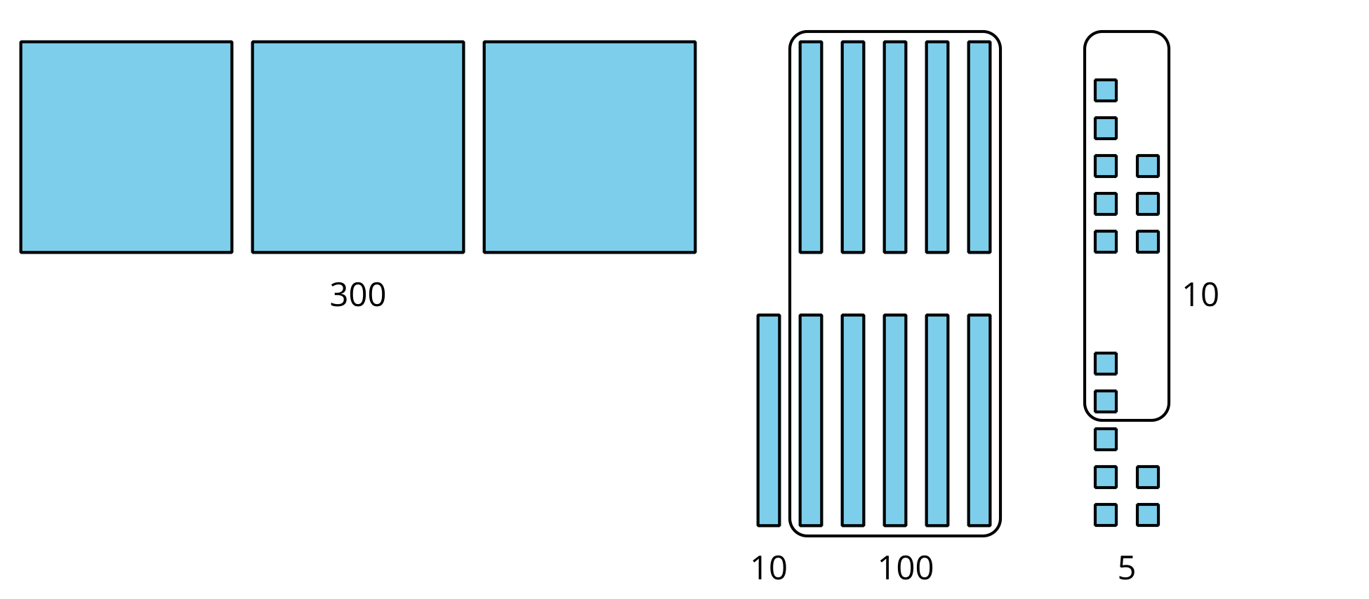
- 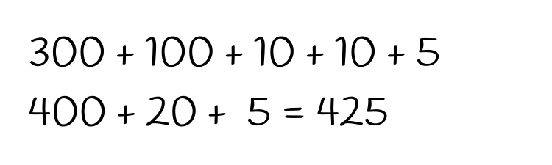
- Lin's work
- 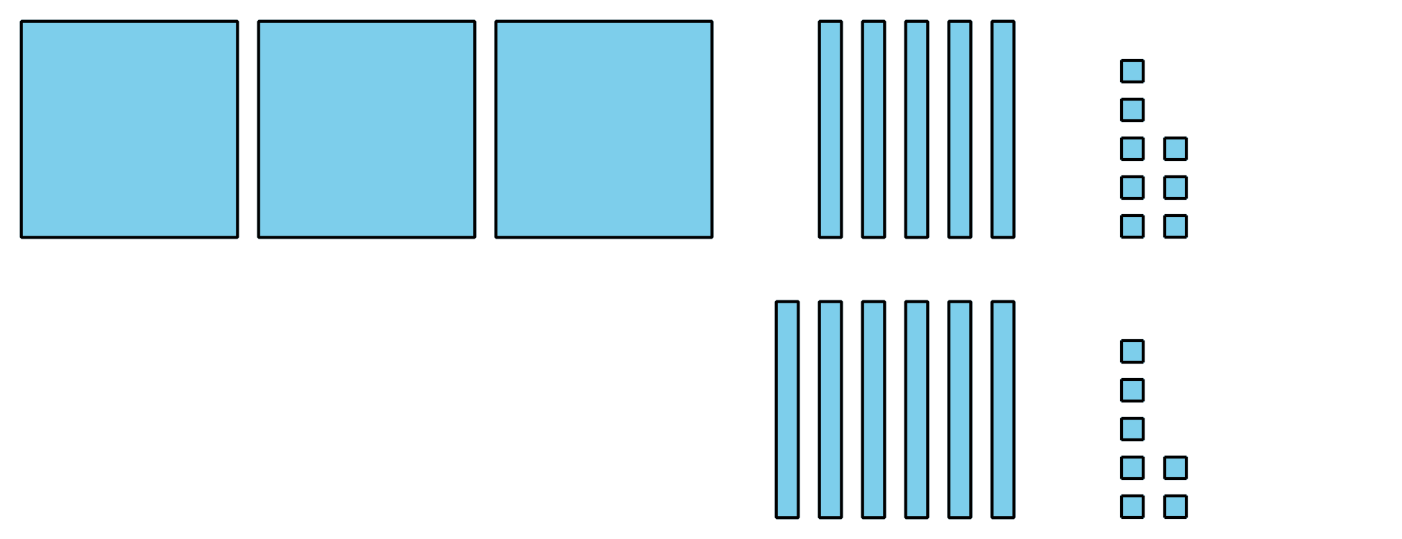
- 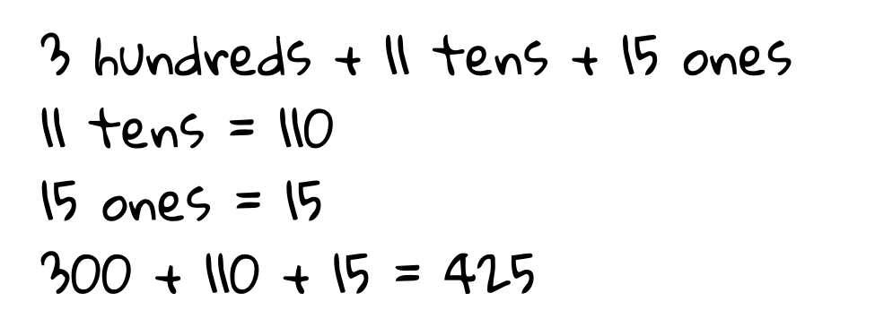
- What do you notice about their work? What is the same and different about their representations? Be prepared to explain your thinking.
- Find the value of $546+86$.
- Show your thinking. Use base-ten blocks if it helps.
© CC BY 2021 Illustrative Mathematics®

