Lesson 8: The Size of Angles in Degrees

Standards Alignments
Building On | 4.NBT.A.1
Addressing | 4.MD.C.5.a, 4.MD.C.7
Building Towards | 4.MD.C.5, 4.MD.C.6, 4.MD.C.7

Teacher-facing Learning Goals
- Understand that the measure of a full rotation of a ray at a fixed point is 360 degrees.
- Use benchmark angle measurementes (such as ${90}^{∘}$, ${180}^{∘}$, ${270}^{∘}$, ${360}^{∘}$) to reason about and estimate the size of angles in degrees.

Student-facing Learning Goals
- Let’s describe the size of angles using degrees.

Lesson Purpose
The purpose of this lesson is for students to understand that angles can be measured in degrees and use benchmark angle measurements to make sense of the new unit.
Previously, students used the hands of an analog clock to describe and compare the size of angles. In this lesson, students learn about degrees as a unit for measuring angles.
In the first activity, students are introduced to 360 degrees as the measurement of a full rotation of a ray about a fixed point. They use this to interpret and describe other benchmark angle measurements (90, 180, 270). They then use these benchmarks to estimate and sketch new angles with given measurements in degrees.
Next, students use these reference angles to create an angle measurement tool from paper. They partition the straight angle of a semi-circle into into smaller angles by folding. In doing so, they draw from their experience with the clock, where each hour or each minute can be thought of as equal-size parts around the center point of the clock.
Throughout the lesson, listen for the way students make connections to their work with clocks and to their understanding of fractions of a circle as they reason about how to estimate and sketch angles in degrees using an understanding that a full rotation is 360 degrees.

Instructional Routines
What Do You Know About _____? (Warm-up)

Materials to Gather
- Paper: Activity 2
- Rulers or straightedges: Activity 2

Materials to Copy
- Making a Measuring Tool (groups of 3): Activity 2

Lesson Timeline
Warm-up | 10 min
Activity 1 | 15 min
Activity 2 | 20 min
Lesson Synthesis | 10 min
Cool-down | 5 min

Teacher Reflection Question
How did students connect the angles they created in the second activity to the fractions of a circle? How can you help students make connections between degrees and a fraction of a circle in upcoming lessons?

Cool-down
(to be completed at the end of the lesson) 5min
Estimate Angle Size in Degrees

Standards Alignments
Addressing | 4.MD.C.5.a

Student-facing Task Statement
Use the tool you created to estimate the size of each angle in degrees.
a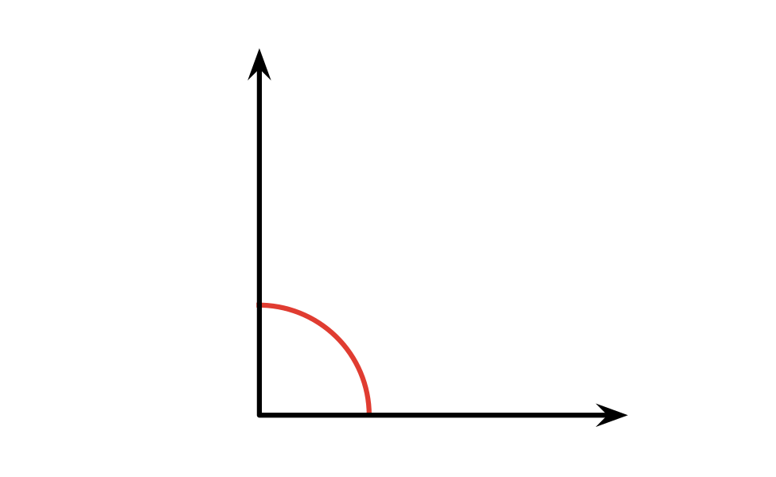
b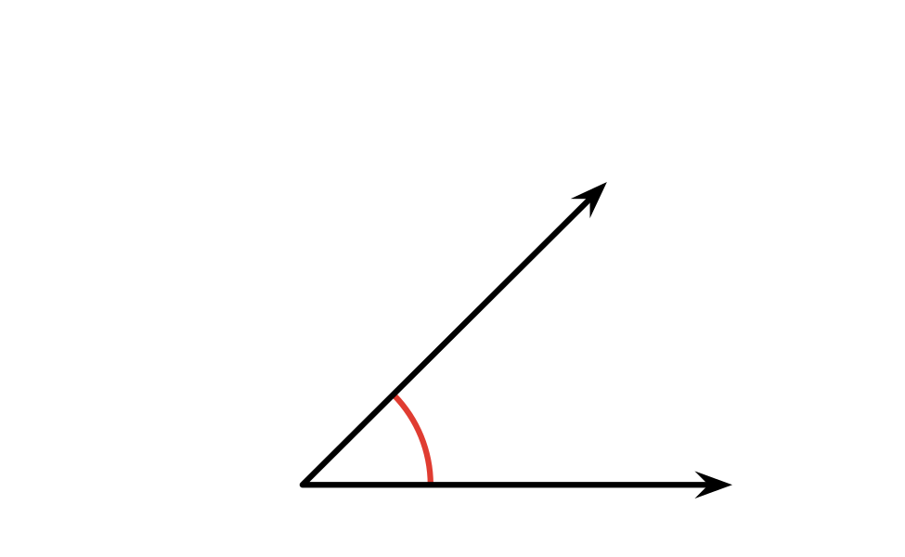
c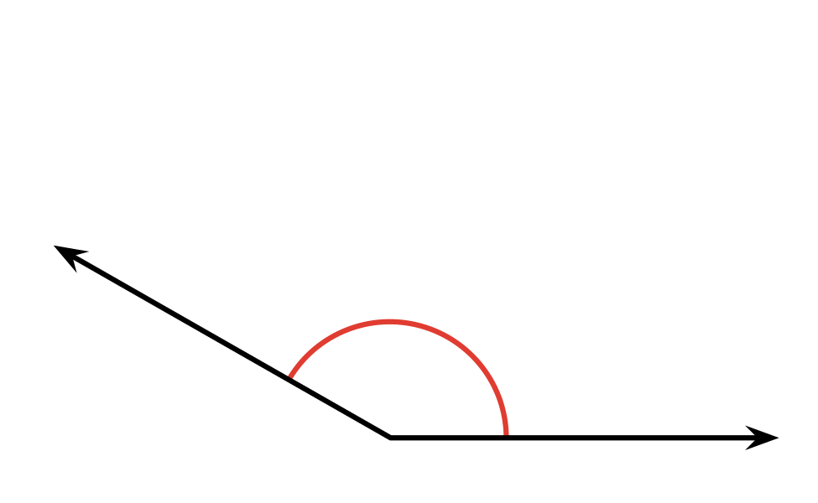

Student Responses
- 90 degrees
- 45 degrees
- 150 degrees

