Unit 4 Lesson 5: Changes Over Rational Intervals

1 Changes Over Intervals (Warm up)

Student Task Statement
Consider the exponential function $h\left(x\right)=4^{x}$. For each question, be prepared to share your reasoning with the class.
- By what factor does $h$ increase when the exponent $x$ increases by 1?
- By what factor does $h$ increase when the exponent $x$ increases by 2?
- By what factor does $h$ increase when the exponent $x$ increases by 0.5?

2 Machine Depreciation

Student Task Statement
After purchase, the value of a machine depreciates exponentially. The table shows its value as a function of years since purchase. If a spreadsheet tool is available, consider using it to help you reason about the following questions.
years since purchase | value in dollars
0 | 16,000
0.5
1 | 13,600
1.5
2 | 11,560
3 | 9,826
- The value of the machine in dollars is a function $f$ of time $t$, the number of years since the machine was purchased. Find an equation defining $f$ and be prepared to explain your reasoning.
- Find the value of the machine when $t$ is 0.5 and 1.5. Record the values in the table.
- Observe the values in the table. By what factor did the value of the machine change:
  - every one year, say from 1 year to 2 years, or from 0.5 years to 1.5 years?
  - every half a year, say from 0 to 0.5 year, or from 1.5 years to 2 years?
- Suppose we know $f\left(q\right)$, the value of the machine $q$ years since purchase. Explain how we could use $f\left(q\right)$ to find $f\left(q+0.5\right)$, the value of the machine half a year after that point.

3 Fever Medicine

Student Task Statement
The graph shows the amount of medicine in a child’s body $h$ hours after taking the medicine. The amount of medicine decays exponentially.
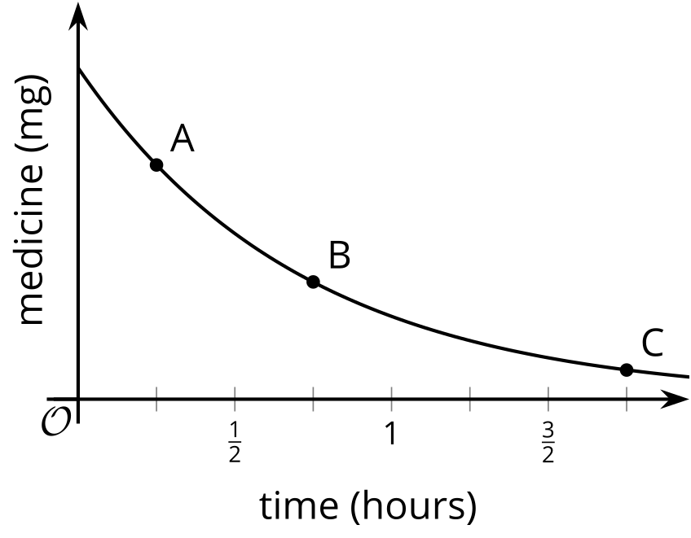
- After $\frac{1}{4}$ hour there are about 7 mg of medicine left. After $\frac{3}{4}$ hour there are about 3.5 mg of medicine left. About how many mg of medicine are left after 1$\frac{3}{4}$ hours? Explain how you know.
- How does the decay rate from $\frac{1}{4}$ hour to $\frac{1}{2}$ hour compare to the decay rate from $\frac{1}{2}$ hour to $\frac{3}{4}$ hour? Explain how you know.
© CC BY 2019 by Illustrative Mathematics®

