Lesson 23 Practice Problems
- Select all the identities:​​​​
  - ${\left(x+2\right)}^{3}=x^{3}+8$
  - $\left(x^{6}+x\right)=\left(x−1\right)\left(x^{5}+x^{4}+x^{3}+x^{2}+x\right)$
  - $\left(x^{2}−1\right)\left(x^{4}+x^{2}+1\right)=x^{6}−1$
  - ${\left(x+1\right)}^{4}=x^{4}+x^{3}+x^{2}+x+1$
  - $\left(x+1\right)\left(x^{4}−x^{3}+x^{2}−x+1\right)=x^{5}+1$
  - $\left(x^{3}−1\right)\left(x^{3}+1\right)=x^{6}−1$
- Is $2{\left(x+1\right)}^{2}={\left(2x+2\right)}^{2}$ an identity? Explain or show your reasoning.
- Mai is solving the rational equation $5=\frac{2+7x}{x}$ for $x$. What move do you think Mai would make first to solve for $x$? Explain your reasoning.
- For $x$-values of 0 and -2, $\left(x^{5}+32\right)={\left(x+2\right)}^{5}$. Does this mean the equation is an identity? Explain your reasoning.
- Clare finds an expression for $S\left(r\right)$ that gives the surface area in square inches of any cylindrical can with a specific fixed volume, in terms of its radius $r$ in centimeters. This is the graph Clare gets if she allows $r$ to take on any value between -1.2 and 3.
  - What would be a more appropriate domain for Clare to use instead?
  - What is the approximate minimum surface area for her can?
- 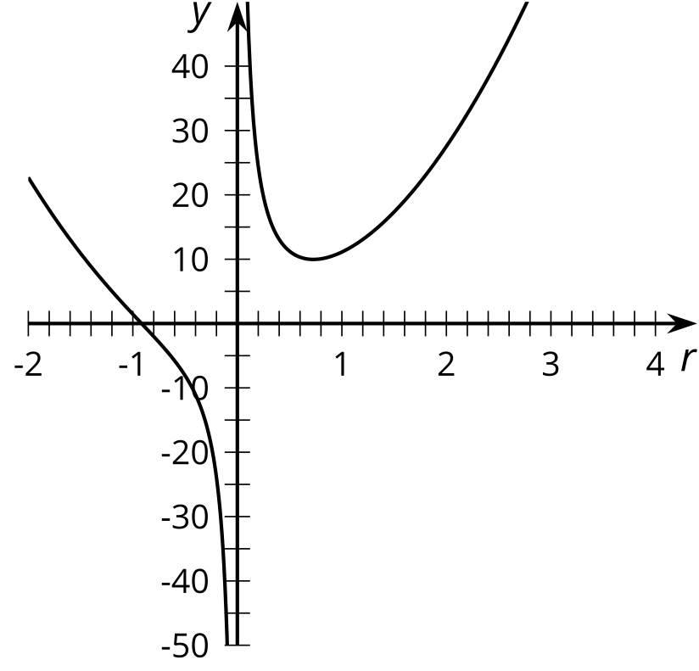
- (From Unit 2, Lesson 16.)
- Which values of $x$ make $\frac{3x+1}{x}=\frac{1}{x−3}$ true?
- (From Unit 2, Lesson 22.)
© CC BY 2019 by Illustrative Mathematics®

