Lesson 8: Divide to Multiply Non-unit Fractions
- Let’s solve problems about multiplying whole numbers by fractions.

Warm-up: True or False: A Fraction by a Whole Number
Decide if each statement is true or false. Be prepared to explain your reasoning.
- $2×\left(\frac{1}{3}×6\right)=\frac{2}{3}×6$
- $2×\left(\frac{1}{3}×6\right)=2×\left(6÷3\right)$
- $\frac{2}{3}×6=2×\left(\frac{1}{4}×6\right)$

8.1: Multiply a Whole Number by a Fraction
Find the value of each expression. Explain or show your reasoning. Draw a diagram if it is helpful.
- $\frac{1}{5}×3$
- $\frac{2}{5}×3$
- $\frac{3}{5}×3$

8.2: Match Expressions to Diagrams
Explain how each expression represents the shaded region.
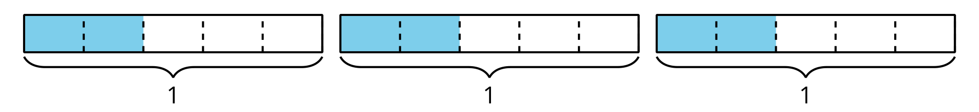
- $2×\left(3÷5\right)$
- $\frac{6}{5}$
- $3×\frac{2}{5}$
- $3×2×\frac{1}{5}$

Section Summary
Section Summary
In this section, we explored the relationship between multiplication and division. We learned that 1 diagram can represent different multiplication and division expressions. For example, we can interpret this diagram with 4 different expressions:
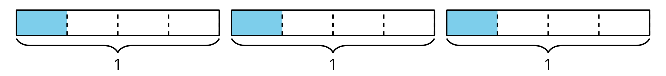
- $\frac{3}{4}$ because each rectangle is divided into 4 equal parts and three of them are shaded.
- $3×\frac{1}{4}$ because there are 3 parts shaded and each one is $\frac{1}{4}$ of the rectangle.
- $3÷4$ because there are 3 rectangles and each one is divided into 4 equal parts.
- $\frac{1}{4}×3$ because there are 3 rectangles and $\frac{1}{4}$ of each one is shaded.
We know that all of these expressions are equal because they all represent the same diagram. We can use any of these expressions to represent and solve this problem:
- Mai ate $\frac{1}{4}$ of a 3 pound bag of blueberries. How many pounds of blueberries did Mai eat?
© CC BY 2021 Illustrative Mathematics®

