Unit 8 Lesson 1: Sort, Count, and Compare Groups of Objects

WU Choral Count: Count on within 100 (Warm up)

Student Task Statement

1 Sort, Count, and Compare

Student Task Statement
How many beads are in each group?
Show your thinking using drawings, numbers, or words.
_______________
_______________
Circle the group that has fewer beads.

2 Who Has More? (Optional)

Student Task Statement
- How many beads are in each group?
Show your thinking using drawings, numbers, or words.
- _______________
- _______________
- How many beads are in your bag altogether?
- _______________

3 Centers: Choice Time

Student Task Statement
Choose a center.
Less, Same, More
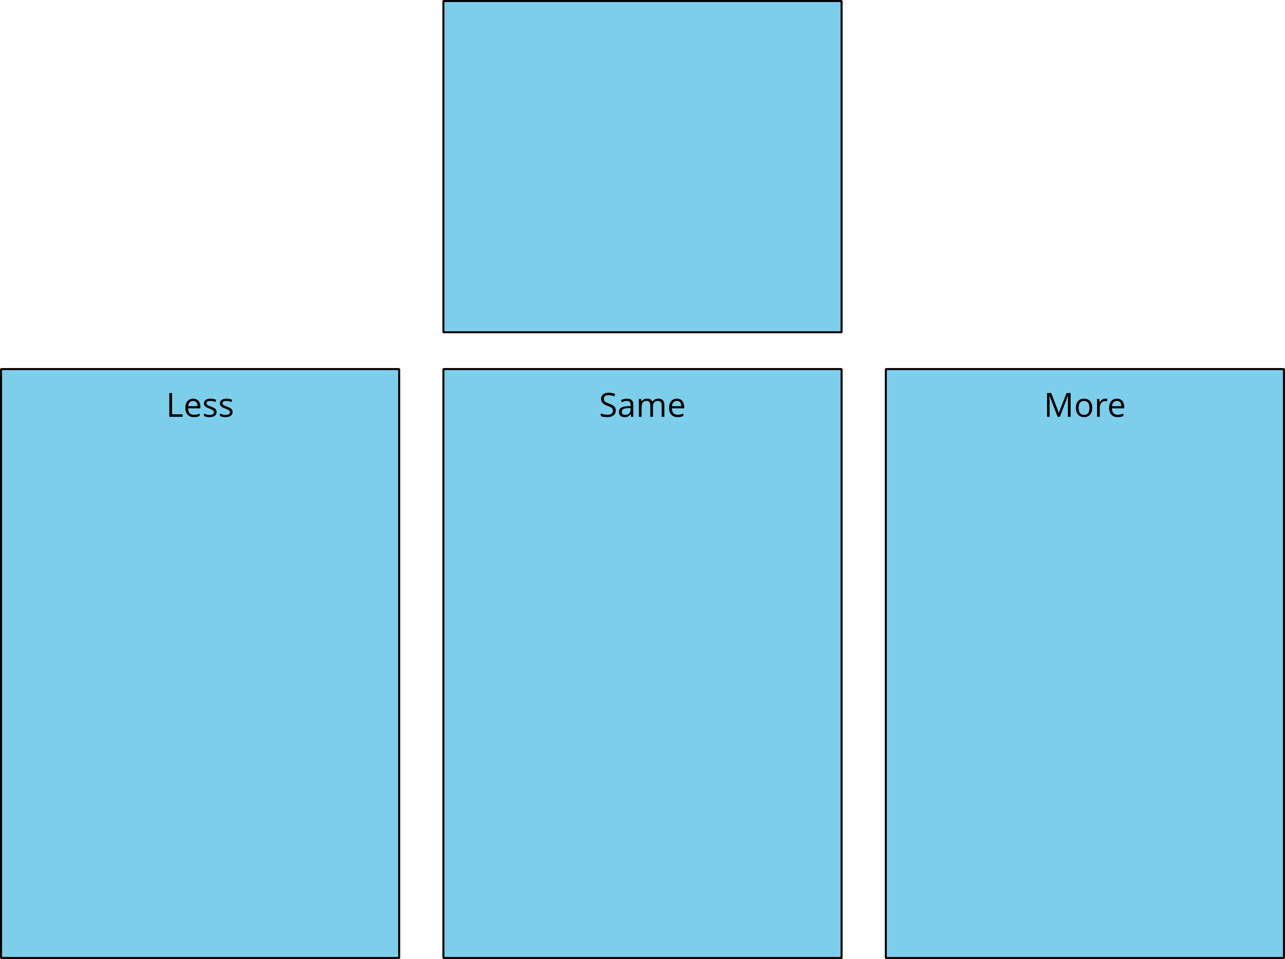
Math Fingers
Tower Build
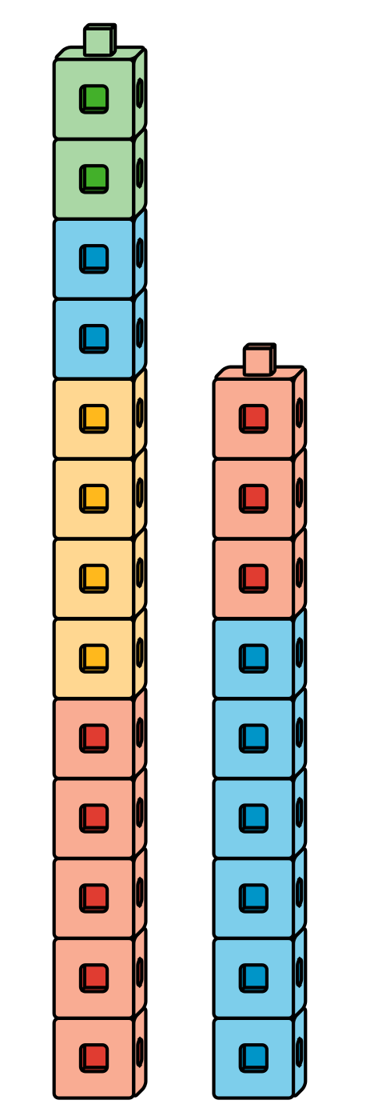
Math Stories
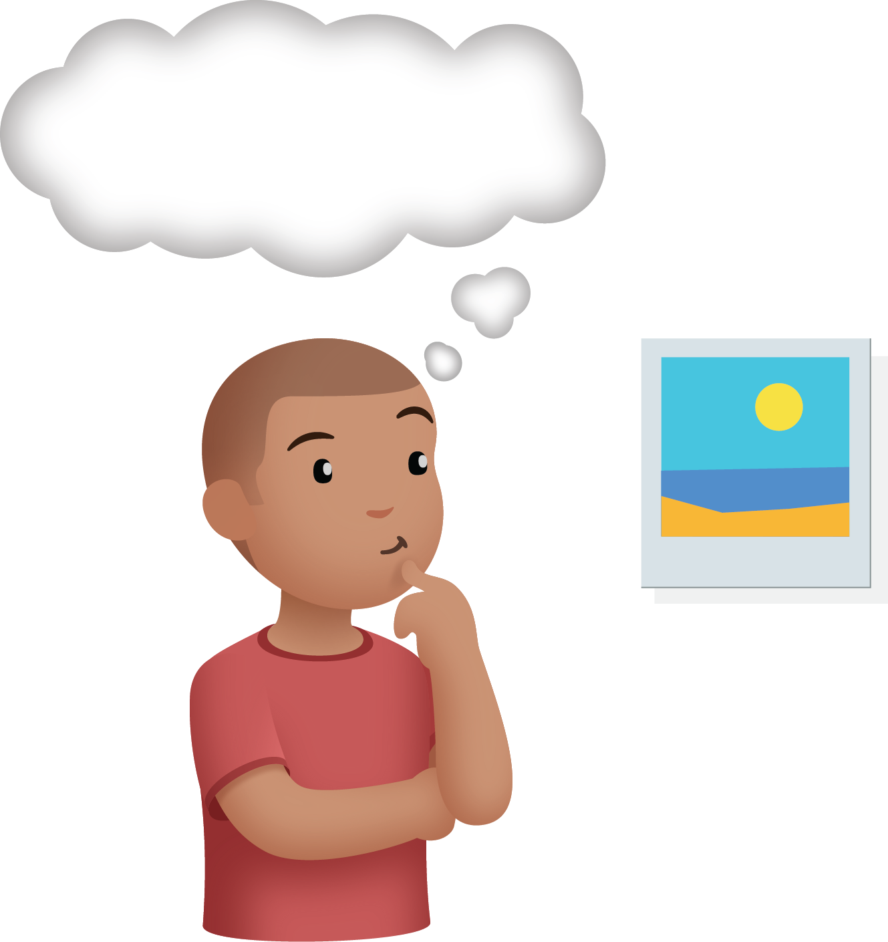
Which One

Images for Activity Synthesis
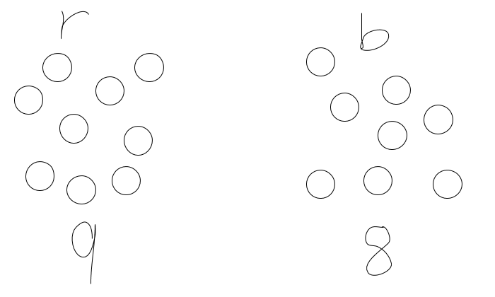
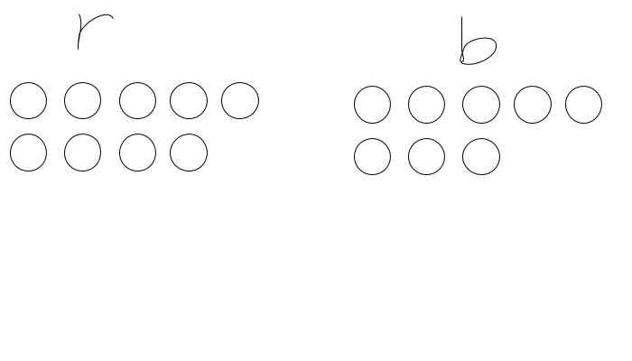
© CC BY 2021 Illustrative Mathematics®

