Lesson 9: The Difference Between Numbers
- Let’s represent ways to subtract on the number line.

Warm-up: Number Talk: Add To
Find the value of each expression mentally.
- $20−2$
- $20−17$
- $49−3$
- $67−64$

9.1: Add or Subtract
- What number makes this equation true?_____
- $38−4=?$
- Represent your thinking on the number line.
- What number makes this equation true?_____
- $75−68=?$
- Represent your thinking on the number line.
- What number makes this equation true?_____
- $57−24=?$
- Represent your thinking on the number line.

9.2: Different Ways to Find the Difference
- Elena had a length of string that was much too long for her project. The string was 65 inches long. Elena cut off 33 inches. How long is the string now?
- Choose 2 number lines that show a way to find the length of Elena’s string.
  - 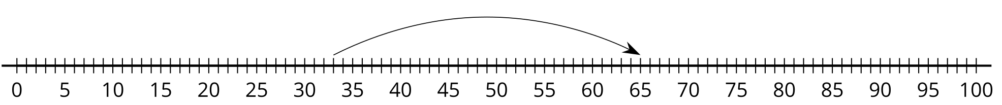
  - 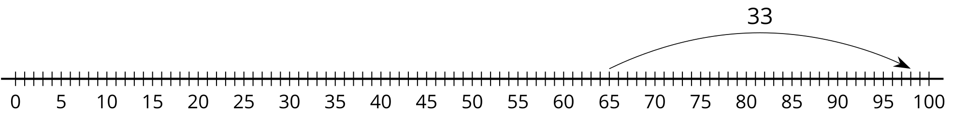
  - 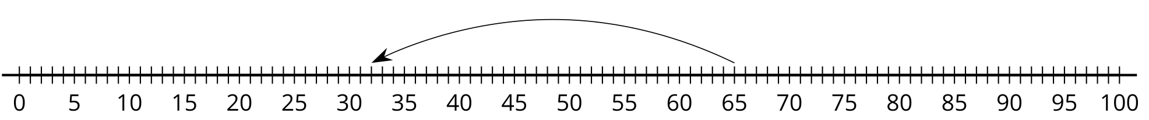
- Han had 87 inches of string. He cut off 85 inches of it. How much string does he have left?
  - Write an equation to represent the problem with a ? for the unknown.
  - Find the number that makes the equation true.
  - Represent your thinking on the number line.
- Find someone who used a different method.
- Show their method on the number line.
© CC BY 2021 Illustrative Mathematics®

