Lesson 11: Make Them the Same
- Let’s make cube towers have the same number of cubes.

Warm-up: Notice and Wonder: Cube Towers
What do you notice?
What do you wonder?
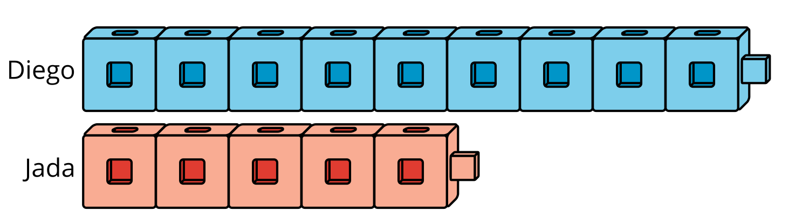

11.1: Cube Towers
How can Diego and Jada make their towers have the same number of cubes?
Show your thinking using drawings, numbers, or words.

- 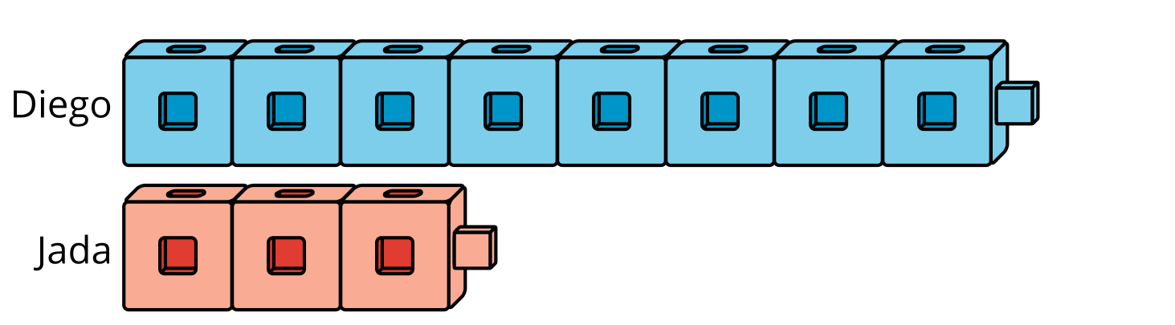

- 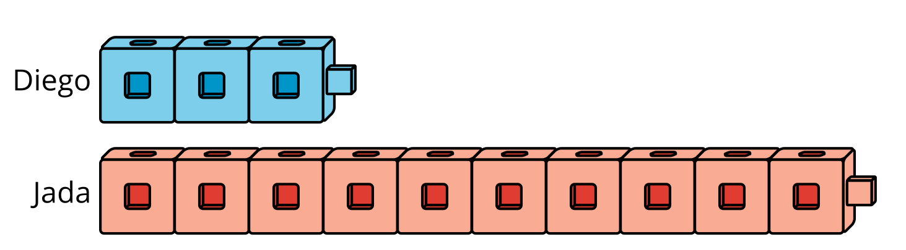

11.2: Cube Tower Problems

- 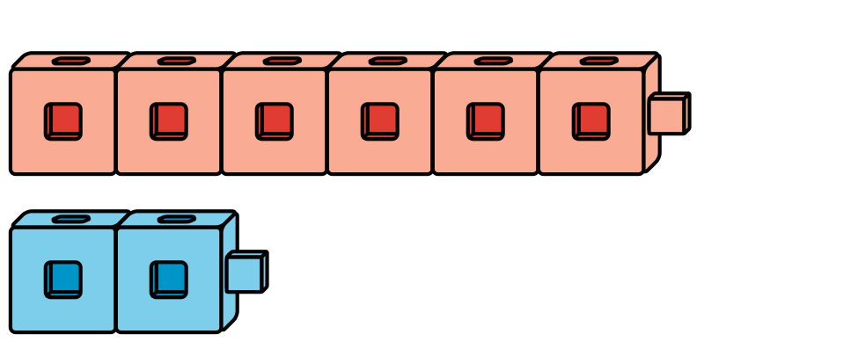
- Lin has only blue cubes.
How can Lin make the towers have the same number of cubes?
Show your thinking using drawings, numbers, or words.

- 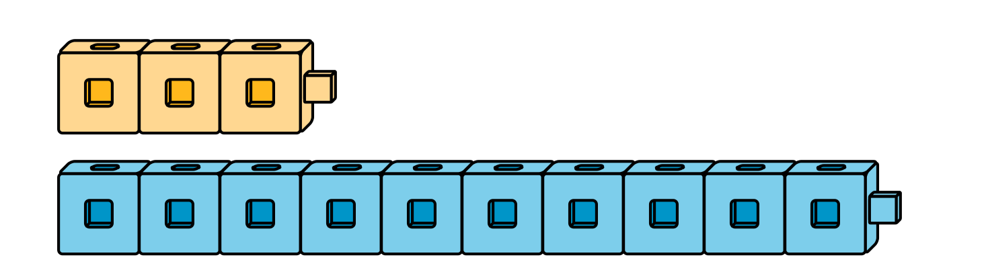
- Lin has no more yellow cubes.
How can she make the towers have the same number of cubes?
Show your thinking using drawings, numbers, or words.
- Lin is making 2 cube towers.
The red tower has 6 cubes.
The blue tower has 9 cubes.
She has no more red cubes.
How can she make the towers have the same number of cubes?
Show your thinking using drawings, numbers, or words.
- Lin is making 2 cube towers.
The yellow tower has 7 cubes.
The red tower has 3 cubes.
She only has red cubes.
How can she make the towers have the same number of cubes?
Show your thinking using drawings, numbers, or words.
If you have time: Write your own problem about 2 cube towers.
Trade problems with a partner and solve.
© CC BY 2021 Illustrative Mathematics®

