Lesson 1: Add and Subtract to Compare
- Let’s solve Compare problems with larger numbers.

Warm-up: Which One Doesn’t Belong: Compare Representations
Which one doesn’t belong?
A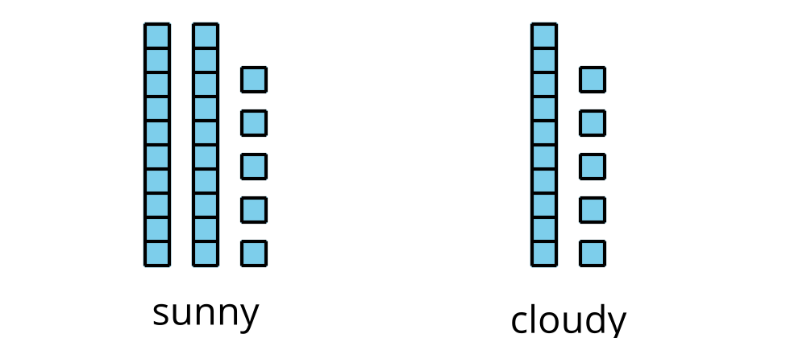
B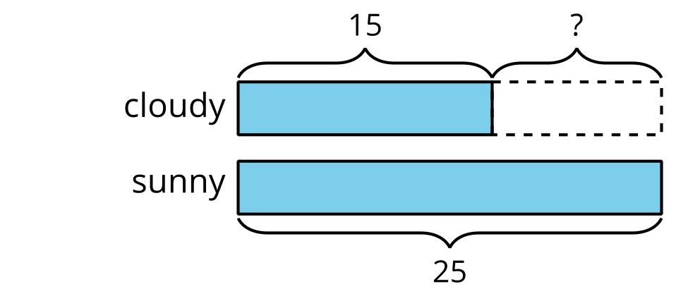
C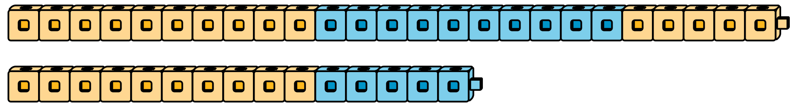
D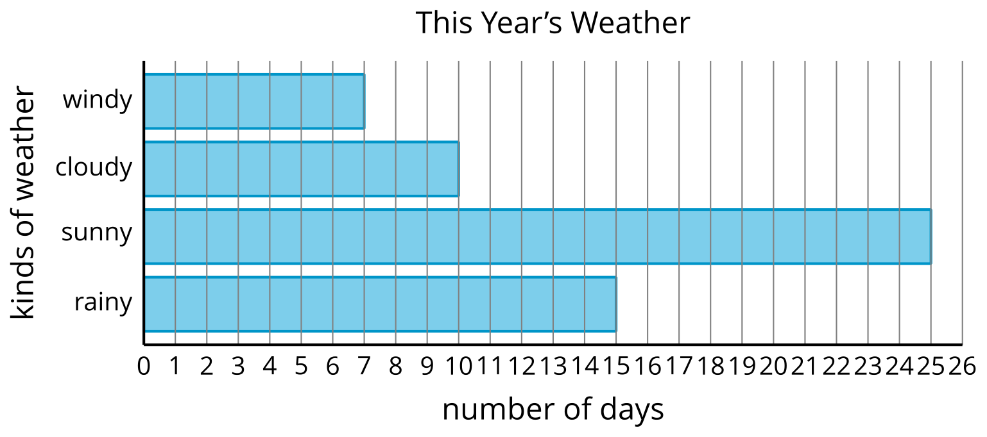

1.1: Movie Snacks
Use the bar graph to answer the questions.
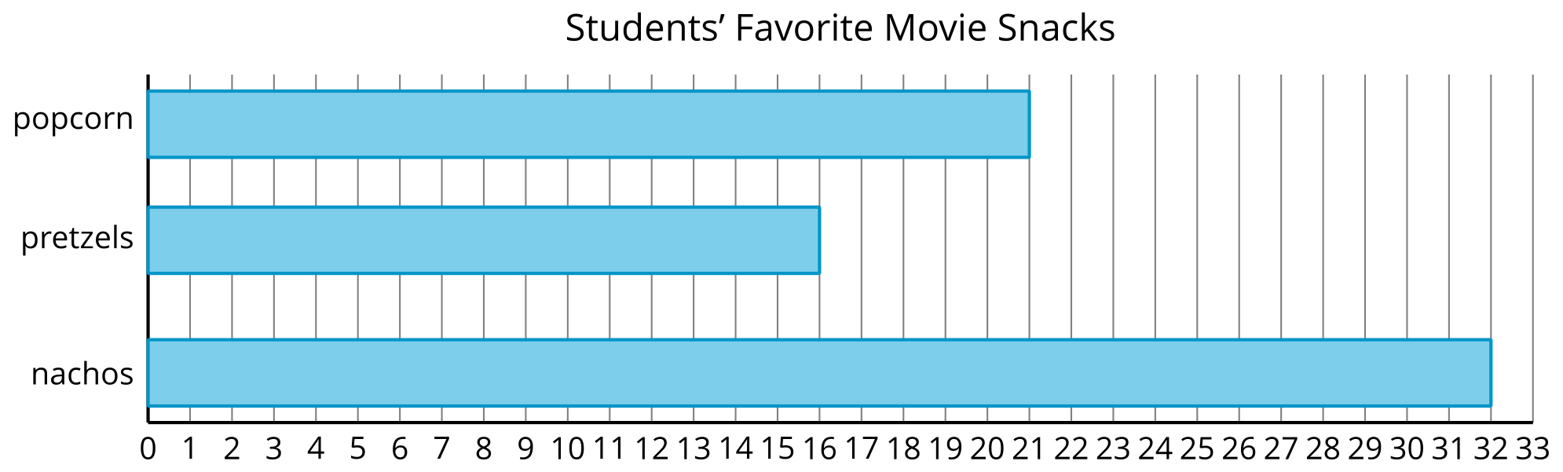
- What is the total number of students that chose popcorn or pretzels? Show your thinking.
- How many more students chose nachos than chose popcorn? Show your thinking.

1.2: Build and Compare
- Lin and Clare used cubes to make trains. What do you notice? What do you wonder?
- Make trains with cubes.
- partner | - number of cubes
- Partner A | - 46
- Partner B | - 22
- Find the total number of cubes you and your partner used. Show your thinking.
- Find the difference between the number of cubes you and your partner used. Show your thinking.
© CC BY 2021 Illustrative Mathematics®

