Unit 7 Lesson 5: Center Day 1

WU How Many Do You See: Hundreds, Tens, and Ones (Warm up)

Student Task Statement
How many do you see? How do you see them?
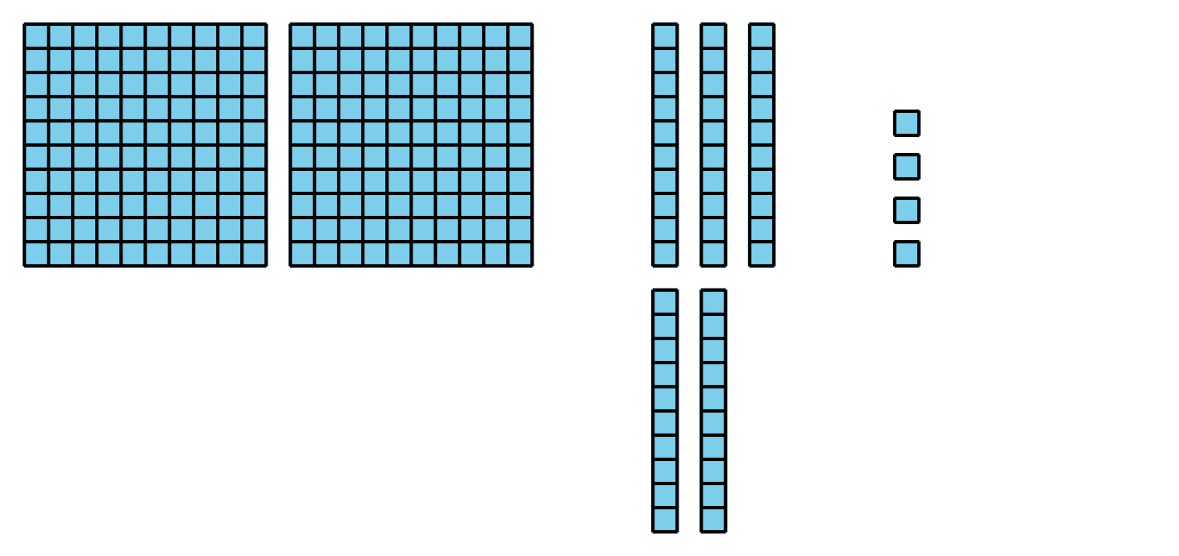
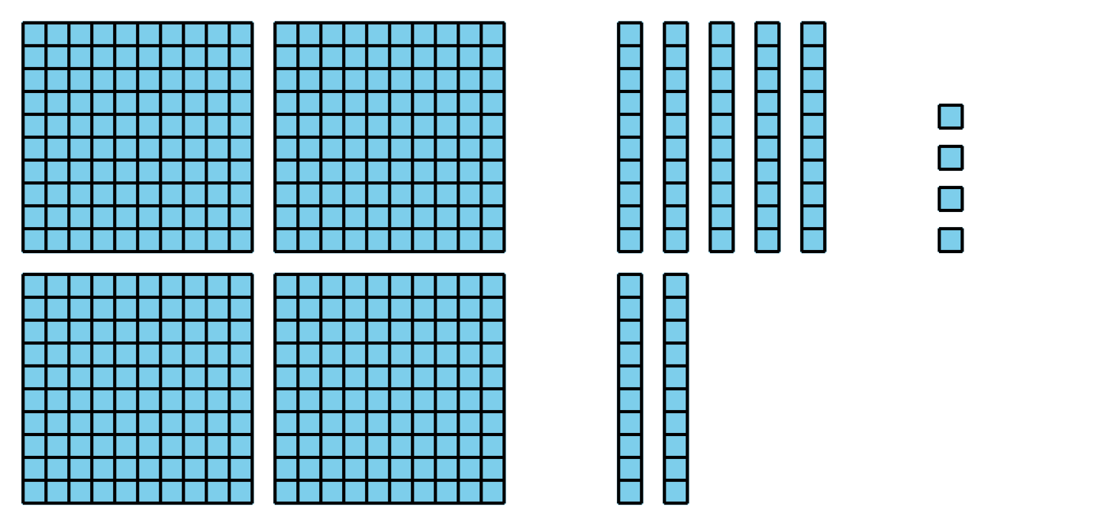
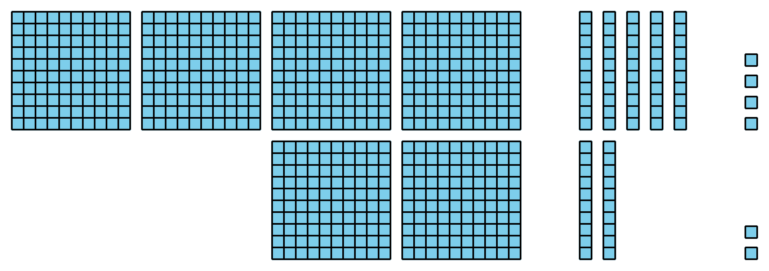

1 Introduce Five in a Row, Add within 1,000 without Composing

Student Task Statement

2 Centers: Choice Time

Student Task Statement
Choose a center.
Five in a Row: Addition and Subtraction
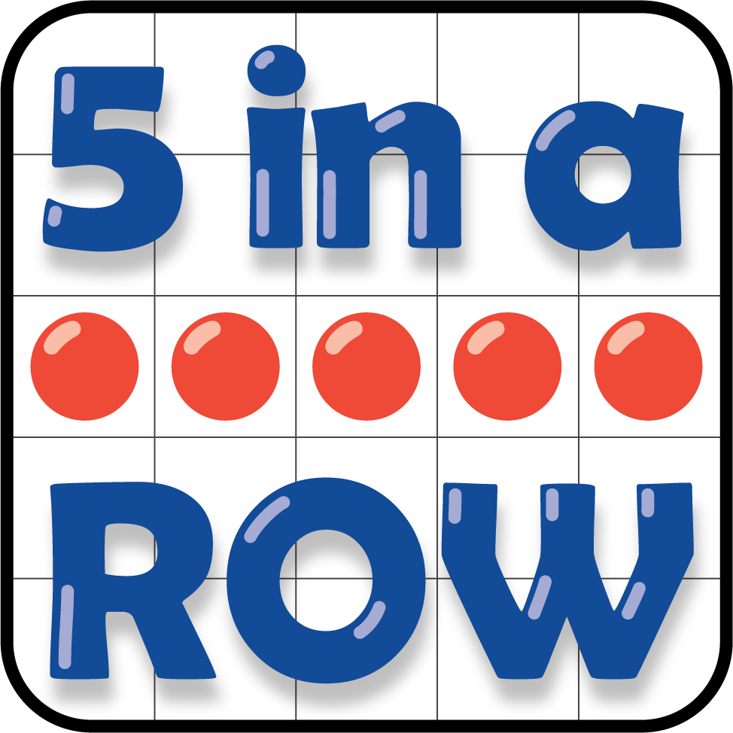
Get Your Numbers in Order
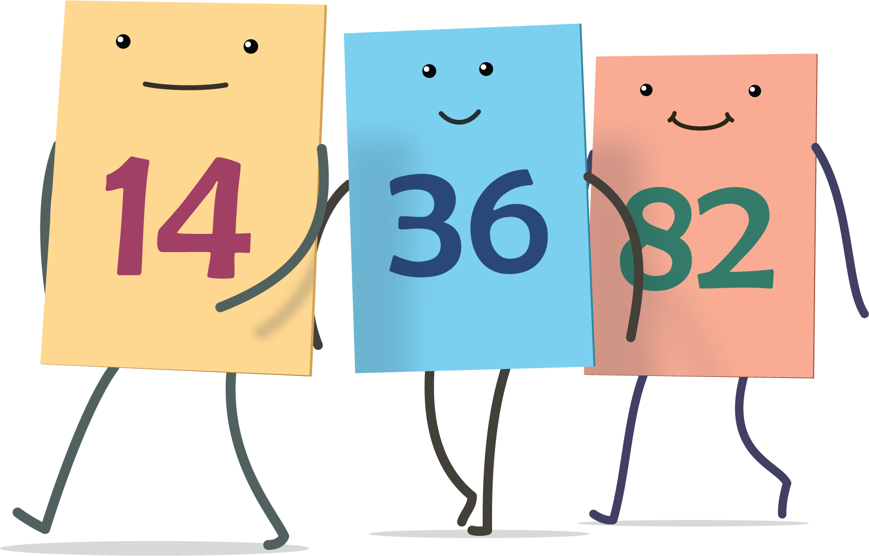
Mystery Number
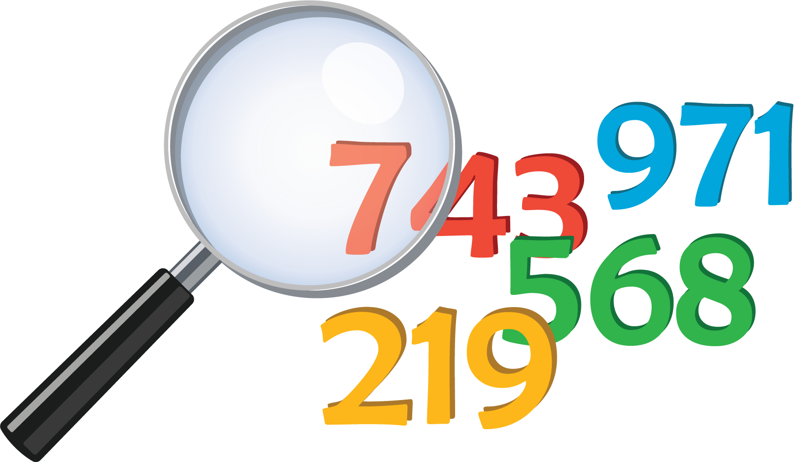
The Greatest of them All
© CC BY 2021 Illustrative Mathematics®

