Unit 8 Lesson 3: Interpreting Histograms

1 Dog Show (Part 1) (Warm up)

Student Task Statement
Here is a dot plot showing the weights, in pounds, of 40 dogs at a dog show.
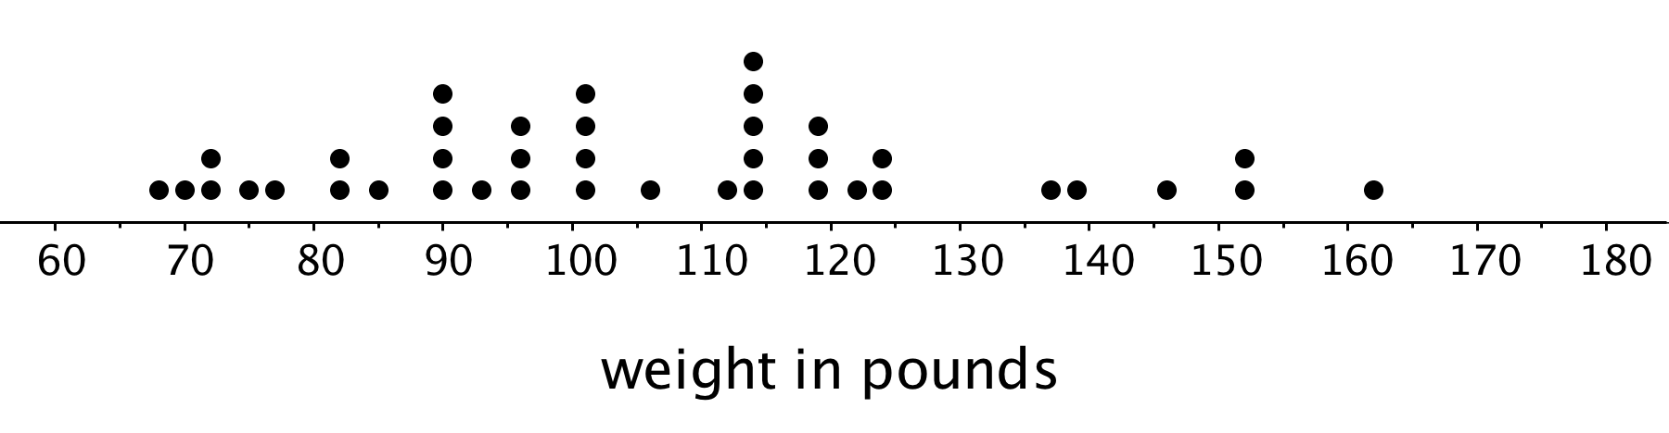
- Write two statistical questions that can be answered using the dot plot.
- What would you consider a typical weight for a dog at this dog show? Explain your reasoning.

2 Dog Show (Part 2)

Student Task Statement
Here is a histogram that shows some dog weights in pounds.
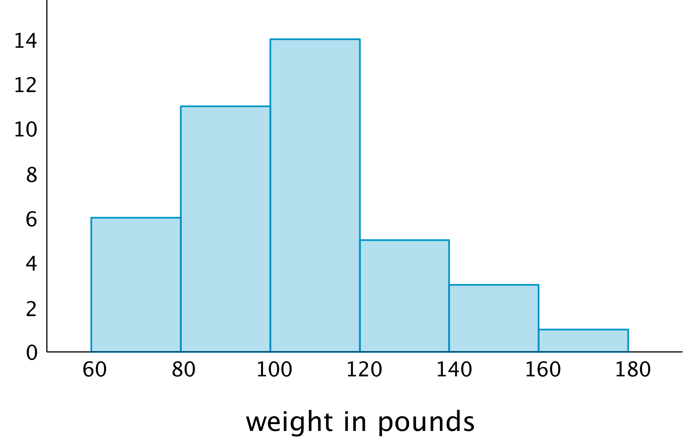
Each bar includes the left-end value but not the right-end value. For example, the first bar includes dogs that weigh 60 pounds and 68 pounds but not 80 pounds.
- Use the histogram to answer the following questions.
  - How many dogs weigh at least 100 pounds?
  - How many dogs weigh exactly 70 pounds?
  - How many dogs weigh at least 120 and less than 160 pounds?
  - How much does the heaviest dog at the show weigh?
  - What would you consider a typical weight for a dog at this dog show? Explain your reasoning.
- Discuss with a partner:
  - If you used the dot plot to answer the same five questions you just answered, how would your answers be different?
  - How are the histogram and the dot plot alike? How are they different?

3 Tall and Taller Players

Student Task Statement
Professional basketball players tend to be taller than professional baseball players.
Here are two histograms that show height distributions of 50 male professional baseball players and 50 male professional basketball players.
- Decide which histogram shows the heights of baseball players and which shows the heights of basketball players. Be prepared to explain your reasoning.
- 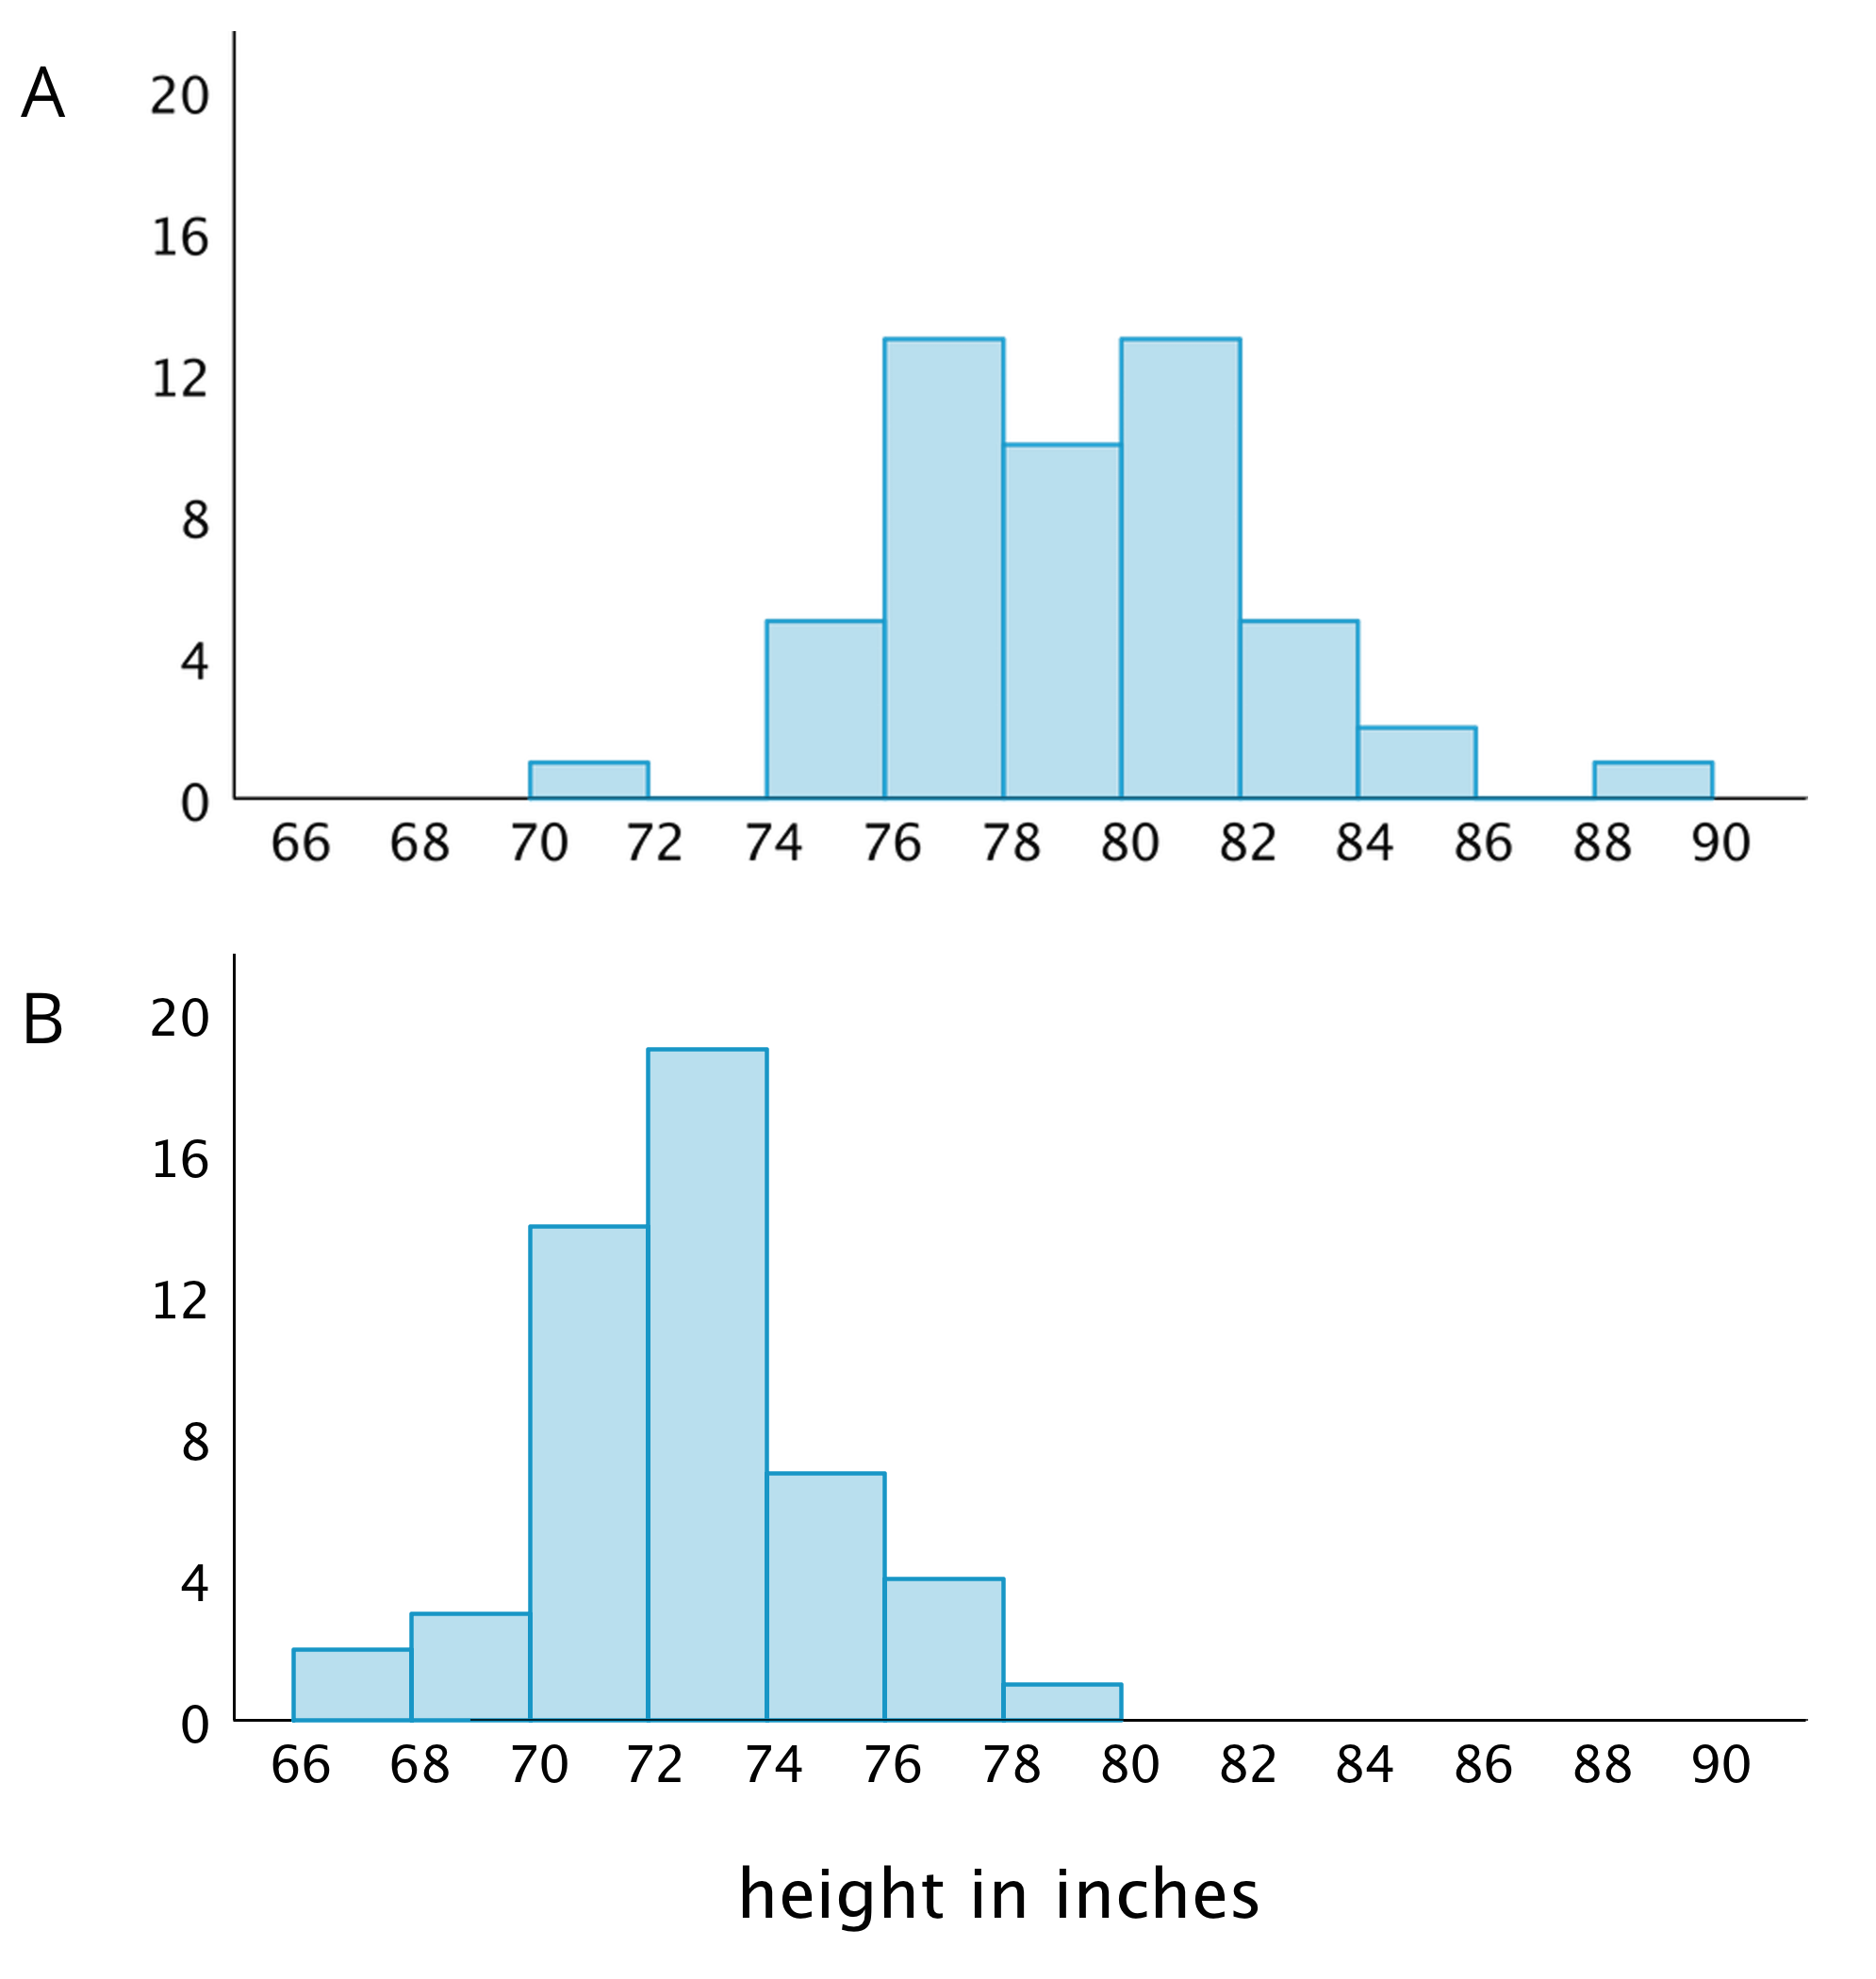
- Write 2–3 sentences that describe the distribution of the heights of the basketball players. Comment on the center and spread of the data.
- Write 2–3 sentences that describe the distribution of the heights of the baseball players. Comment on the center and spread of the data.

Images for Activity Synthesis
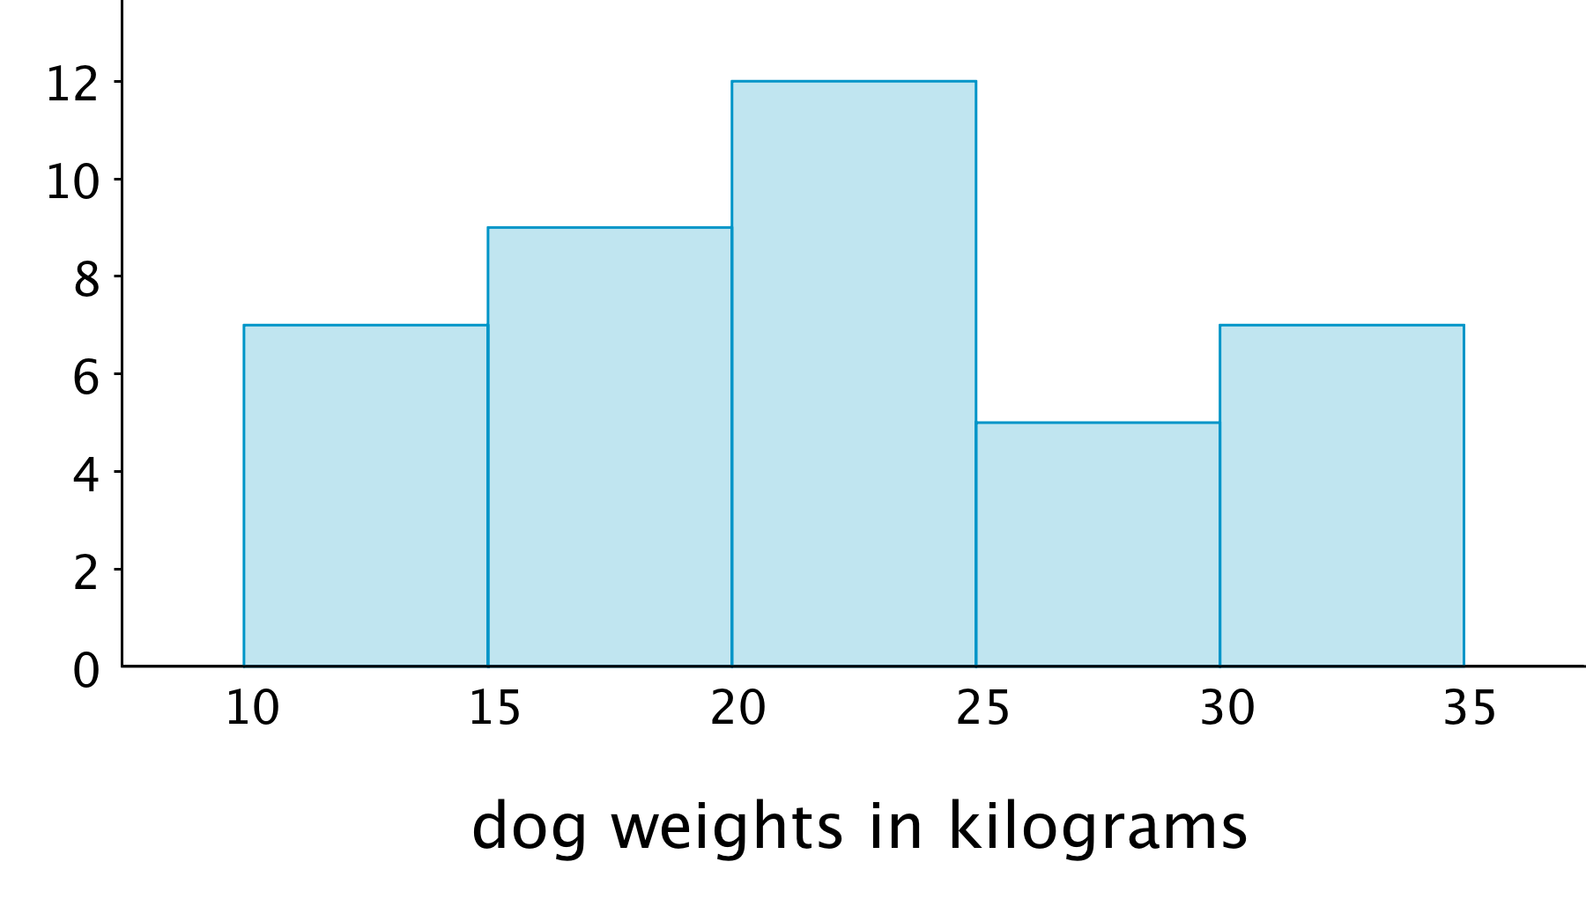
© CC BY Open Up Resources. Adaptations CC BY IM.

