Lesson 9: Usemos un transportador para medir ángulos

Standards Alignments
Addressing | 4.MD.C.5.a, 4.MD.C.5.b, 4.MD.C.6, 4.MD.C.7, 4.NBT.B.5

Teacher-facing Learning Goals
- Recognize that 1 degree is a measurement of a $\frac{1}{360}$ turn through a full circle.
- Use tools to measure angles.

Student-facing Learning Goals
- Usemos algunas herramientas para medir ángulos.

Lesson Purpose
The purpose of this lesson is for students to understand $1^{∘}$ as a measurement of a turn through $\frac{1}{360}$ of a circle and to use a protractor to measure angles.
Before this lesson, students have compared and measured angles using informal tools (analog clocks) and reference angles, all of which were multiples of $5^{∘}$ or multiples of ${10}^{∘}$. In this lesson, students transition to measuring angles in units of $1^{∘}$.
Students then make sense of one-degree angles in terms of a fraction of a ${360}^{∘}$ turn and are introduced to the protractor as a tool of measurement. They make sense of the numbers on the tool and how $1^{∘}$ angles are shown. They learn to read the measurement of angles whose vertices have been pre-aligned to the center point of a protractor.
Students will continue to add new vocabulary to their personal word walls. In the next lesson, students will further develop their ability to use a protractor by measuring a variety of angles with less support.

Access for:

Students with Disabilities
- Action and Expression (Activity 2)

English Learners
- MLR2 (Activity 1)

Instructional Routines
MLR1 Stronger and Clearer Each Time (Activity 2), True or False (Warm-up)

Materials to Gather
- Protractors: Activity 1

Lesson Timeline
Warm-up | 10 min
Activity 1 | 15 min
Activity 2 | 20 min
Lesson Synthesis | 10 min
Cool-down | 5 min

Teacher Reflection Question
The first two activities offered opportunities for students to take multiple solution paths. Were all unique perspectives or strategies heard? Which students were able to share their ideas? Which didn’t get a chance? How can their voices be added into the conversation tomorrow?

Cool-down
(to be completed at the end of the lesson) 5min
Mide los ángulos

Standards Alignments
Addressing | 4.MD.C.5.b, 4.MD.C.6, 4.MD.C.7

Student-facing Task Statement
- Un ángulo se compone de diecisiete ángulos de $1^{∘}$. ¿Cuántos grados mide el ángulo?
- ¿Cuál es la medida de cada ángulo?

  - 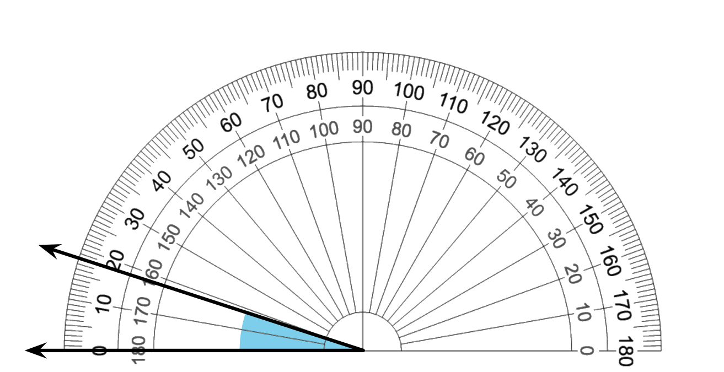

  - 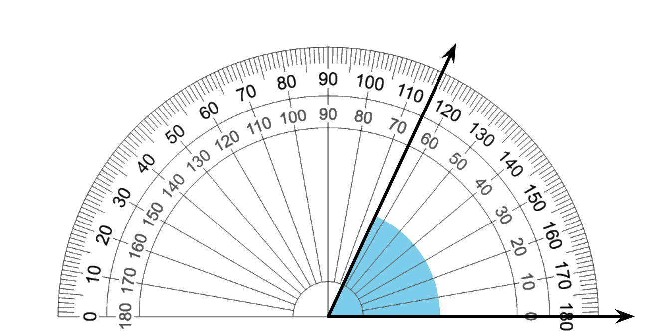

Student Responses
- ${17}^{∘}$

  - ${18}^{∘}$
  - ${65}^{∘}$

