Unit 8 Lesson 13: Dominoes to 5

Notice and Wonder: Ways to Make 4 (Warm up)

Student Task Statement
What do you notice?
What do you wonder?

1 Domino Sort

Student Task Statement
Sort the dominoes based on the total number of dots.
Choose 1 group.
Write an expression for each domino.
___________________________
___________________________
___________________________
___________________________
___________________________
___________________________

Activity Synthesis
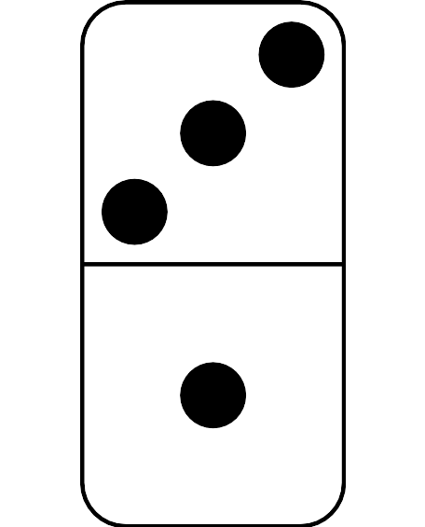

2 Compare Dots on Dominoes

Images for Launch
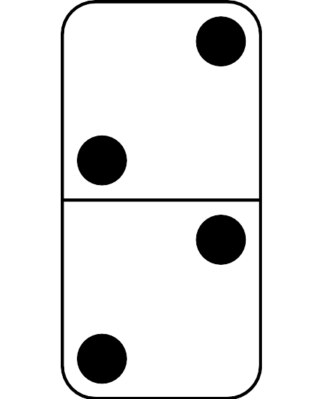
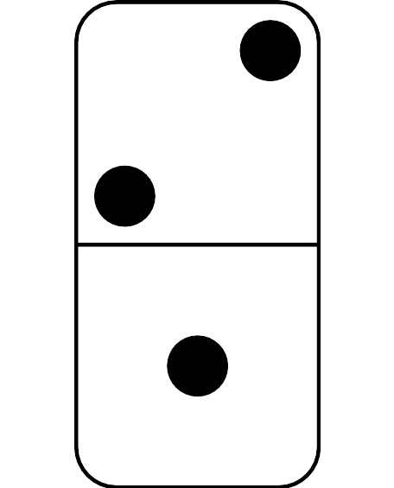

Student Task Statement
Flip over a card.
Compare the number of dots using “fewer” or “the same number.”
Compare the number of dots using “more” or “the same number.”

3 Centers: Choice Time

Student Task Statement
Choose a center.
5-frames
Roll and Add
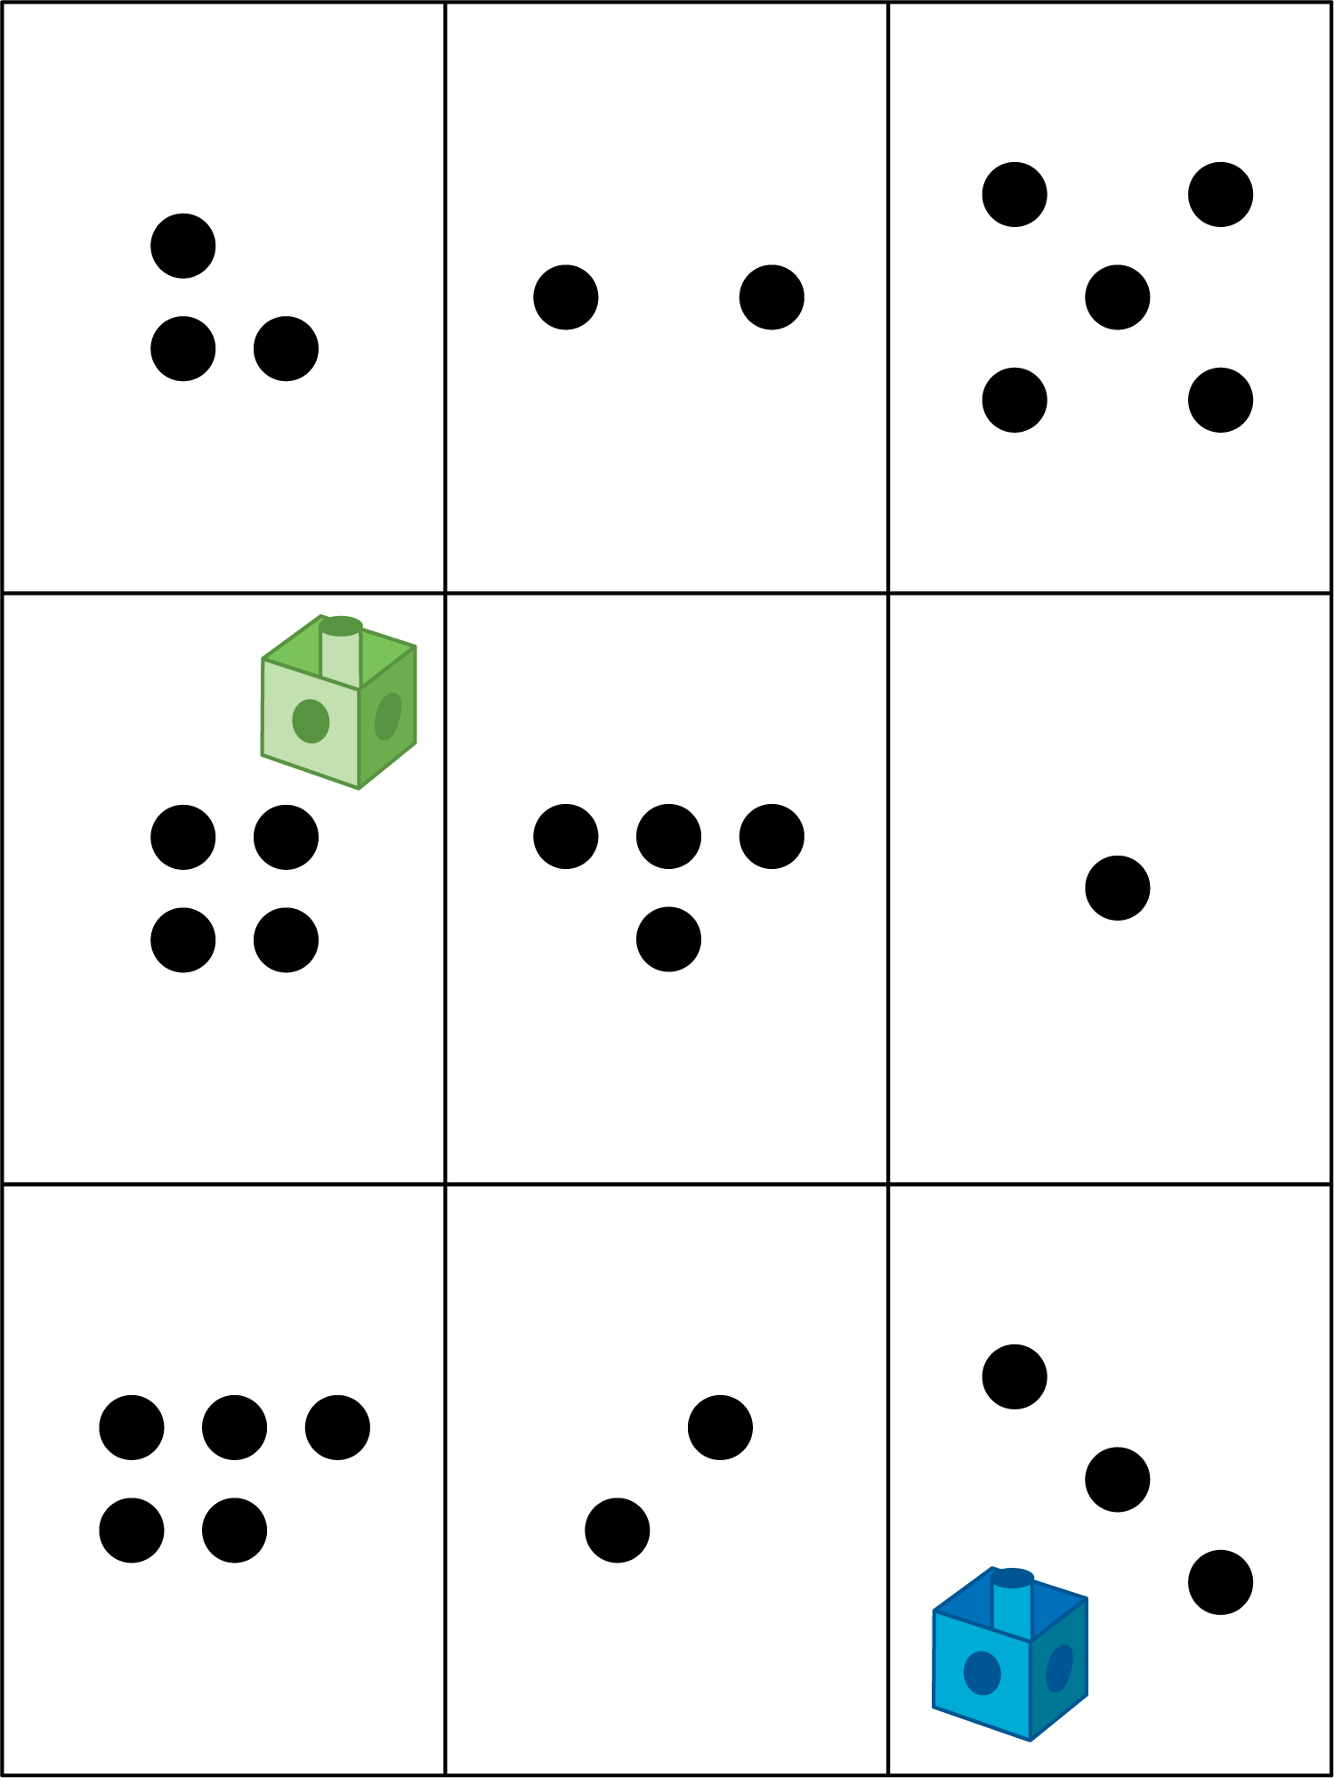
Bingo
Geoblocks
Find the Value of Expressions

Images for Activity Synthesis
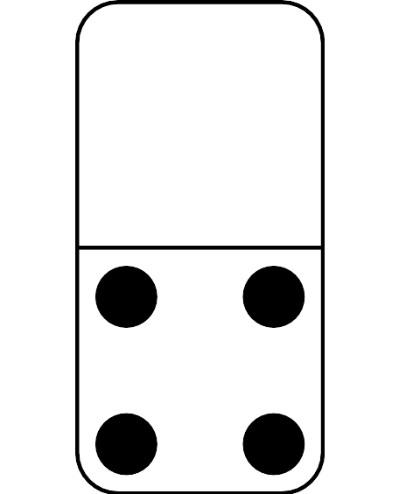
© CC BY 2021 Illustrative Mathematics®

