Unit 2 Lesson 2: Circular Grid

1 Notice and Wonder: Concentric Circles (Warm up)

Student Task Statement
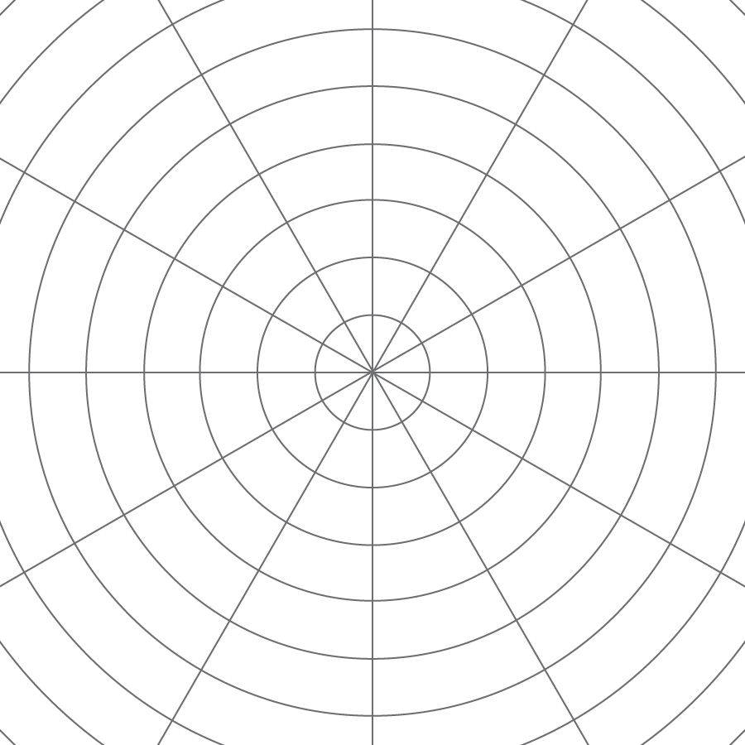
What do you notice? What do you wonder?

2 A Droplet on the Surface

Student Task Statement
The larger Circle d is a dilation of the smaller Circle c. $P$ is the center of dilation.
- Draw four points on the smaller circle (not inside the circle!), and label them $E$, $F$, $G$, and $H$.
- Draw the rays from $P$ through each of those four points.
- Label the points where the rays meet the larger circle $E^{′}$, $F^{′}$, $G^{′}$, and $H^{′}$.
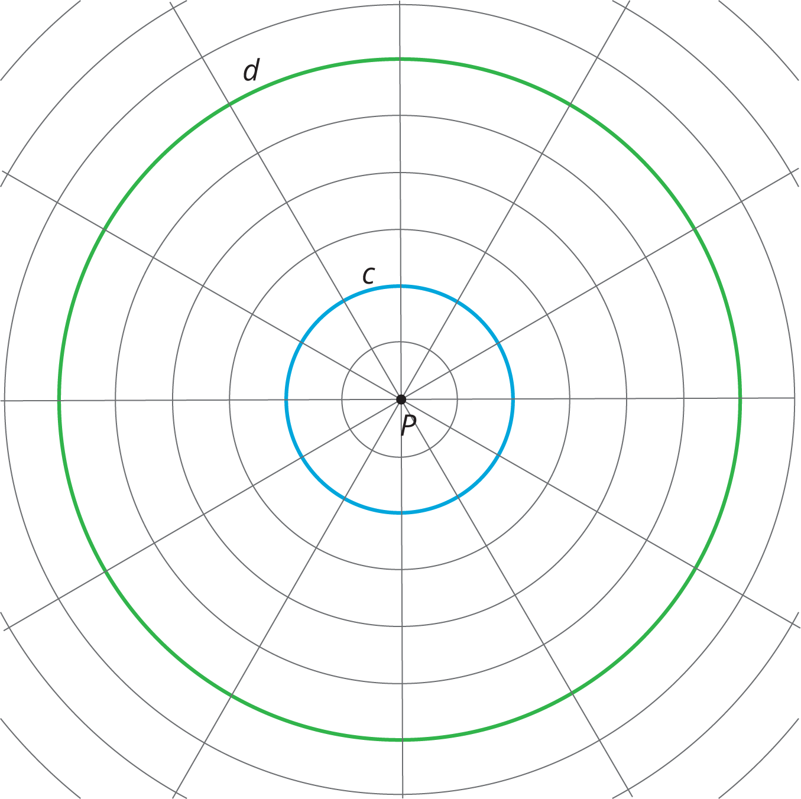
4. Complete the table. In the row labeled c, write the distance between $P$ and the point on the smaller circle in grid units. In the row labeled d, write the distance between $P$ and the corresponding point on the larger circle in grid units.
 | $E$ | $F$ | $G$ | $H$
c
d
5. The center of dilation is point $P$. What is the scale factor that takes the smaller circle to the larger circle? Explain your reasoning.

3 Quadrilateral on a Circular Grid

Images for Launch
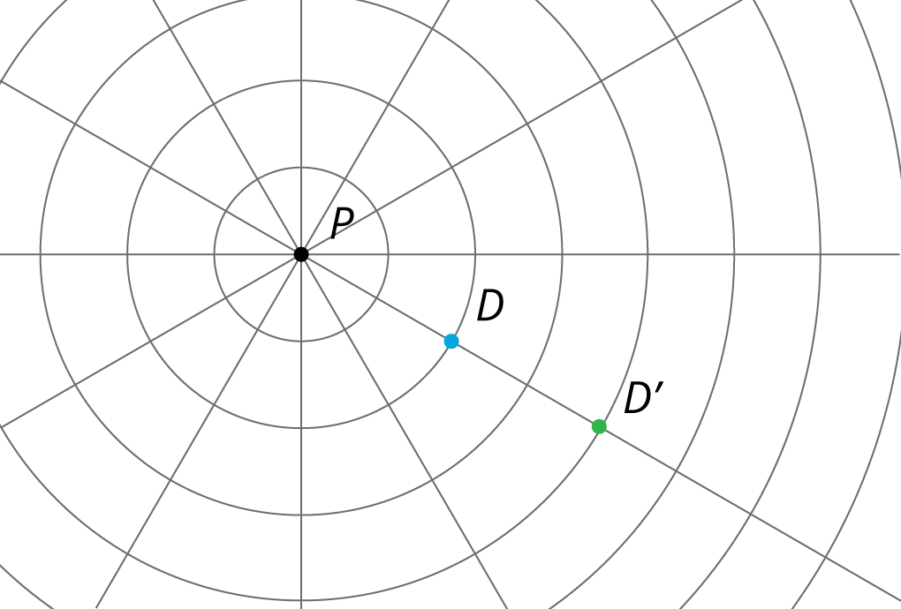

Student Task Statement
Here is a polygon $ABCD$.
- Dilate each vertex of polygon $ABCD$ using $P$ as the center of dilation and a scale factor of 2. Label the image of $A$ as $A^{′}$, and label the images of the remaining three vertices as $B^{′}$, $C^{′}$, and $D^{′}$.
- Draw segments between the dilated points to create polygon $A^{′}B^{′}C^{′}D^{′}$.
- What are some things you notice about the new polygon?
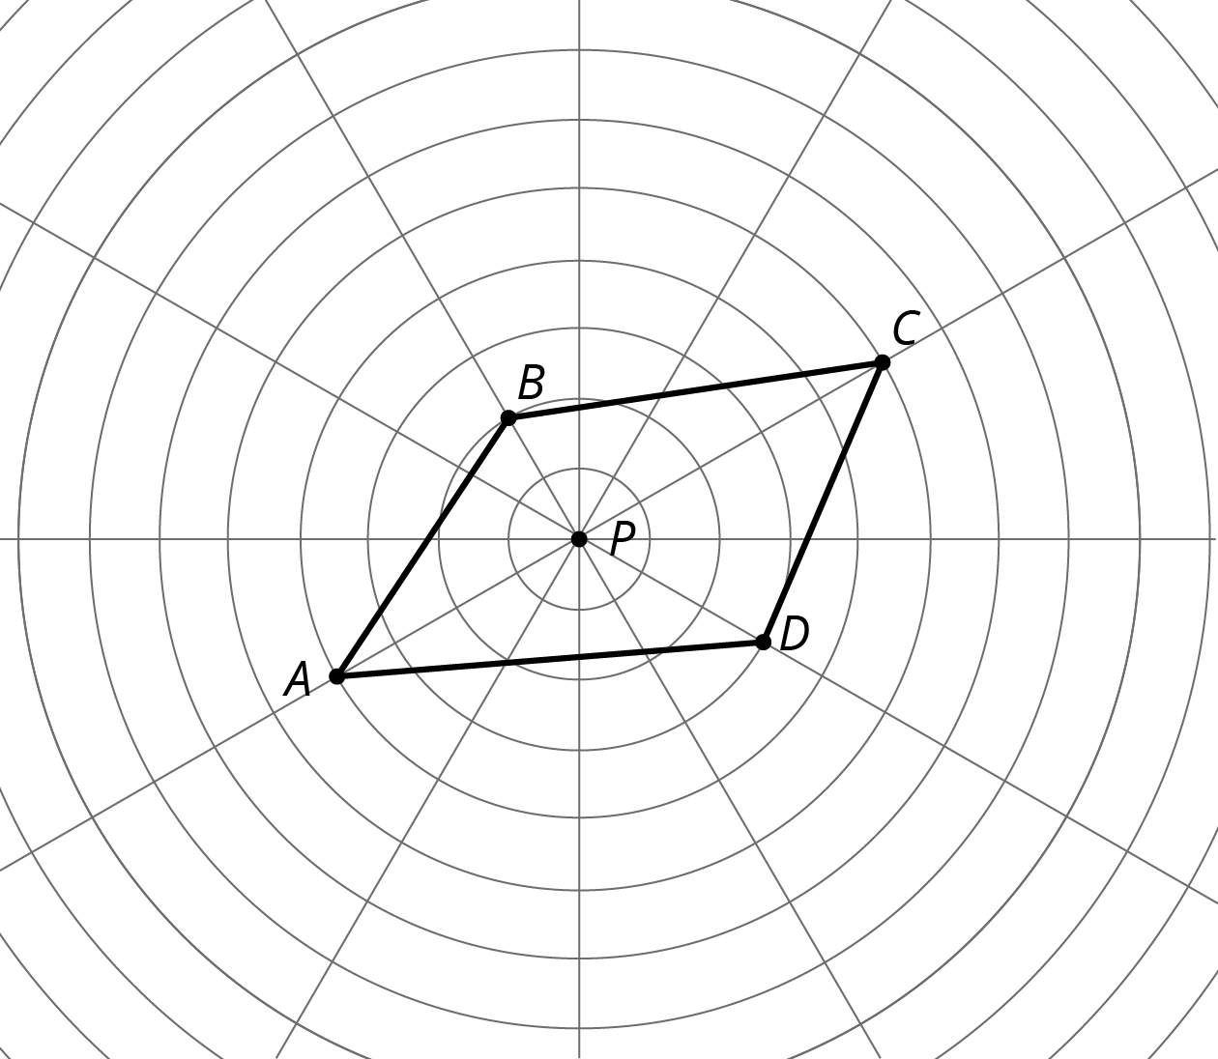
4. Choose a few more points on the sides of the original polygon and transform them using the same dilation. What do you notice?
5. Dilate each vertex of polygon $ABCD$ using $P$ as the center of dilation and a scale factor of $\frac{1}{2}$. Label the image of $A$ as $E$, the image of $B$ as $F$, the image of $C$ as $G$ and the image of $D$ as $H$.
6. What do you notice about polygon $EFGH$?

Activity Synthesis
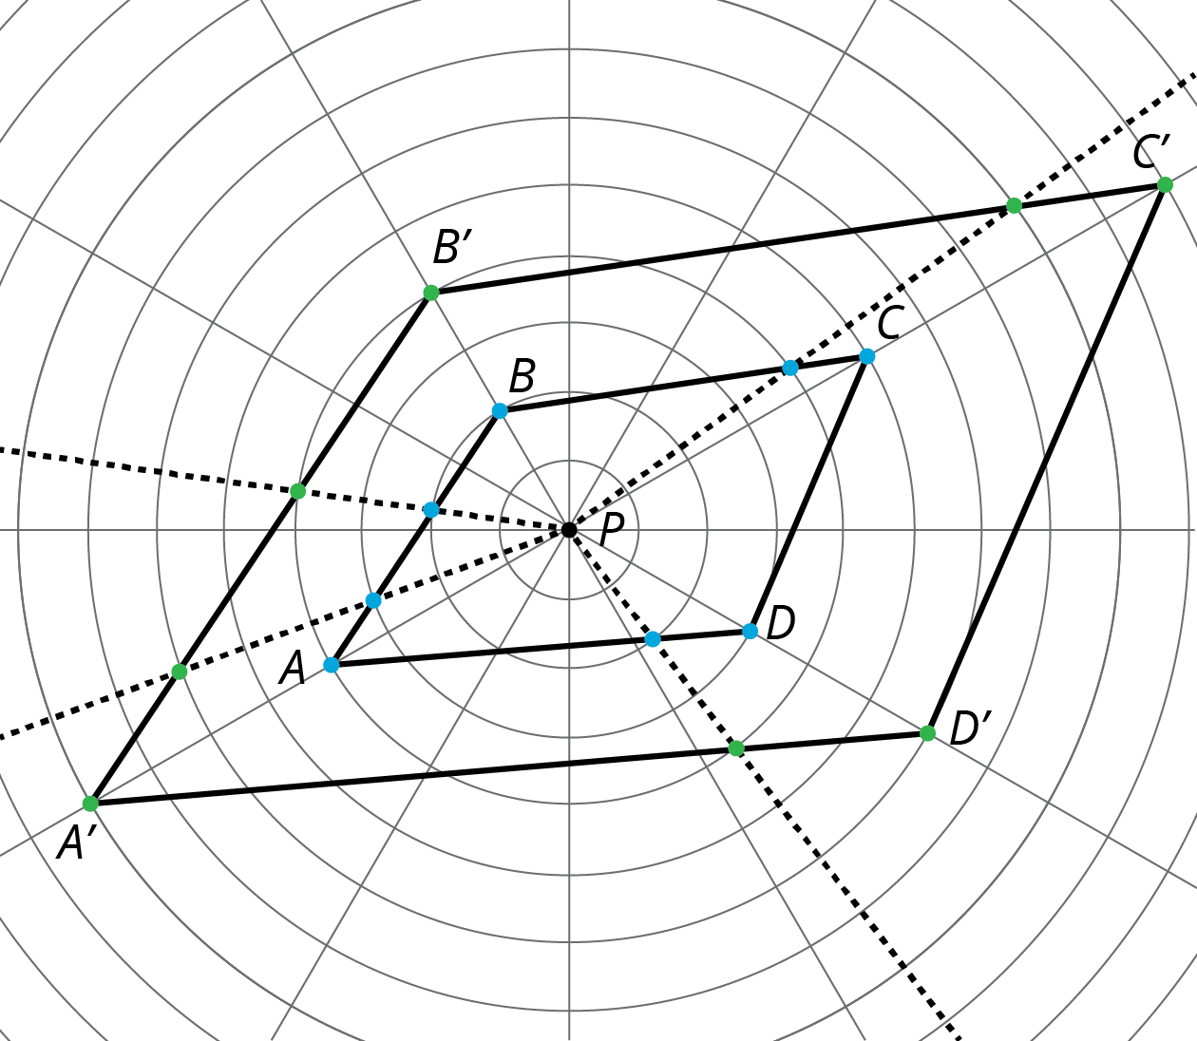

4 A Quadrilateral and Concentric Circles (Optional)

Student Task Statement
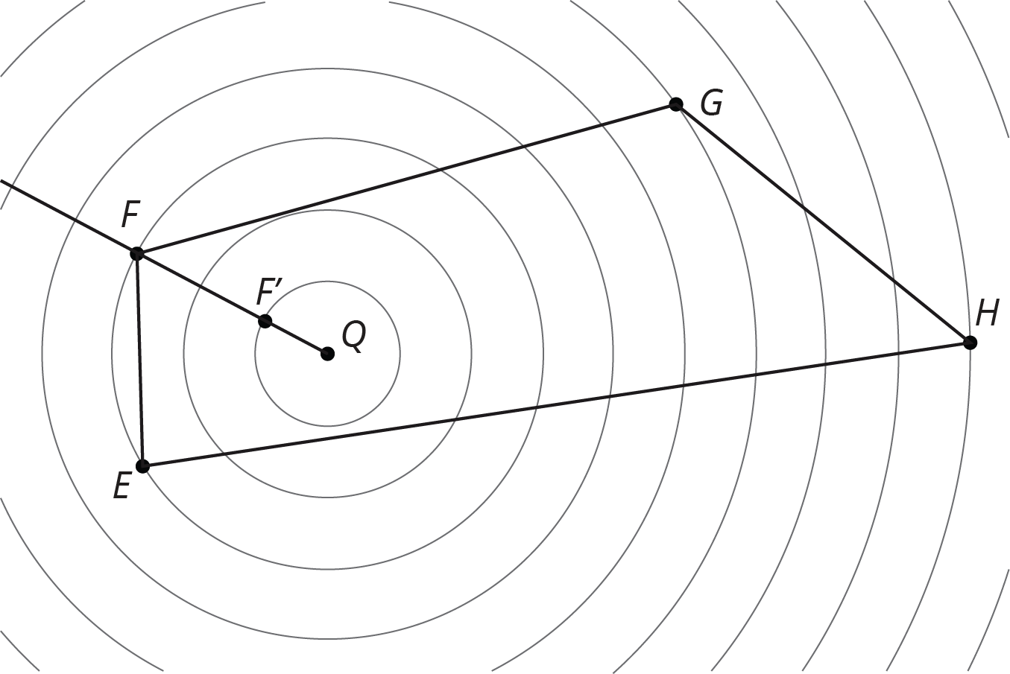
Dilate polygon $EFGH$ using $Q$ as the center of dilation and a scale factor of $\frac{1}{3}$. The image of $F$ is already shown on the diagram. (You may need to draw more rays from $Q$ in order to find the images of other points.)

Images for Activity Synthesis
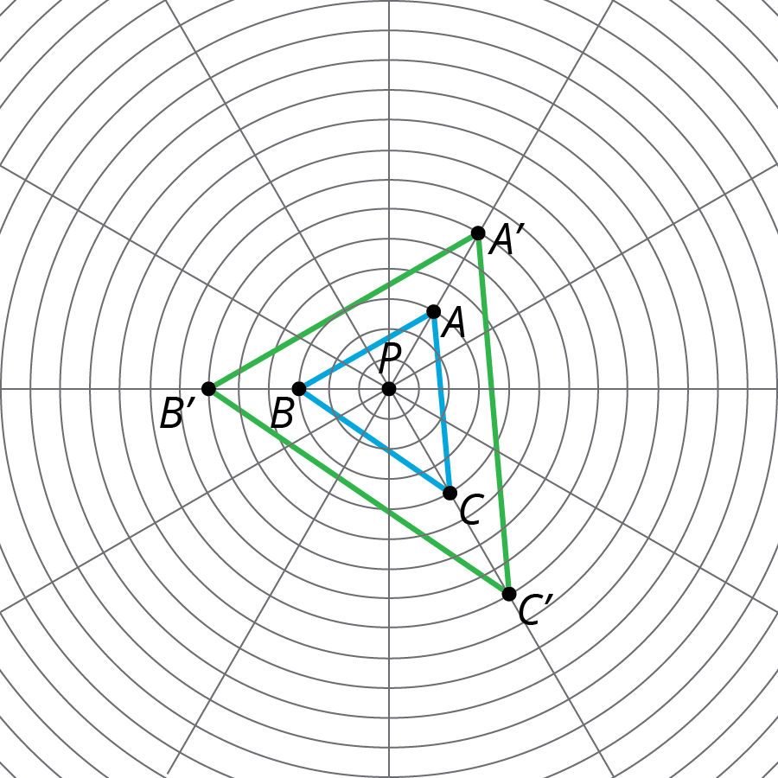
© CC BY Open Up Resources. Adaptations CC BY IM.

