Lesson 9: Relate Area to Multiplication
- Let’s explore the area of rectangles with one side length that is a unit fraction.

Warm-up: Which One Doesn’t Belong: Area
Which one doesn’t belong?
A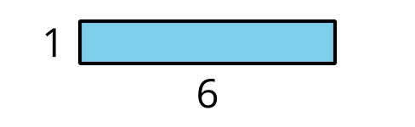
B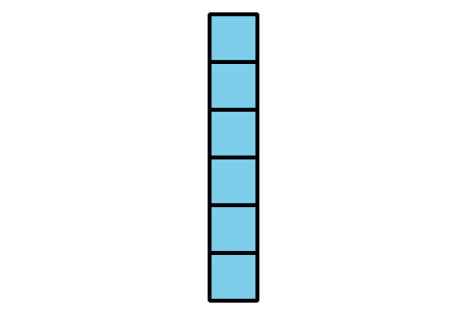
C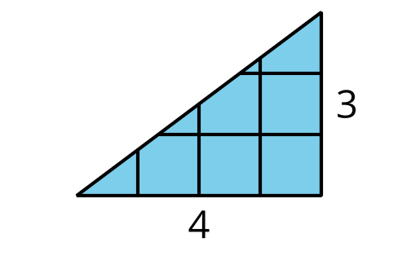
D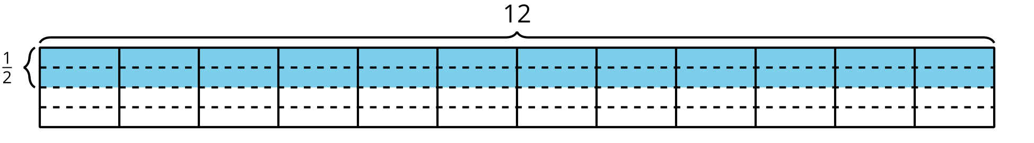

9.1: Find the Area
Find the area of the shaded region. Explain or show your reasoning.

- 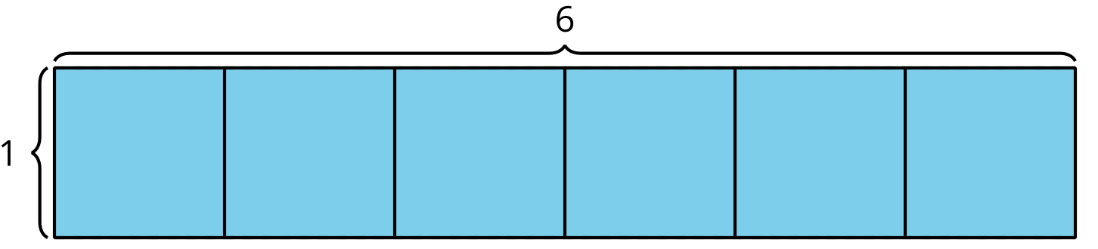

- 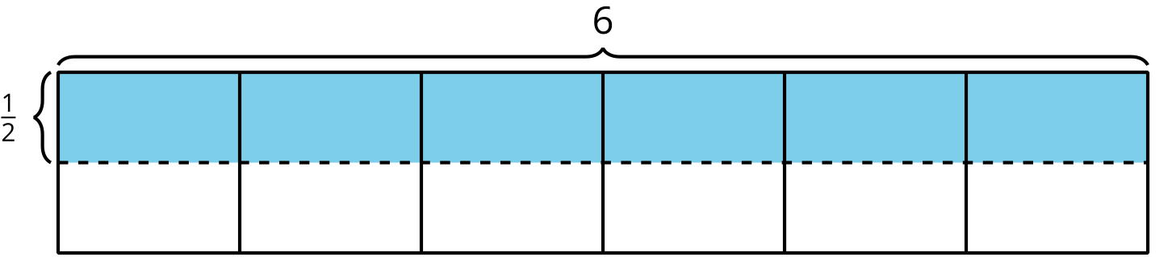

- 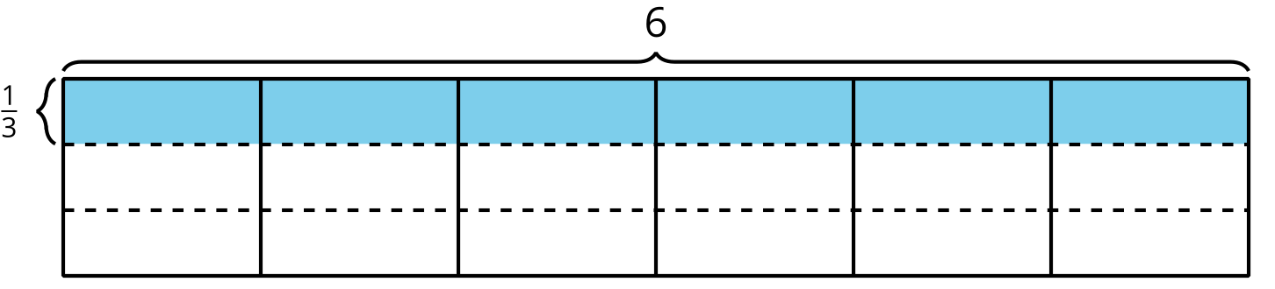

- 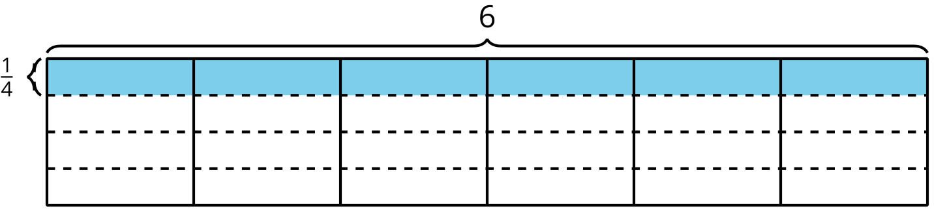

9.2: Draw Rectangles
- Represent each rectangle on grid paper:
  - $\frac{1}{2}$ unit by 1 unit
  - $\frac{1}{2}$ unit by 2 units
  - $\frac{1}{2}$ unit by 3 units
  - $\frac{1}{2}$ unit by 4 units
- Find the area of each rectangle that you drew.
- What information do you need to find the area of the shaded region?
- What might the area of the shaded region be? Explain or show your reasoning.
© CC BY 2021 Illustrative Mathematics®

