Unit 8 Lesson 2: Count and Compare Collections

WU How Many Do You See: 10 and Some More (Warm up)

Student Task Statement
How many do you see?
How do you see them?
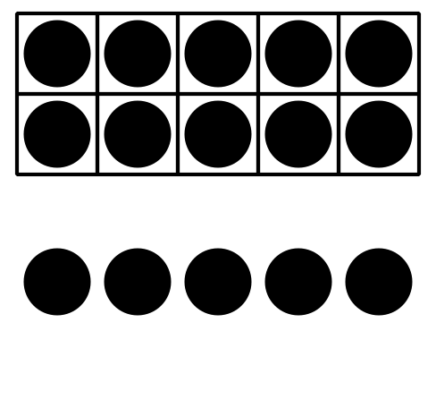
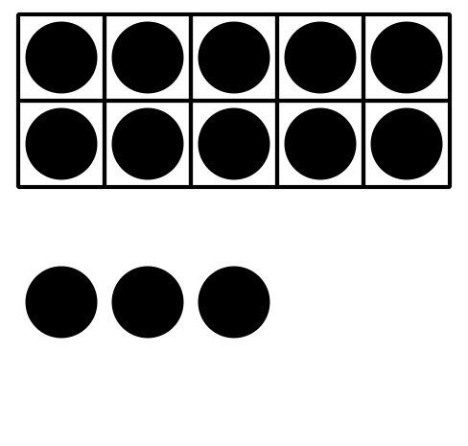
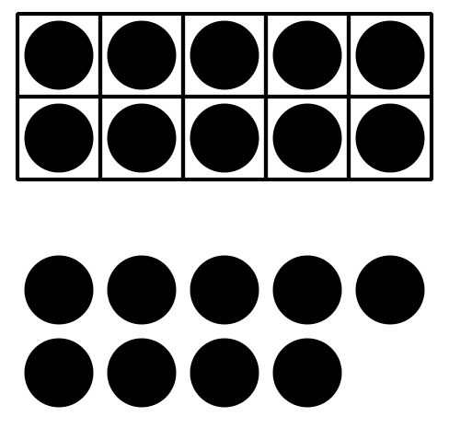

1 Counting Collections

Student Task Statement
How many objects are in your collection?
Show your thinking using drawings, numbers, or words.
_______________

2 Comparing Collections

Student Task Statement
How many objects are in your collection?
Show your thinking using drawings, numbers, or words.
_______________

3 Centers: Choice Time

Student Task Statement
Choose a center.
Less, Same, More
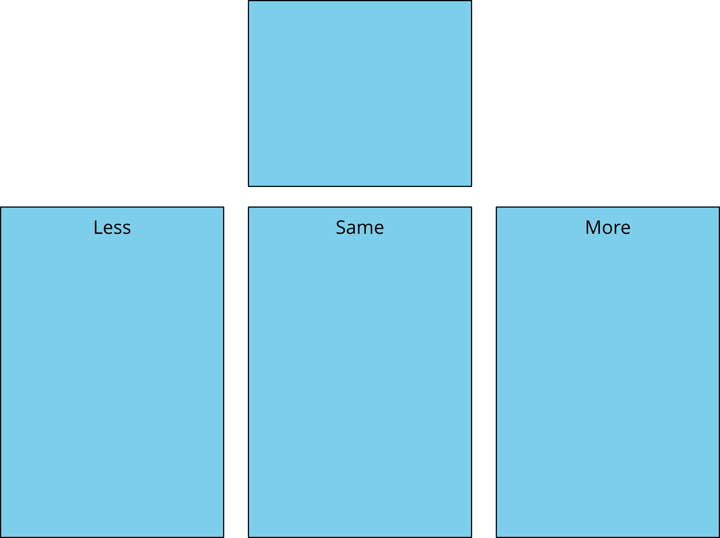
Math Fingers
Tower Build
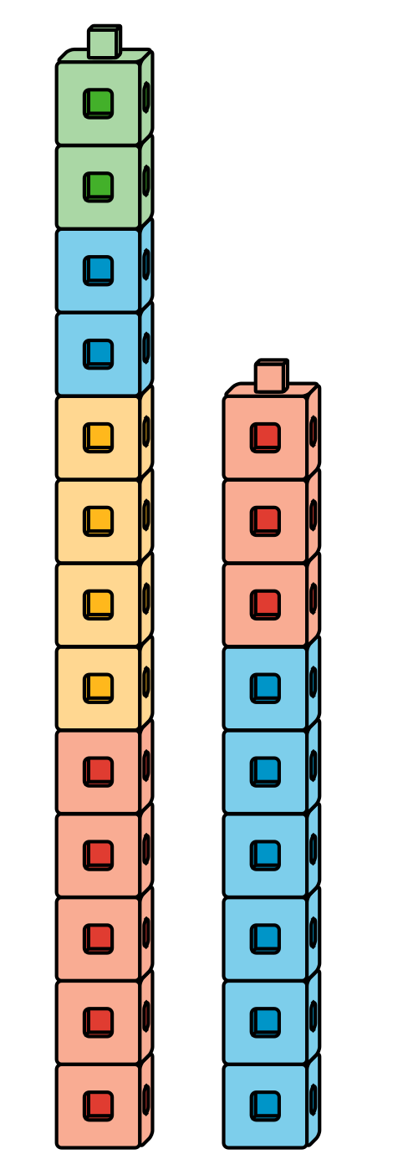
Math Stories
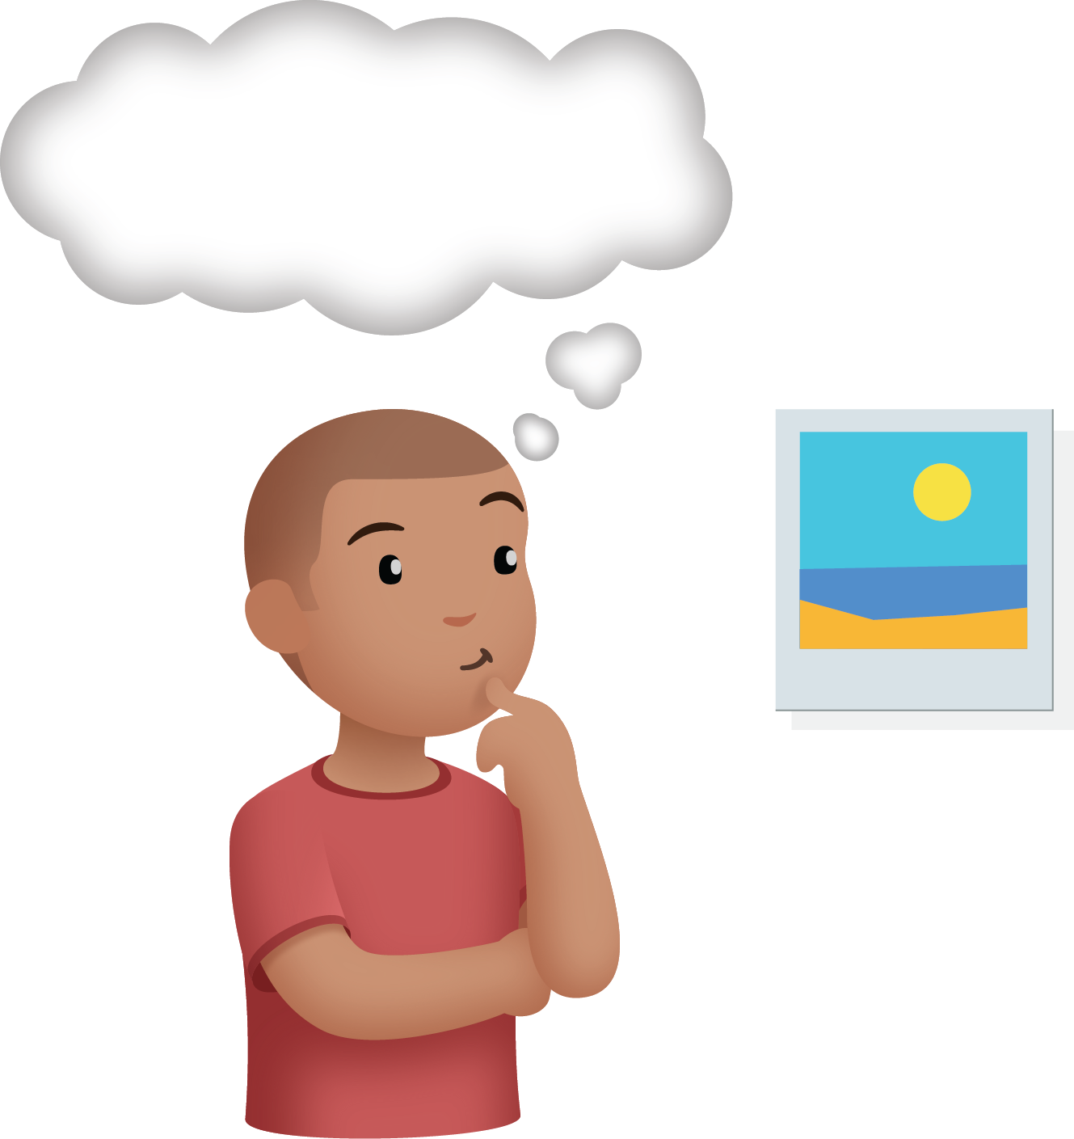
Which One

Images for Activity Synthesis
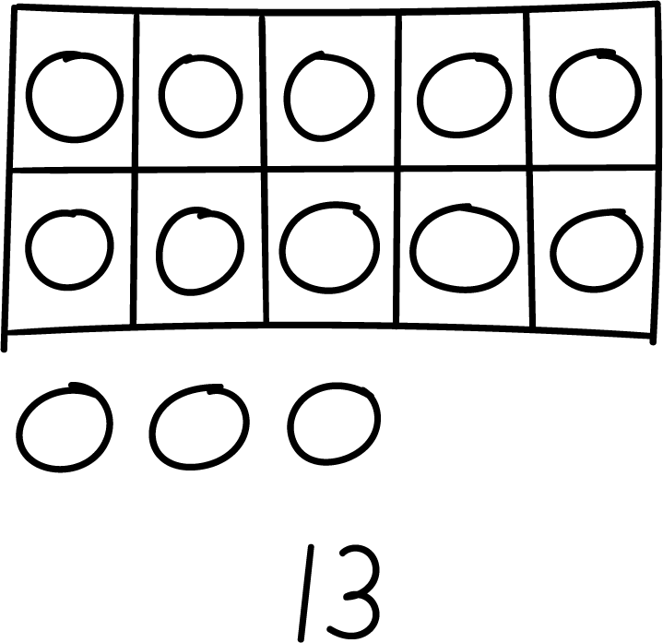
© CC BY 2021 Illustrative Mathematics®

