Lesson 10: Place Value and the Number Line
- Let’s compare methods using the number line.

Warm-up: Notice and Wonder: Base-ten and the Number Line
What do you notice? What do you wonder?
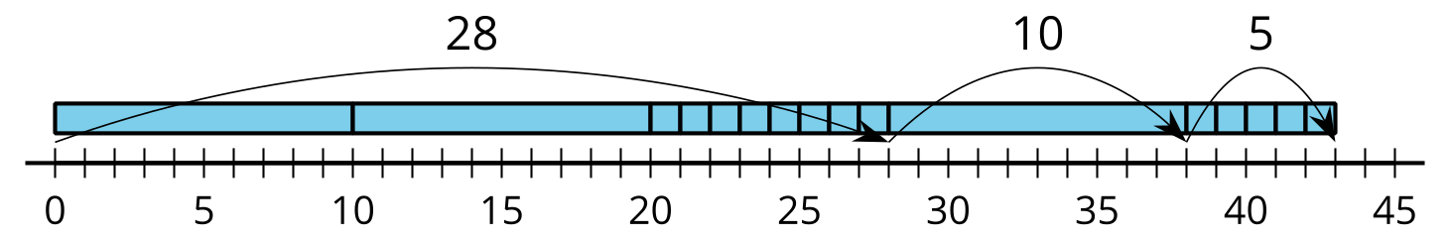

10.1: Compare Representations
Clare subtracted and represented her work with a base-ten diagram.
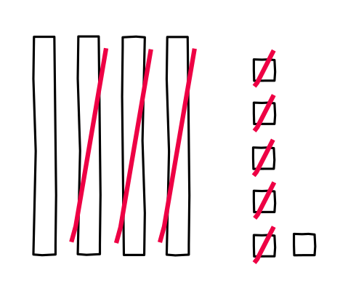
- Write an equation to represent Clare's work.
- Represent Clare’s method on the number line.
- Find the value of $58−24$.
- Show your thinking using a base-ten diagram.
- Represent how you found the value of $58−24$ on the number line.

10.2: On the Number Line
Diego is finding the value of $33+45$. He says he can count on by tens, then by ones. He used a number line to show what he means.
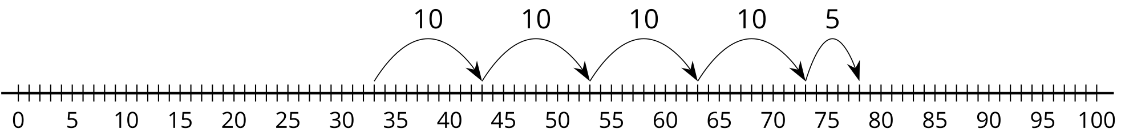
- Write an equation to show the sum for Diego’s work.
- Find the value of $23+24$.
- Represent your thinking on the number line.
- Find the value of $50−32$.
- Represent your thinking on the number line.
- Find the value of $40−26$.
- Represent your thinking on the number line.
© CC BY 2021 Illustrative Mathematics®

