Lesson 12: School Supplies
- Let’s find the difference between quantities.

Warm-up: Notice and Wonder: School Supplies
What do you notice?
What do you wonder?
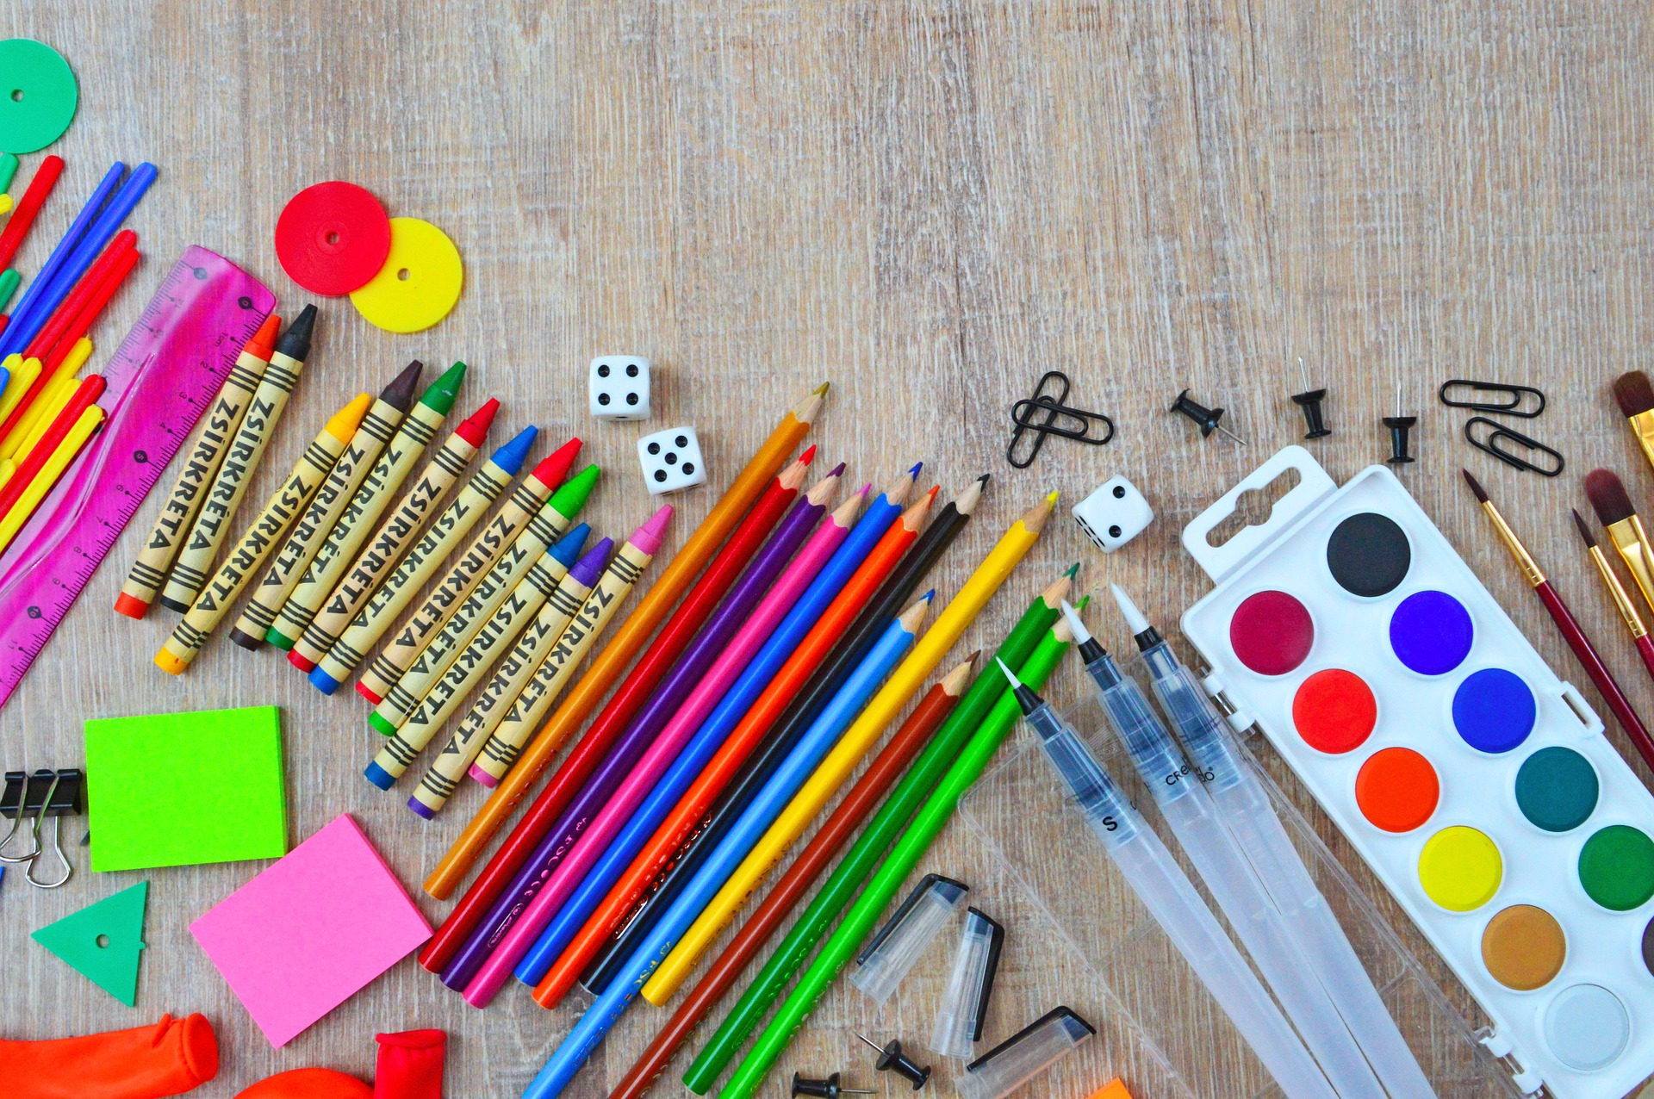

12.1: Not Enough Pencils
There are 10 students at the table.
There are 6 pencils.
How many students won't get a pencil?
Show your thinking using drawings, numbers, or words.

12.2: Compare Problems
- There are 9 markers in a bin.
There are 4 caps for the markers.
How many more caps are needed so that each marker has a cap?
Show your thinking using drawings, numbers, or words.
- Equation: ____________________________
- There are 2 folders on the teacher's desk.
There are 9 folders on the supply table.
How many fewer folders are there on the desk than the table?
Show your thinking using drawings, numbers, or words.
- Equation: ________________________________
- There are 5 dry erase boards at each table.
There are 8 markers at each table.
How many more markers are there than dry erase boards at each table?
Show your thinking using drawings, numbers, or words.
- Equation: ________________________________
© CC BY 2021 Illustrative Mathematics®

