Lesson 2: Find the Unknown Addend
- Let’s find values that make the equations true.

2.1: How Did You Find It?
- 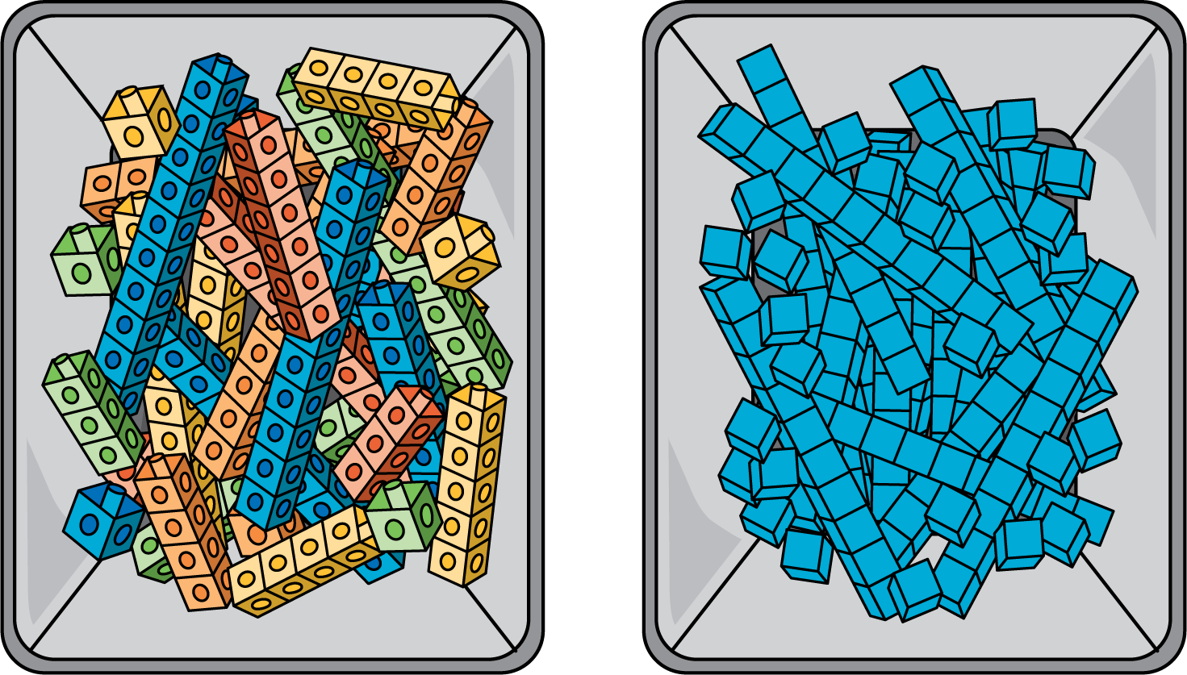
- What is the same and what is different between these tools?
- Find the number that makes the equation true. Show your thinking using the cubes, blocks, or drawings.
- 41+ _=84

2.2: You Go This Way, I’ll Go That Way
Han and Mai use blocks to find the number that makes the equation true.
17+ _=48
- Han starts by using blocks to show 17. Show how he could find the number that makes the equation true.
- Mai starts by using blocks to show 48. Show how she could find the number that makes the equation true.
- Try this one on your own. Choose who will start with 21 and who will start with 96.
- 21+ _=96
- Show your partner how you found the number that makes the equation true.
© CC BY 2021 Illustrative Mathematics®

