Lesson 6: Compare and Describe Angles

Standards Alignments
Addressing | 4.G.A.1, 4.MD.C.5
Building Towards | 4.MD.C.5.a

Teacher-facing Learning Goals
- Compare angles in ways that make sense to students.
- Reason about how to describe the size of angles.

Student-facing Learning Goals
- Let’s think about how to compare and describe angles.

Lesson Purpose
The purpose of this lesson is for students to consider ways to compare angles and describe the size of angles.
In previous lessons, students identified and described lines, line segments, rays, and angles in geometric and real-world contexts. The purpose of the exploratory work in this lesson is for students to make sense of which attributes define an angle (rays at a common endpoint) and which attributes do not (length of the line segments). The activities in the lesson intentionally elicit students’ ideas for how to describe an angle’s size.
Throughout the lesson, monitor for the ways students distinguish visible line segments from the rays that compose the angles and the language they use to describe the size of angles.

Instructional Routines
MLR2 Collect and Display (Activity 1), Which One Doesn’t Belong? (Warm-up)

Materials to Gather
- Materials from a previous activity: Activity 2
- Patty paper: Activity 2

Materials to Copy
- Card Sort: Angles (groups of 2): Activity 1

Lesson Timeline
Warm-up | 10 min
Activity 1 | 20 min
Activity 2 | 15 min
Lesson Synthesis | 10 min
Cool-down | 5 min

Teacher Reflection Question
In today’s lesson, students had the opportunity to compare angles using the language that makes sense to them. What language did they use to describe the size of angles? How can you build on this language in the next lesson when the size of an angle is described as a turn from one ray from the other?

Cool-down
(to be completed at the end of the lesson) 5min
Compare Two Angles

Standards Alignments
Addressing | 4.MD.C.5

Student-facing Task Statement
Here are two angles.
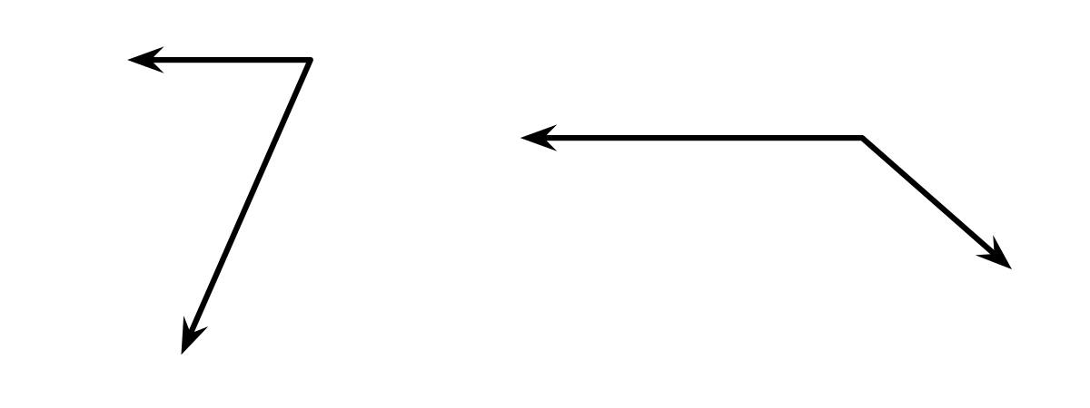
- Describe at least one way they are alike.
- Describe at least one way they are different.

Student Responses
Sample response:
- Alike:
  - They both show 2 rays that share a common endpoint.
  - They both have one ray that is pointing in the same direction.
- Different:
  - They each have one ray that is pointing in different directions.
  - One angle has a line segment that is longer than the other.
  - The angle on the right looks wider than the other angle.

