Unit 3 Lesson 7: Exploring the Area of a Circle

1 Estimating Areas (Warm up)

Images for Launch
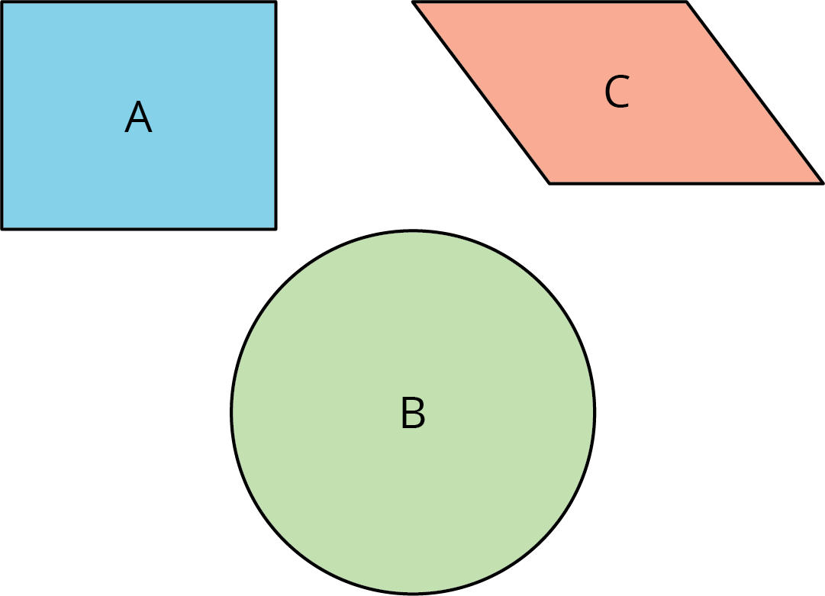
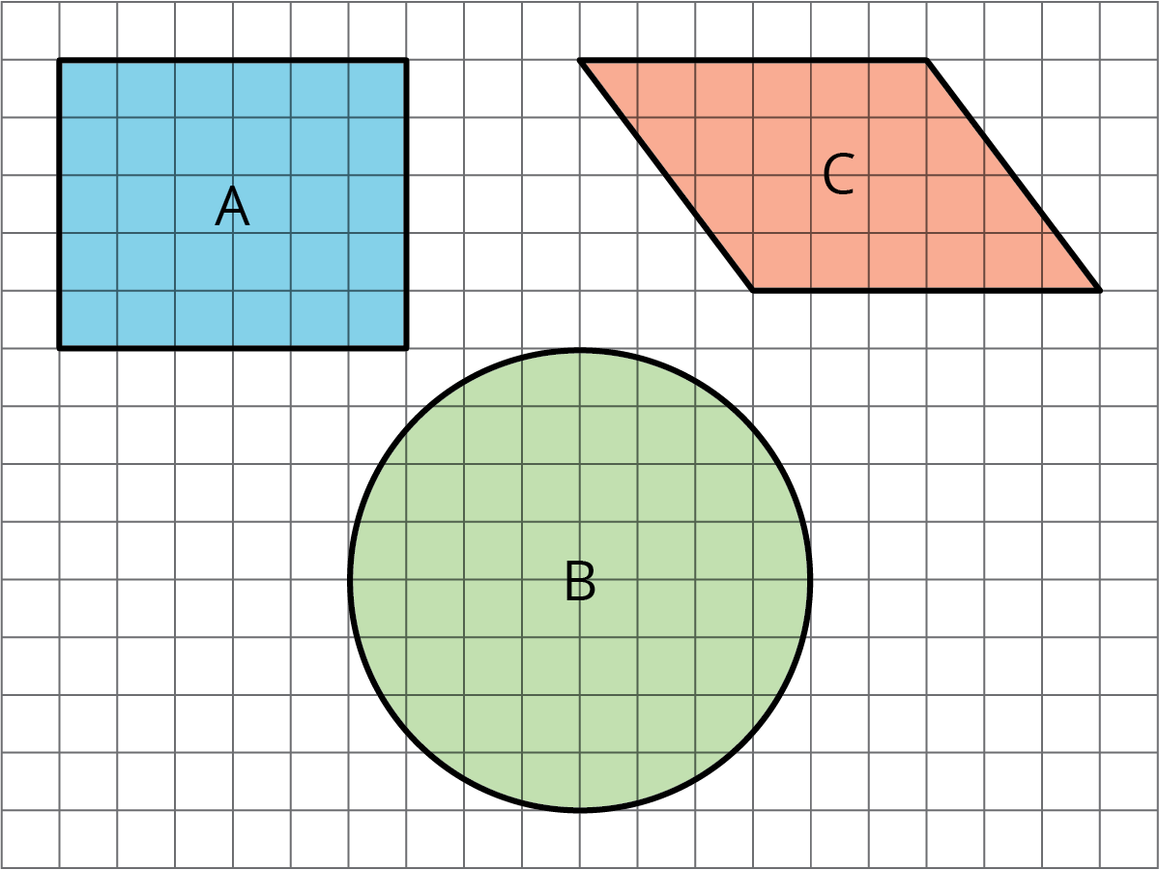

Student Task Statement
Your teacher will show you some figures. Decide which figure has the largest area. Be prepared to explain your reasoning.

2 Estimating Areas of Circles

Student Task Statement
Your teacher will give your group two circles of different sizes.
- For each circle, use the squares on the graph paper to measure the diameter and estimate the area of the circle. Record your measurements in the table.
- diameter (cm) | - estimated area (cm²)
- Plot the values from the table on the class coordinate plane. Then plot the class’s data points on your coordinate plane.
- In a previous lesson, you graphed the relationship between the diameter and circumference of a circle. How is this graph the same? How is it different?

3 Covering a Circle (Optional)

Student Task Statement
Here is a square whose side length is the same as the radius of the circle.
How many of these squares do you think it would take to cover the circle exactly?

Activity Synthesis
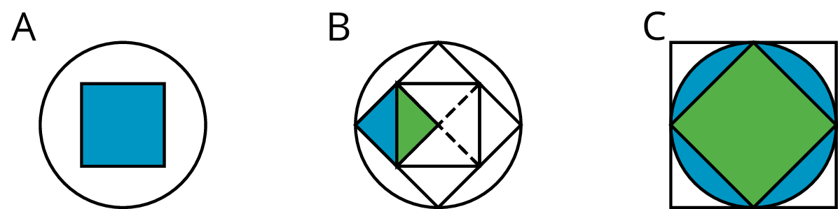

Images for Activity Synthesis
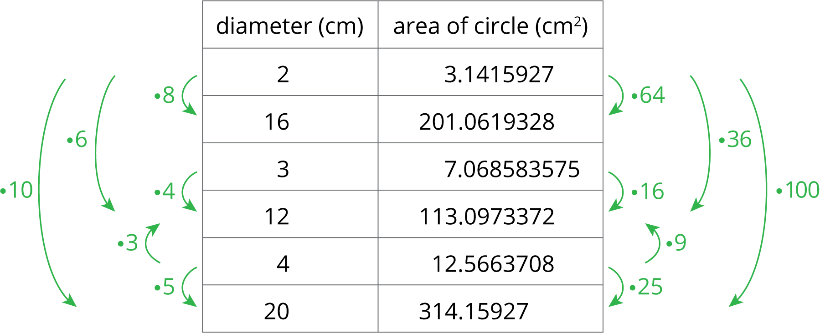
© CC BY Open Up Resources. Adaptations CC BY IM.

