Unit 8 Lesson 4: The Mean

1 Which One Doesn’t Belong: Division (Warm up)

Student Task Statement
Which expression does not belong? Be prepared to explain your reasoning.
$\frac{8+8+4+4}{4}$
$\frac{10+10+4}{4}$
$\frac{9+9+5+5}{4}$
$\frac{6+6+6+6+6}{5}$

2 Spread Out and Share

Student Task Statement
- The kittens in a room at an animal shelter are placed in 5 crates.
  - The manager of the shelter wants the kittens distributed equally among the crates. How might that be done? How many kittens will end up in each crate?
  - The number of kittens in each crate after they are equally distributed is called the mean number of kittens per crate, or the average number of kittens per crate. Explain how the expression $10÷5$ is related to the average.
  - Another room in the shelter has 6 crates. No two crates has the same number of kittens, and there is an average of 3 kittens per crate. Draw or describe at least two different arrangements of kittens that match this description.
- Five servers were scheduled to work the number of hours shown. They decided to share the workload, so each one would work equal hours.
- server A: 3
- server B: 6
- server C: 11
- server D: 7
- server E: 4
  - On the grid on the left, draw 5 bars whose heights represent the hours worked by servers A, B, C, D, and E.
  - 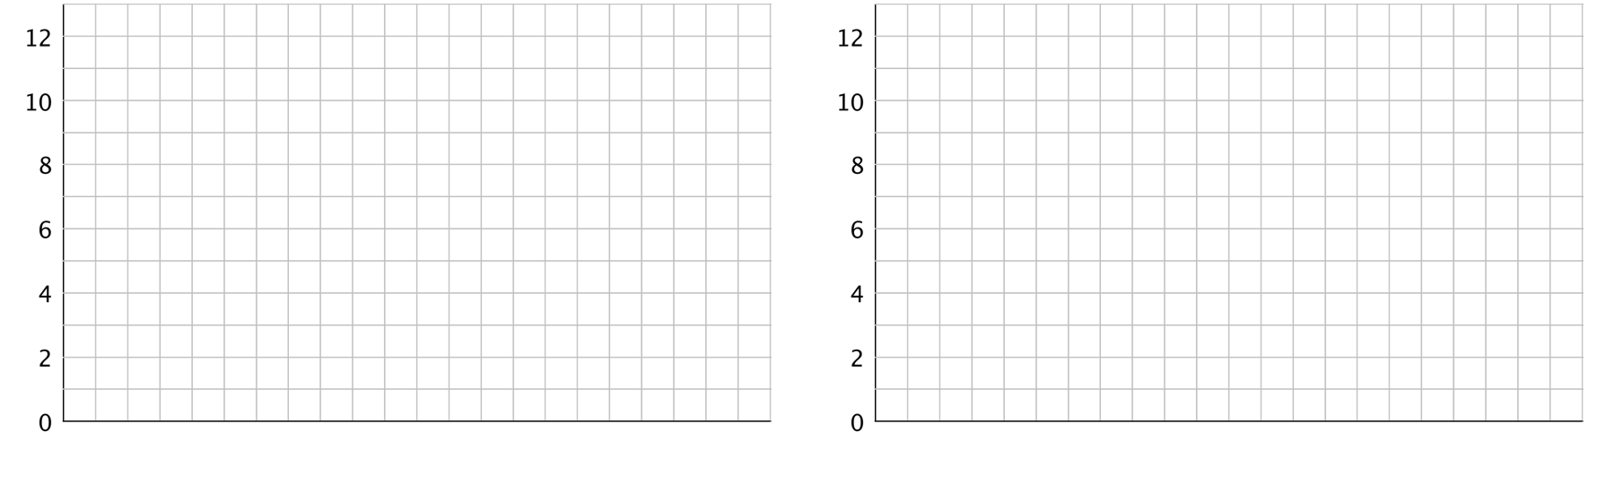
  - Think about how you would rearrange the hours so that each server gets a fair share. Then, on the grid on the right, draw a new graph to represent the rearranged hours. Be prepared to explain your reasoning.
  - Based on your second drawing, what is the average or mean number of hours that the servers will work?
  - Explain why we can also find the mean by finding the value of the expression $31÷5$.
  - Which server will see the biggest change to work hours? Which server will see the least change?

3 Travel Times (Part 2)

Student Task Statement
- Here are dot plots showing how long Diego’s trips to school took in minutes—which you studied earlier—and how long Andre’s trips to school took in minutes. The dot plots include the means for each data set, marked by triangles.
- 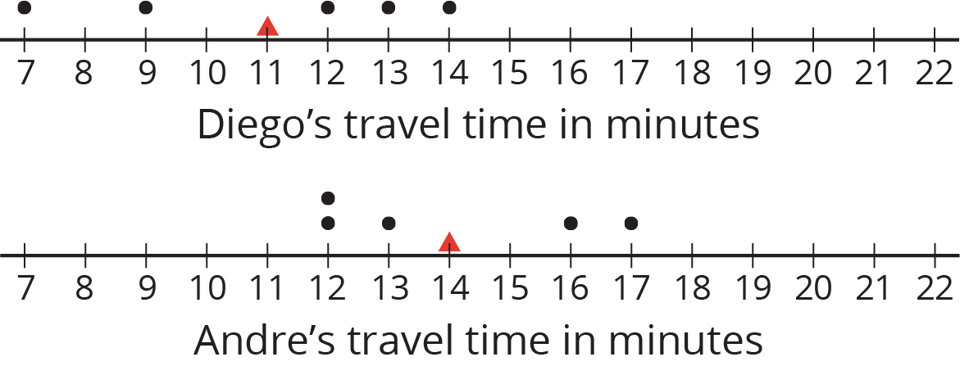
  - Which of the two data sets has a larger mean? In this context, what does a larger mean tell us?
  - Which of the two data sets has larger sums of distances to the left and right of the mean? What do these sums tell us about the variation in Diego’s and Andre’s travel times?
- Here is a dot plot showing lengths of Lin’s trips to school.
- 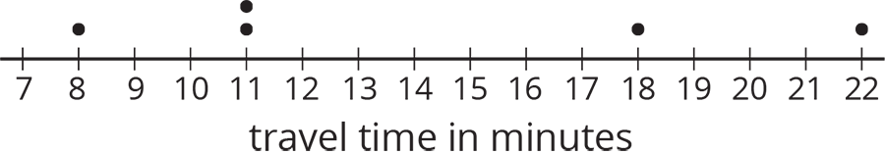
  - Calculate the mean of Lin’s travel times.
  - Complete the table with the distance between each point and the mean as well whether the point is to the left or right of the mean.
- time in minutes | - distance from the mean | - left or right of the mean?
  - 22
  - 18
  - 11
  - 8
  - 11
  - Find the sum of distances to the left of the mean and the sum of distances to the right of the mean.
  - Use your work to compare Lin’s travel times to Andre’s. What can you say about their average travel times? What about the variability in their travel times?

Activity Synthesis
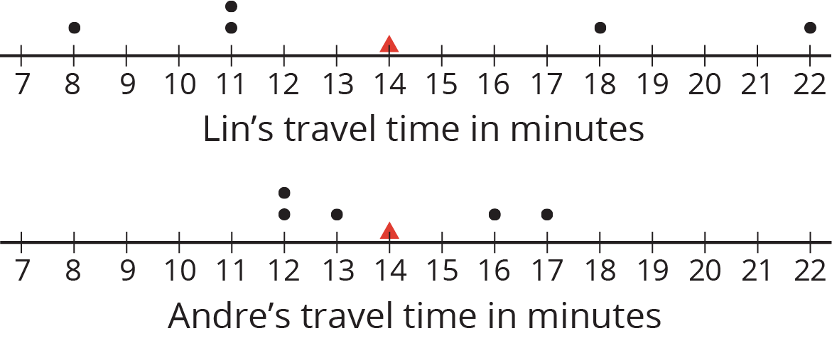
© CC BY Open Up Resources. Adaptations CC BY IM.

