Unit 1 Lesson 6: No Bending or Stretching

1 Measuring Segments (Warm up)

Student Task Statement
For each question, the unit is represented by the large tick marks with whole numbers.
- Find the length of this segment to the nearest $\frac{1}{8}$ of a unit.
- 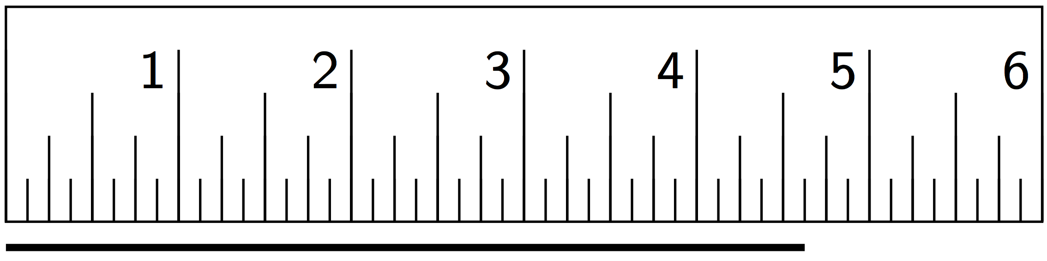
- Find the length of this segment to the nearest 0.1 of a unit.
- 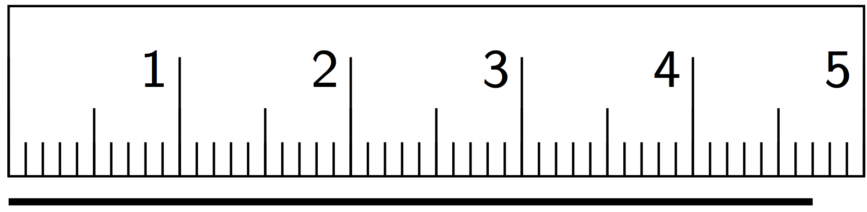
- Estimate the length of this segment to the nearest $\frac{1}{8}$ of a unit.
- 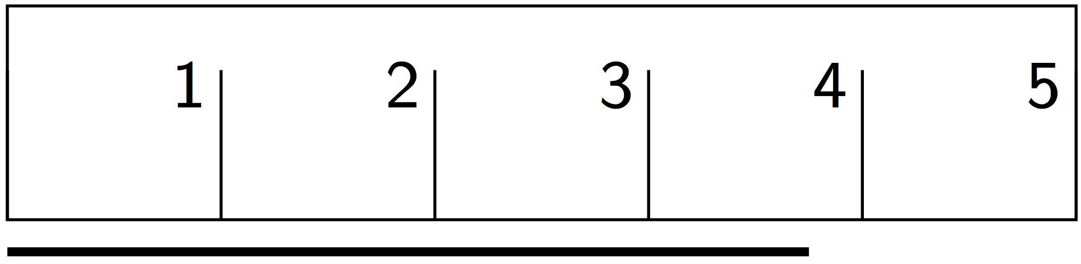
- Estimate the length of the segment in the prior question to the nearest 0.1 of a unit.

2 Sides and Angles

Student Task Statement
- Translate Polygon $A$ so point $P$ goes to point $Q$. In the image, write the length of each side, in grid units, next to the side.
- 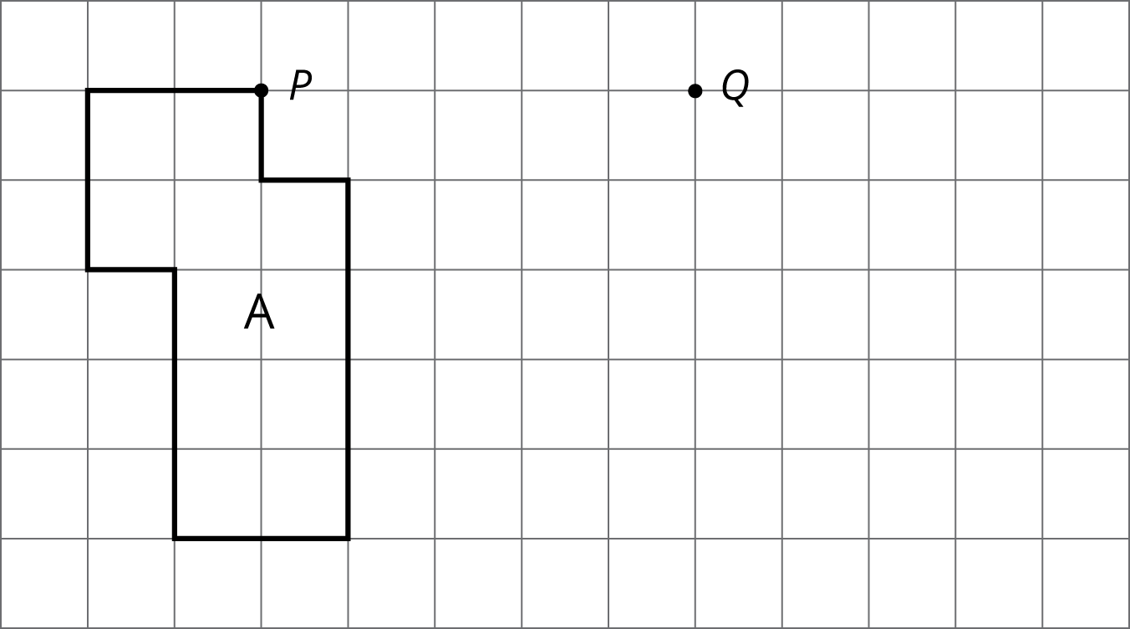
- Rotate Triangle $B$ 90 degrees clockwise using $R$ as the center of rotation. In the image, write the measure of each angle in its interior.
- 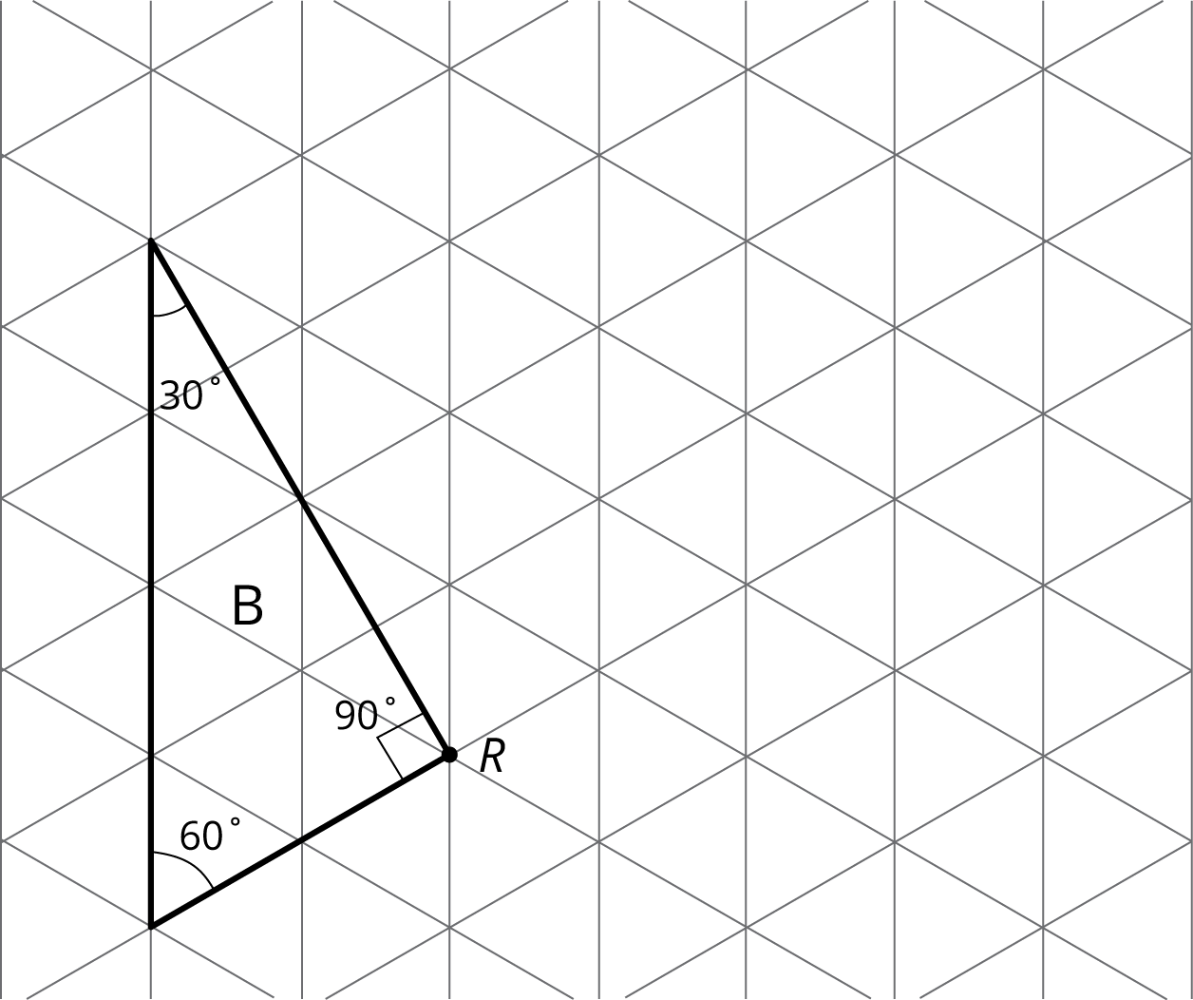

- Reflect Pentagon $C$ across line $ℓ$.
  - In the image, write the length of each side, in grid units, next to the side. You may need to make your own ruler with tracing paper or a blank index card.
  - In the image, write the measure of each angle in the interior.
- 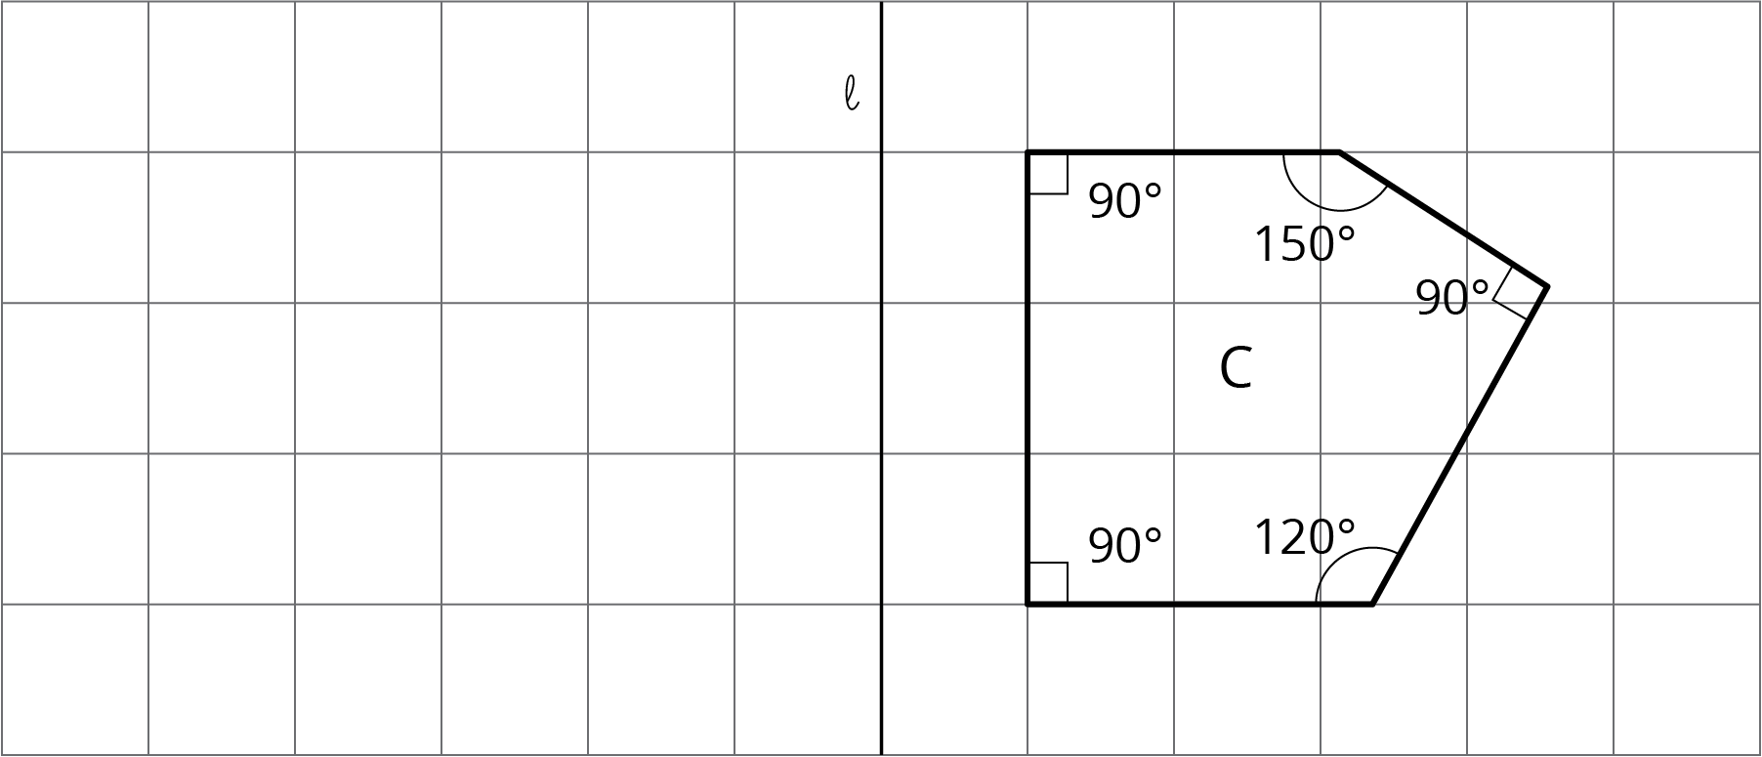

Activity Synthesis
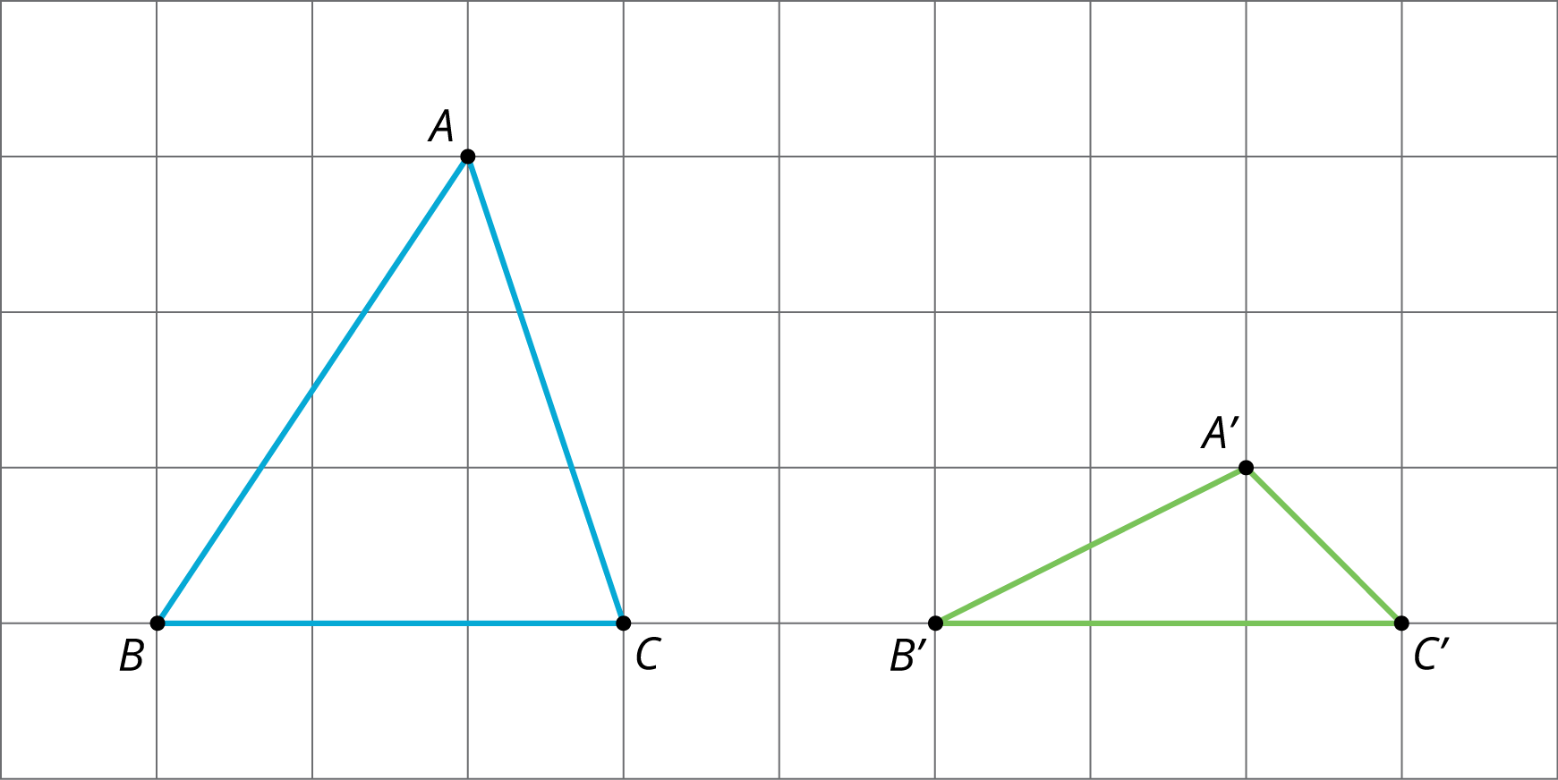

3 Which One?

Student Task Statement
Here is a grid showing triangle $ABC$ and two other triangles.
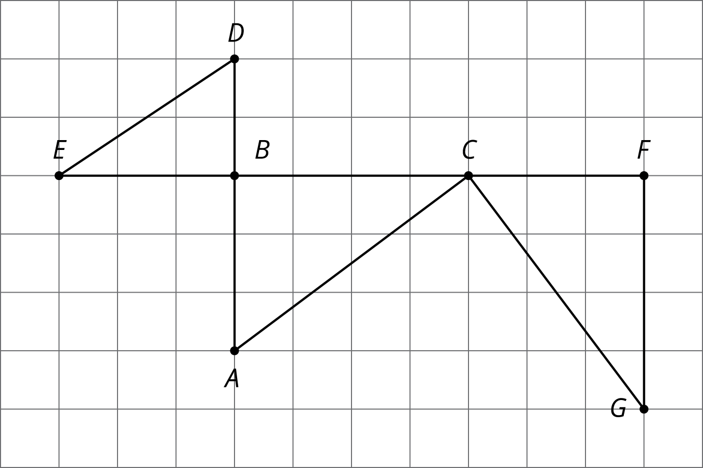
You can use a rigid transformation to take triangle $ABC$ to one of the other triangles.
- Which one? Explain how you know.
- Describe a rigid transformation that takes $ABC$ to the triangle you selected.
© CC BY Open Up Resources. Adaptations CC BY IM.

